Recall Cases Summary – Canada (Last Update Date: 30 June 2024)

Date | Product | Categories | Hazard | Image
6-Jun-2024 | Fodoss Baby Bedside Bassinet | Toys and Childcare Products | Entrapment Hazard, Suffocation Hazard | 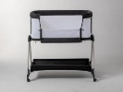  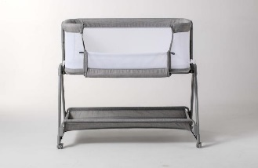
6-Jun-2024 | Lawn and Garden Equipment | Machinery | Fire Hazard, Burn Hazard | 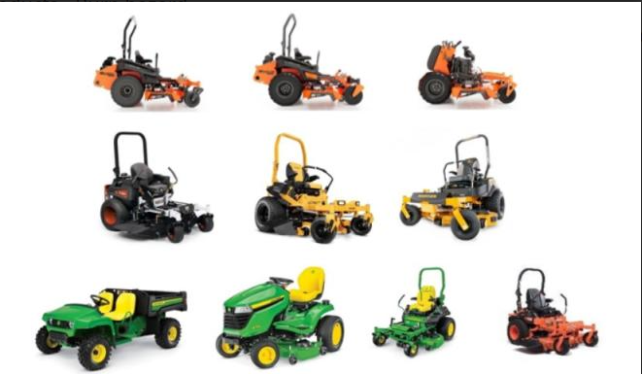
6-Jun-2024 | Rechargeable LED Motion-Activated Light Bar | Electrical Appliances | Fire Hazard, Burn Hazard | 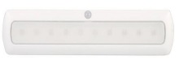  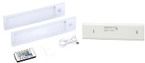
6-Jun-2024 | Dog Conditioner | Pet Items | Microbiological Hazard | 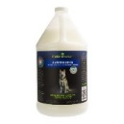
6-Jun-2024 | Electric Kettles | Home Electrical Appliances | Fire Hazard | 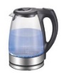  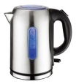  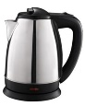
10-Jun-2024 | Wild Country Ropeman 1 Ascenders | Tools and Hardware | Safety Risk Hazard | 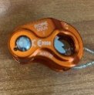  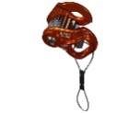
13-Jun-2024 | Neve Strap Crampons | Sporting Goods / Equipment | Fall Hazard | 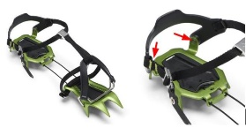
20-Jun-2024 | Instinct Cordless Hair Clipper | Electrical Appliances | Burn Hazard | 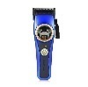
20-Jun-2024 | Cargo Bicycles | Sporting Goods / Equipment | Fall Hazard | 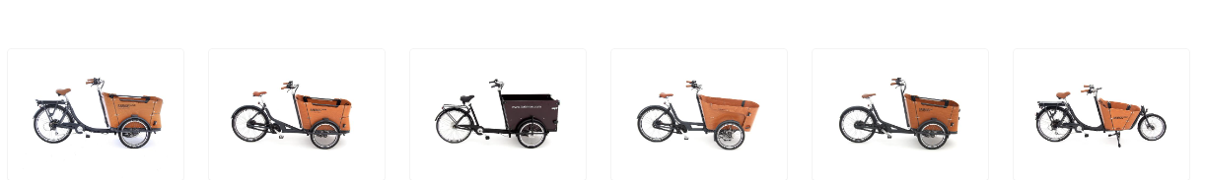  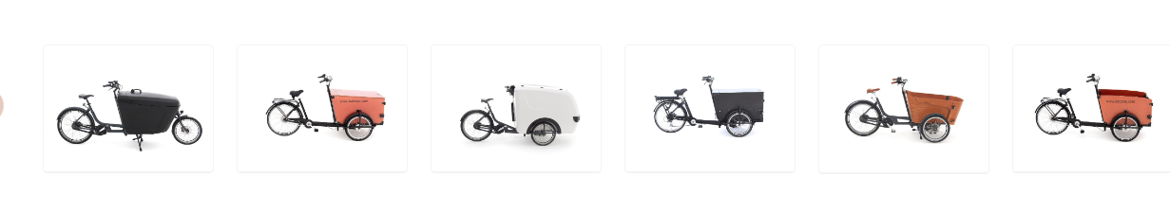  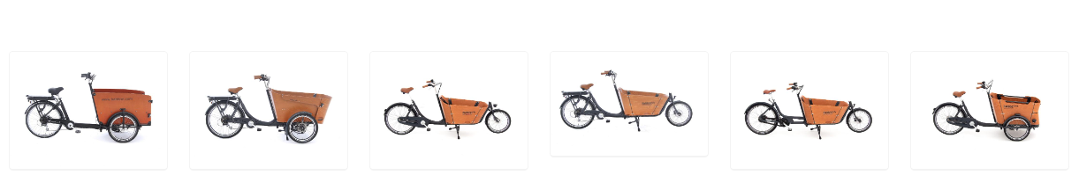  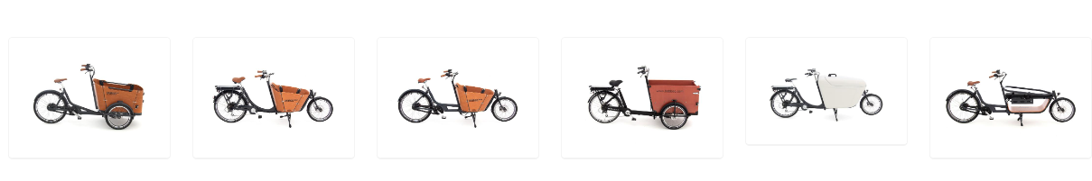
20-Jun-2024 | Blending Containers and Blade Bases | Electrical Appliances | Laceration Hazard | 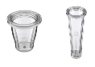  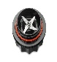
20-Jun-2024 | Goal Zero Yeti Link Expansion Module (and Associated EC8 Cables) | Electrical Appliances | Fire Hazard, Burn Hazard | 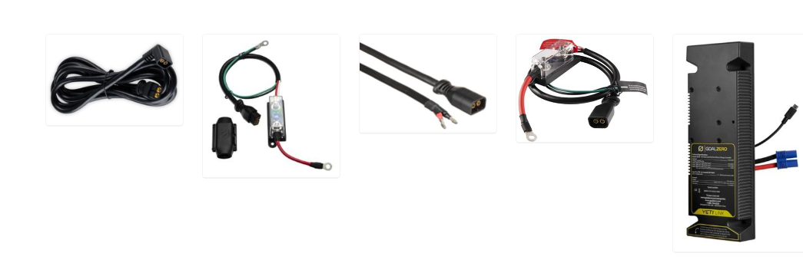
25-Jun-24 | MGA's Miniverse "Make It Mini" Products with Unused Liquid Resins | Toys and Childcare Products | Skin Irritation Risk, Eye Irritation Risk | 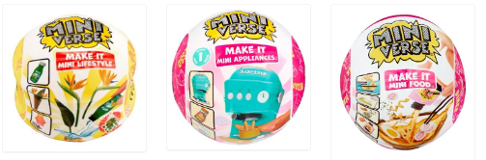
27-Jun-2024 | One-Piece Sleepsuits | Fabric / Textile / Garment / Home Textile | Burn Hazard | 