Recall Cases Summary – China (Last Update Date: 30 June 2024)

Date | Province | Product | Categories | Hazard | Image
4-Jun-2024 | Inner Mongolia | Electric Bicycles | Sporting Goods / Equipment | Safety Risk Hazard | 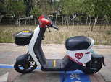
4-Jun-2024 | Fujian | Embedded LED Lamps | Electrical Appliances | Electric Shock Hazard, Safety Risk Hazard | 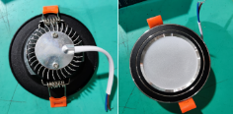
4-Jun-2024 | Fujian | Fixed LED Ceiling Lights | Electrical Appliances | Electric Shock Hazard, Fire Hazard | 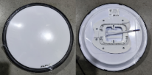
6-Jun-2024 | Beijing | Aquatec Enamel Finish | Chemicals | Chemical Hazard | 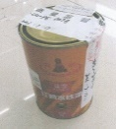
11-Jun-2024 | Beijing | Baby Mattresses | Fabric / Textile / Garment / Home Textile | Injury Hazard, Laceration Hazard | 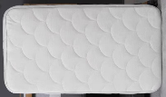
14-Jun-2024 | Shanghai | Indoor Heaters | Home Electrical Appliances | Fire Hazard | 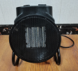
14-Jun-2024 | Shanghai | Children's Sports Shoes | Footwear | Chemical Hazard | 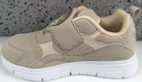
17-Jun-2024 | Anhui | Sockets and Super Sockets | Electrical Appliances | Electric Shock Hazard | /
17-Jun-2024 | Anhui | Foot Warmers | Home Electrical Appliances | Electric Shock Hazard | /
17-Jun-2024 | Anhui | Disposable Bamboo Chopsticks | Food Contact Material | Puncture Hazard | /
17-Jun-2024 | Anhui | Electric Bicycle Battery Chargers | Electrical Appliances | Electric Shock Hazard | /
17-Jun-2024 | Anhui | Electric Bicycle Chargers | Electrical Appliances | Electric Shock Hazard, Laceration Hazard | /
17-Jun-2024 | Anhui | Electric Bicycle Lithium Battery Chargers | Electrical Appliances | Electric Shock Hazard | /
17-Jun-2024 | Anhui | Children's Dress | Fabric / Textile / Garment / Home Textile | Entanglement Hazard, Injury Hazard, Suffocation Hazard | /
17-Jun-2024 | Anhui | Toilet Paper Rolls | Household Items | Chemical Hazard | /
17-Jun-2024 | Anhui | Storage Boxes | Household Items | Laceration Hazard | /
17-Jun-2024 | Anhui | Student Exercise Books | Stationery | Laceration Hazard | /
18-Jun-2024 | Anhui | Apartment Beds and Desks | Furniture | Laceration Hazard | /
18-Jun-2024 | Anhui | Household Instantaneous Water Heaters | Electrical Appliances | Electric Shock Hazard, Injury Hazard | /
18-Jun-2024 | Anhui | Toilet Paper | Household Items | Chemical Hazard | /
18-Jun-2024 | Anhui | Exercise Books | Stationery | Laceration Hazard | /
19-Jun-2024 | Fujian | Ruler Sets | Stationery | Laceration Hazard | 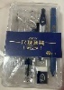
19-Jun-2024 | Fujian | Hooded Down Jackets | Fabric / Textile / Garment / Home Textile | Injury Hazard | 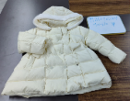
19-Jun-2024 | Fujian | Electronic Keyboards (Children's Toys) | Toys and Childcare Products | Suffocation Hazard | 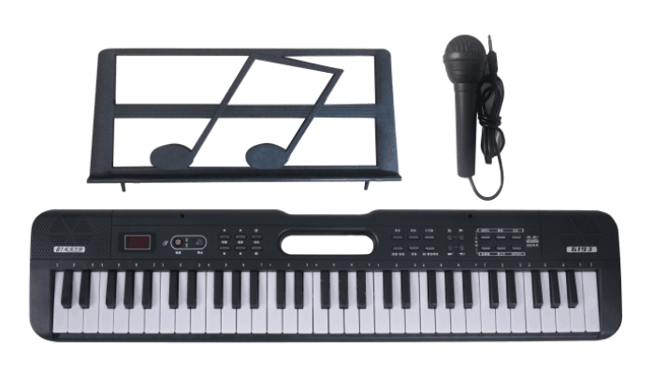
19-Jun-2024 | Fujian | Hooded Down Jackets | Fabric / Textile / Garment / Home Textile | Chemical Hazard | 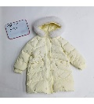
20-Jun-2024 | Hunan | Paper Bowls | Food Contact Material | Burn Hazard | 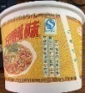
20-Jun-2024 | Hunan | Disposable Aviation Cups | Food Contact Material | Burn Hazard | 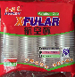
20-Jun-2024 | Hunan | Disposable Aviation Cups | Food Contact Material | Burn Hazard | 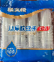
21-Jun-2024 | Zhejiang | Ceiling Fans | Home Electrical Appliances | Safety Risk Hazard | 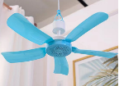
21-Jun-2024 | Zhejiang | Fan | Home Electrical Appliances | Injury Hazard, Electric Shock Hazard | 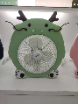
21-Jun-2024 | Zhejiang | Storage Electric Hand Warmers | Electrical Appliances | Electric Shock Hazard | 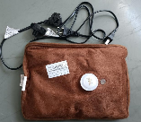
21-Jun-2024 | Zhejiang | Hair Curlers | Electrical Appliances | Fire Hazard | 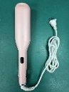
21-Jun-2024 | Zhejiang | Circulation Fans | Electrical Appliances | Fire Hazard | 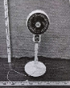
21-Jun-2024 | Shanghai | 36-Color Water-Based Marker Sets | Stationery | Choking Hazard, Suffocation Hazard | 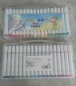
21-Jun-2024 | Guangdong | Tea Cooker | Home Electrical Appliances | Fire Hazard | 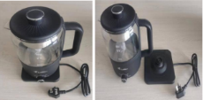
21-Jun-2024 | Guangdong | Fire Fighting Filter Type Self Rescue Respirator | Protective Equipment | Safety Risk Hazard | 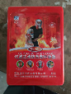
24-Jun-2024 | Beijing | Neutral Silicone Mildew Weatherproof Silicone Sealant | Chemicals | Chemical Hazard | 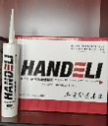
24-Jun-2024 | Hunan | Foot Warmers | Home Electrical Appliances | Fire Hazard | 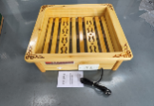
24-Jun-2024 | Hunan | Heaters | Electrical Appliances | Electric Shock Hazard | 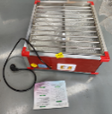
24-Jun-2024 | Hunan | Heaters | Home Electrical Appliances | Fire Hazard, Safety Risk Hazard | 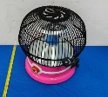
24-Jun-2024 | Hunan | Heaters | Electrical Appliances | Electric Shock Hazard | 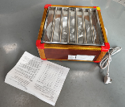
24-Jun-2024 | Hunan | Wooden Foot Warmers | Home Electrical Appliances | Electric Shock Hazard, Fire Hazard | 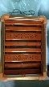
24-Jun-2024 | Hunan | Foot Warmers | Home Electrical Appliances | Fire Hazard | 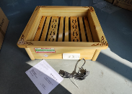
24-Jun-2024 | Hunan | Indoor Heaters (Multi-Function Heaters) | Home Electrical Appliances | Electric Shock Hazard | 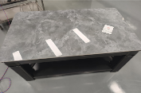
24-Jun-2024 | Henan | Axial Fan | Home Electrical Appliances | Electric Shock Hazard, Fire Hazard | /
24-Jun-2024 | Sichuan | Electric Bicycles | Sporting Goods / Equipment | Crash Hazard | /
24-Jun-2024 | Sichuan | Electric Bicycles | Sporting Goods / Equipment | Crash Hazard, Safety Risk Hazard | /
24-Jun-2024 | Guangdong | Electric Bicycles | Sporting Goods / Equipment | Explosion Hazard, Safety Risk Hazard | 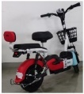
24-Jun-2024 | Guangdong | Electric Bicycles | Sporting Goods / Equipment | Explosion Hazard, Fire Hazard | 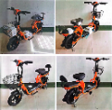
24-Jun-2024 | Guangdong | Electric Bicycles | Sporting Goods / Equipment | Explosion Hazard, Safety Risk Hazard | 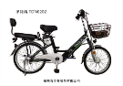
25-Jun-2024 | Hubei | Dishwashing Liquids | Chemicals | Microbiological Hazard | /
25-Jun-2024 | Jilin | Women's and Men's Boat Socks | Fabric / Textile / Garment / Home Textile | Chemical Hazard | /
26-Jun-2024 | Yunnan | Portable Dry Powder Fire Extinguishers | Protective Equipment | Safety Risk Hazard | /
26-Jun-2024 | Guangxi | Strap Covers | Fabric / Textile / Garment / Home Textile | Suffocation Hazard, Safety Risk Hazard | /
26-Jun-2024 | Guangdong | Portable Power Banks | Electrical Appliances | Burn Hazard | /
26-Jun-2024 | Guangdong | Electric Kettles | Home Electrical Appliances | Electric Shock Hazard, Fire Hazard | 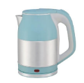
26-Jun-2024 | Guangdong | Electric Kettles | Home Electrical Appliances | Electric Shock Hazard, Fire Hazard | 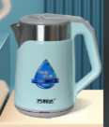
27-Jun-2024 | Hubei | Electric Bicycles | Sporting Goods / Equipment | Fire Hazard | /
27-Jun-2024 | Hubei | Electric Bicycles | Sporting Goods / Equipment | Fire Hazard | /
27-Jun-2024 | Guangdong | Electric Kettles | Home Electrical Appliances | Electric Shock Hazard, Fire Hazard | 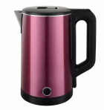
27-Jun-2024 | Guangdong | Electric Kettles | Home Electrical Appliances | Electric Shock Hazard, Fire Hazard | 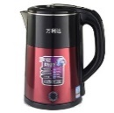
27-Jun-2024 | Guangdong | Electric Kettles | Home Electrical Appliances | Electric Shock Hazard, Fire Hazard | 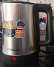
27-Jun-2024 | Guangdong | Electric Kettles | Home Electrical Appliances | Electric Shock Hazard | 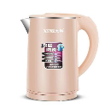
27-Jun-2024 | Guangdong | Electric Kettles | Home Electrical Appliances | Electric Shock Hazard, Fire Hazard | 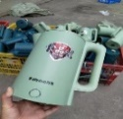
28-Jun-2024 | Hebei | Electric Blankets | Home Electrical Appliances | Electric Shock Hazard | /
28-Jun-2024 | Hebei | Electric Blankets | Home Electrical Appliances | Electric Shock Hazard | /
28-Jun-2024 | Hebei | Electric Blankets | Home Electrical Appliances | Safety Risk Hazard | /
28-Jun-2024 | Hebei | Children's Bicycles | Sporting Goods / Equipment | Chemical Hazard, Safety Risk Hazard | /
28-Jun-2024 | Hebei | Children's Bicycles | Toys and Childcare Products | Chemical Hazard | /

