Recall Cases Summary – Europe (Last Update Date: 30 June 2024)

Date | Notifying Country | Product | Categories | Hazard | Image
3-Jun-2024 | Italy | Hair Gel | Bodycare / Cosmetics | Chemical Hazard | 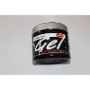
3-Jun-2024 | Sweden | Necklace | Jewelry | Chemical Hazard | 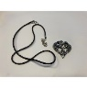
3-Jun-2024 | Sweden | LED Headlamp | Electrical Appliances | Chemical Hazard, Environmental Hazard | 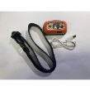
3-Jun-2024 | Sweden | Bag | Fabric / Textile / Garment / Home Textile | Chemical Hazard, Environmental Hazard | 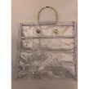
3-Jun-2024 | Lithuania | Plastic Doll | Toys and Childcare Products | Chemical Hazard | 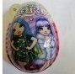
4-Jun-2024 | Italy | Hair Conditioner | Bodycare / Cosmetics | Chemical Hazard | 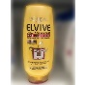
4-Jun-2024 | Italy | Deodorant Stick | Bodycare / Cosmetics | Chemical Hazard | 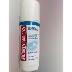
4-Jun-2024 | Italy | Deodorant Stick | Bodycare / Cosmetics | Chemical Hazard | 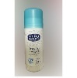
4-Jun-2024 | France | Travel Adaptor | Electrical Appliances | Electric Shock Hazard | 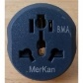
4-Jun-2024 | Belgium | Children's Swim Shorts | Fabric / Textile / Garment / Home Textile | Injury Hazard | 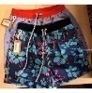
4-Jun-2024 | Lithuania | Toy Pushchair | Toys and Childcare Products | Injury Hazard | 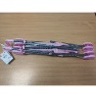
4-Jun-2024 | Sweden | Game Console | Electrical Appliances | Environmental Hazard | 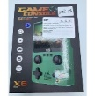
4-Jun-2024 | Sweden | Game Console | Electrical Appliances | Environmental Hazard | 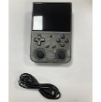
4-Jun-2024 | Sweden | Game Console | Electrical Appliances | Environmental Hazard | 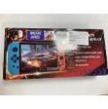
4-Jun-2024 | Sweden | Wireless Earphones | Computer / Audio / Video / Other Electronics & Accessories | Chemical Hazard, Environmental Hazard | 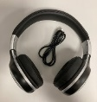
4-Jun-2024 | Sweden | Speaker | Computer / Audio / Video / Other Electronics & Accessories | Environmental Hazard | 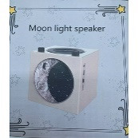
4-Jun-2024 | Sweden | USB Cable | Electrical Appliances | Environmental Hazard | 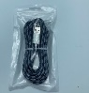
4-Jun-2024 | Sweden | Charger | Electrical Appliances | Environmental Hazard | 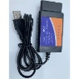
4-Jun-2024 | Sweden | Digital Voice Recorder | Computer / Audio / Video / Other Electronics & Accessories | Environmental Hazard |   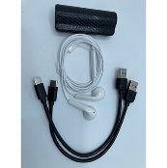
4-Jun-2024 | Belgium | Particle Filter Mask | Protective Equipment | Health Risk Hazard | 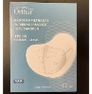
4-Jun-2024 | Bulgaria | Children's Trousers | Fabric / Textile / Garment / Home Textile | Injury Hazard, Strangulation Hazard | 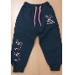
4-Jun-2024 | Bulgaria | Children's Clothing Set | Fabric / Textile / Garment / Home Textile | Injury Hazard, Strangulation Hazard | 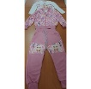  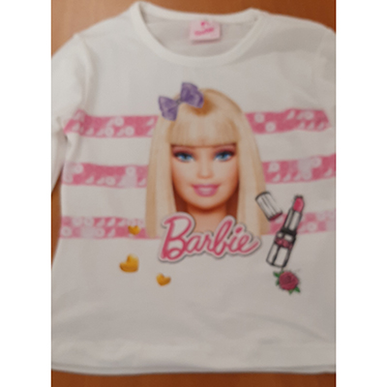
4-Jun-2024 | Sweden | Head Lamp | Electrical Appliances | Environmental Hazard | 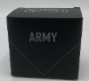
4-Jun-2024 | Bulgaria | Magnet for Fridge | Accessories | Choking Hazard, Suffocation Hazard | 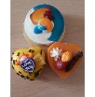
4-Jun-2024 | Poland | Hair Straightener | Electrical Appliances | Electric Shock Hazard | 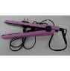
4-Jun-2024 | Lithuania | Hairspray | Bodycare / Cosmetics | Chemical Hazard | 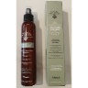
5-Jun-2024 | Italy | Liquid Soap | Bodycare / Cosmetics | Chemical Hazard | 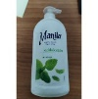
5-Jun-2024 | Italy | Eau De Toilette | Bodycare / Cosmetics | Chemical Hazard | 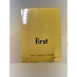
5-Jun-2024 | Italy | Shampoo | Bodycare / Cosmetics | Chemical Hazard | 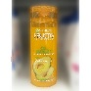
5-Jun-2024 | Italy | Shampoo | Bodycare / Cosmetics | Chemical Hazard | 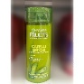
5-Jun-2024 | Italy | Shower Foam | Bodycare / Cosmetics | Chemical Hazard | 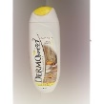
5-Jun-2024 | Italy | Deodorant | Bodycare / Cosmetics | Chemical Hazard | 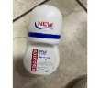
5-Jun-2024 | Italy | Deodorant | Bodycare / Cosmetics | Chemical Hazard | 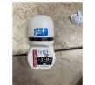
5-Jun-2024 | Italy | Deodorant | Bodycare / Cosmetics | Chemical Hazard | 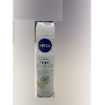
5-Jun-2024 | Sweden | Children's Boots | Footwear | Chemical Hazard | 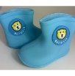
5-Jun-2024 | Poland | Toy Telephone | Toys and Childcare Products | Damage to Hearing | 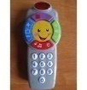
5-Jun-2024 | Ireland | Baby Nest | Toys and Childcare Products | Suffocation Hazard | 
5-Jun-2024 | Germany | USB Charger | Electrical Appliances | Electric Shock Hazard | 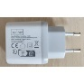
5-Jun-2024 | Sweden | Bike Light | Electrical Appliances | Environmental Hazard | 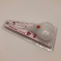
5-Jun-2024 | Denmark | Fireworks | Outdoor Living Items | Burn Hazard, Injury Hazard | 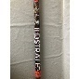
6-Jun-2024 | Italy | Bath Cream | Bodycare / Cosmetics | Chemical Hazard | 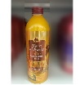
6-Jun-2024 | Italy | Bath and Shower Gel | Bodycare / Cosmetics | Chemical Hazard | 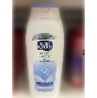
6-Jun-2024 | Sweden | Game Console | Electrical Appliances | Environmental Hazard | 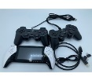
6-Jun-2024 | Ireland | Battery Charger | Electrical Appliances | Burn Hazard | 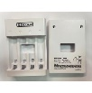
6-Jun-2024 | Czechia | Deodorant | Bodycare / Cosmetics | Chemical Hazard | 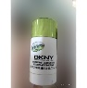
6-Jun-2024 | Czechia | Eau De Toilette | Bodycare / Cosmetics | Chemical Hazard | 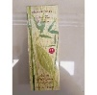
6-Jun-2024 | Germany | Necklace | Jewelry | Chemical Hazard | 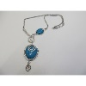
6-Jun-2024 | Germany | Beads | Jewelry | Chemical Hazard | 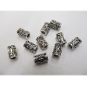
6-Jun-2024 | Austria | Toy Trumpet | Toys and Childcare Products | Choking Hazard | 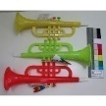
6-Jun-2024 | Czechia | Plastic Doll | Toys and Childcare Products | Chemical Hazard | 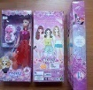
6-Jun-2024 | Hungary | Plastic Bath Toy Set | Toys and Childcare Products | Choking Hazard, Damage to Hearing | 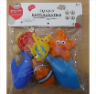
7-Jun-2024 | Sweden | Waterproof Bag | Fabric / Textile / Garment / Home Textile | Chemical Hazard | 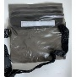
7-Jun-2024 | Czechia | Eau De Toilette | Bodycare / Cosmetics | Chemical Hazard | 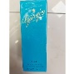
7-Jun-2024 | Czechia | Eau De Toilette | Bodycare / Cosmetics | Chemical Hazard | 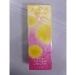
7-Jun-2024 | Czechia | Perfume | Bodycare / Cosmetics | Chemical Hazard | 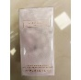
7-Jun-2024 | Czechia | Eau De Toilette | Bodycare / Cosmetics | Chemical Hazard | 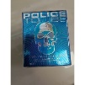
7-Jun-2024 | Hungary | Perfume | Bodycare / Cosmetics | Chemical Hazard | 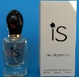
7-Jun-2024 | Hungary | Toy Pushchair | Toys and Childcare Products | Injury Hazard | 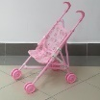
11-Jun-2024 | Italy | Perfume | Bodycare / Cosmetics | Chemical Hazard | 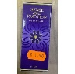
11-Jun-2024 | Italy | Perfume | Bodycare / Cosmetics | Chemical Hazard | 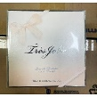
11-Jun-2024 | Italy | Perfume | Bodycare / Cosmetics | Chemical Hazard | 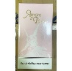
11-Jun-2024 | Italy | Eau De Toilette and Deodorant Set | Bodycare / Cosmetics | Chemical Hazard | 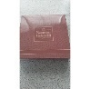
11-Jun-2024 | Germany | Craft Kit | Toys and Childcare Products | Chemical Hazard | 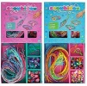
11-Jun-2024 | Germany | Necklace | Jewelry | Chemical Hazard | 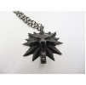
11-Jun-2024 | Germany | Jewelry Set | Jewelry | Chemical Hazard | 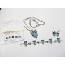
11-Jun-2024 | Germany | Bracelet | Jewelry | Chemical Hazard | 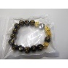
11-Jun-2024 | Germany | Set of Bracelets | Jewelry | Chemical Hazard | 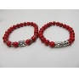
11-Jun-2024 | Germany | Necklace with Pendant | Jewelry | Chemical Hazard | 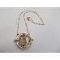
11-Jun-2024 | Germany | Chain with Pendants | Jewelry | Chemical Hazard | 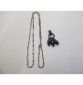
11-Jun-2024 | Germany | Necklace | Jewelry | Chemical Hazard | 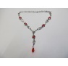
11-Jun-2024 | Germany | Necklace | Jewelry | Chemical Hazard | 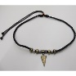
11-Jun-2024 | Germany | Necklace | Jewelry | Chemical Hazard | 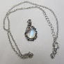
11-Jun-2024 | Denmark | Fireworks | Outdoor Living Items | Burn Hazard, Fire Hazard | 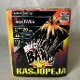
11-Jun-2024 | France | Flea Killer | Chemicals | Chemical Hazard | 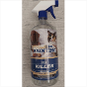
11-Jun-2024 | Hungary | Perfume | Bodycare / Cosmetics | Chemical Hazard | 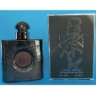
11-Jun-2024 | Czechia | Perfume | Bodycare / Cosmetics | Chemical Hazard | 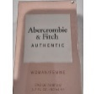
11-Jun-2024 | Czechia | Eau De toilette | Bodycare / Cosmetics | Chemical Hazard | 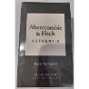
11-Jun-2024 | The Netherlands | Baby Walker | Toys and Childcare Products | Injury Hazard | 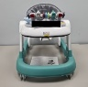
11-Jun-2024 | The Netherlands | Playpen | Toys and Childcare Products | Injury Hazard | 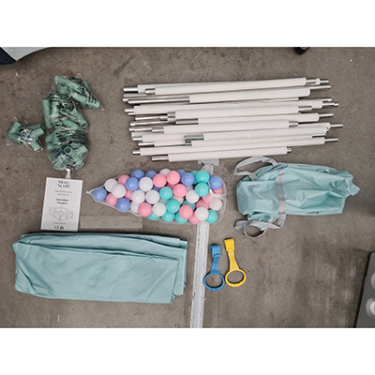
11-Jun-2024 | Denmark | Fireworks | Outdoor Living Items | Burn Hazard, Injury Hazard | 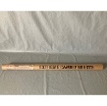
12-Jun-2024 | Sweden | LED Light | Electrical Appliances | Environmental Hazard | 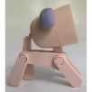
12-Jun-2024 | Finland | Keyring with Soft Toy | Toys and Childcare Products | Choking Hazard | 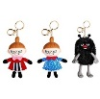
12-Jun-2024 | Hungary | Toy Pushchair | Toys and Childcare Products | Injury Hazard | 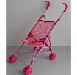
12-Jun-2024 | France | Caterpillar Killer | Chemicals | Chemical Hazard | 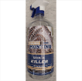
12-Jun-2024 | France | Pest Control Product | Chemicals | Chemical Hazard | 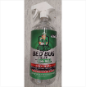
12-Jun-2024 | Germany | Brooch | Jewelry | Chemical Hazard | 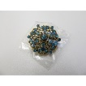
12-Jun-2024 | Finland | Charger for Electric Scooter | Electrical Appliances | Electric Shock Hazard | 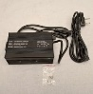
13-Jun-2024 | Italy | Skin Tonic | Bodycare / Cosmetics | Chemical Hazard | 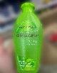
13-Jun-2024 | Germany | Bracelet Set | Jewelry | Chemical Hazard | 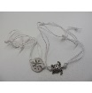
13-Jun-2024 | Germany | Necklace | Jewelry | Chemical Hazard | 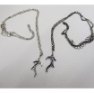
13-Jun-2024 | Germany | Skin Lotion | Bodycare / Cosmetics | Chemical Hazard | 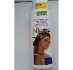
13-Jun-2024 | Slovakia | Electric Scooter | Sporting Goods / Equipment | Electric Shock Hazard, Injury Hazard | 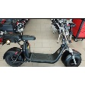
13-Jun-2024 | The Netherlands | Liquid Hourglass | Accessories | Chemical Hazard | 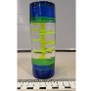
14-Jun-2024 | Germany | Disposable Electronic Cigarette | Chemicals | Health Risk Hazard | 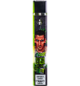  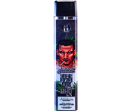  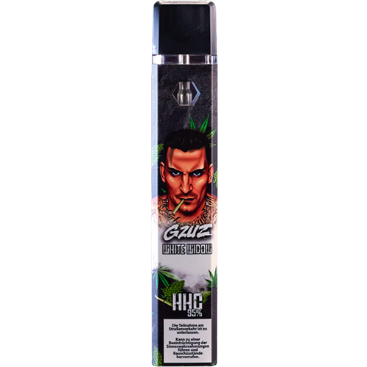  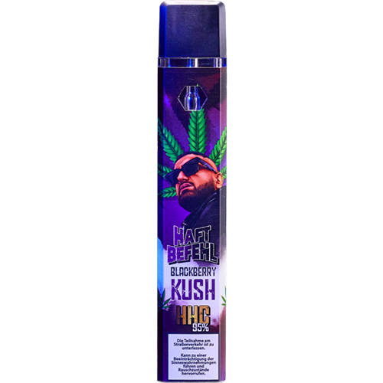  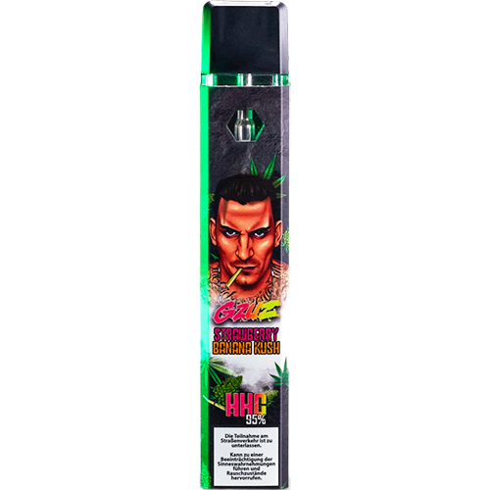  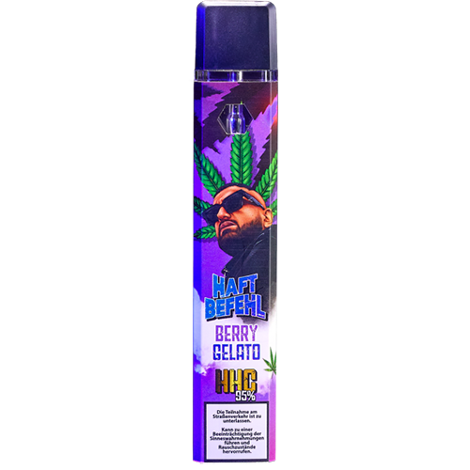  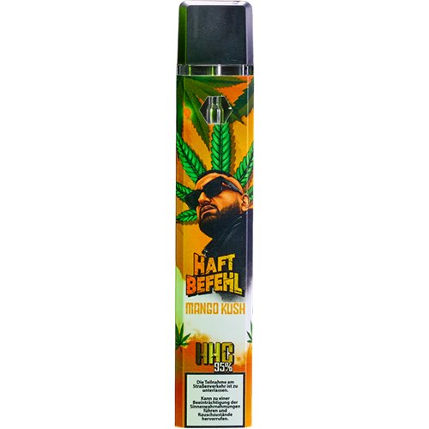  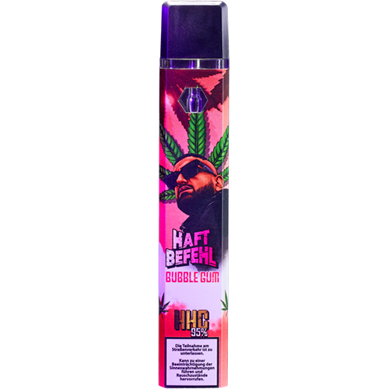  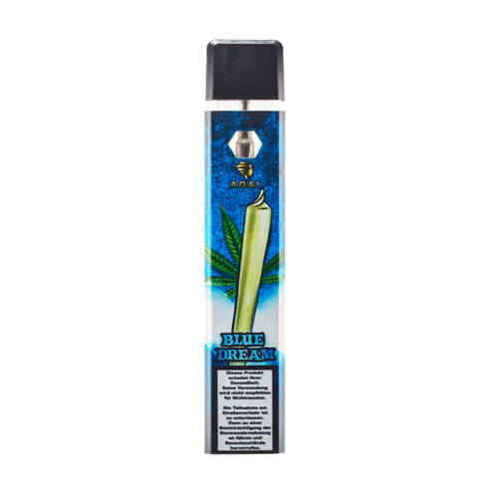  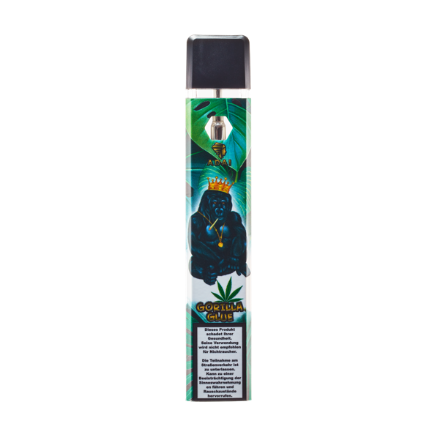
14-Jun-2024 | Hungary | Lighting Chain | Electrical Appliances | Electric Shock Hazard | 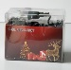
17-Jun-2024 | Romania | USB Charger | Electrical Appliances | Electric Shock Hazard | 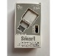
18-Jun-2024 | Ireland | Baby Sleeping Bag | Fabric / Textile / Garment / Home Textile | Suffocation Hazard | 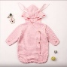
18-Jun-2024 | Ireland | Baby Wrap Blanket | Fabric / Textile / Garment / Home Textile | Suffocation Hazard | 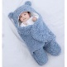
18-Jun-2024 | Italy | Bath and Body Oil Set | Bodycare / Cosmetics | Chemical Hazard | 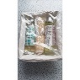
18-Jun-2024 | Italy | Perfume | Bodycare / Cosmetics | Chemical Hazard | 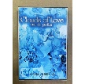
18-Jun-2024 | Italy | Deodorant | Bodycare / Cosmetics | Chemical Hazard | 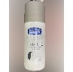
18-Jun-2024 | Italy | Eau De Toilette and Deodorant Set | Bodycare / Cosmetics | Chemical Hazard | 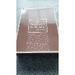
18-Jun-2024 | Italy | Shower Cream | Bodycare / Cosmetics | Chemical Hazard | 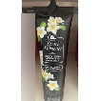
18-Jun-2024 | Italy | Deodorant Spray | Bodycare / Cosmetics | Chemical Hazard | 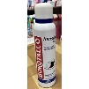
18-Jun-2024 | Italy | Deodorant Spray | Bodycare / Cosmetics | Chemical Hazard | 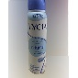
18-Jun-2024 | Italy | Hair Mousse | Bodycare / Cosmetics | Chemical Hazard | 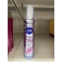
18-Jun-2024 | Italy | Hand Cream | Bodycare / Cosmetics | Chemical Hazard | 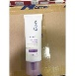
18-Jun-2024 | Spain | Squeezable Toy | Toys and Childcare Products | Choking Hazard | 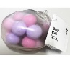
18-Jun-2024 | Spain | Soft Toy | Toys and Childcare Products | Choking Hazard | 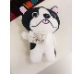
18-Jun-2024 | Sweden | Basketball Set for Trampoline | Toys and Childcare Products | Injury Hazard, Strangulation Hazard | 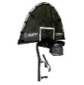
18-Jun-2024 | France | Electric Toy Car Set | Toys and Childcare Products | Chemical Hazard, Choking Hazard | 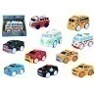
18-Jun-2024 | Denmark | Children's Cutlery Set | Food Contact Material | Choking Hazard | 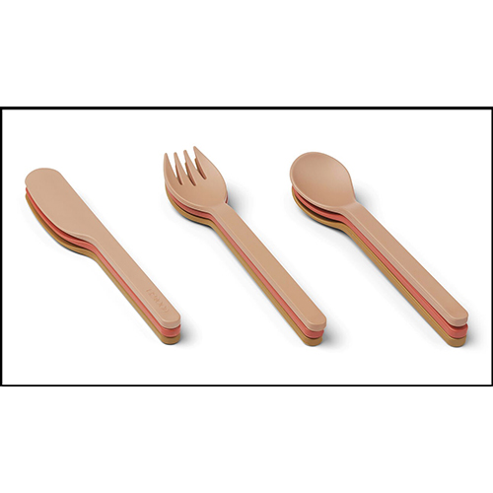  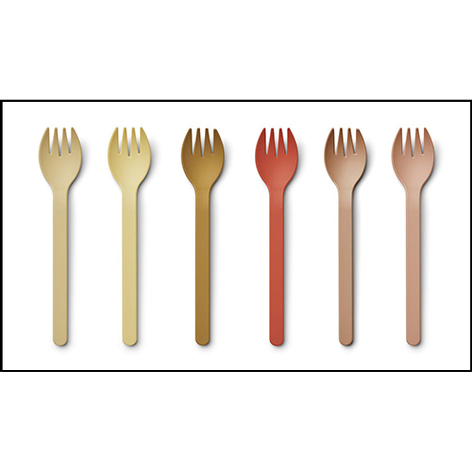  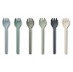
18-Jun-2024 | Denmark | Children's Spoon Cutlery Set | Food Contact Material | Choking Hazard | 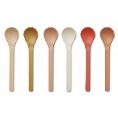  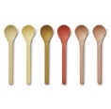
18-Jun-2024 | Slovakia | Extension Lead | Electrical Appliances | Electric Shock Hazard | 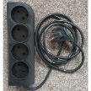
18-Jun-2024 | Slovakia | Extension Lead | Electrical Appliances | Electric Shock Hazard | 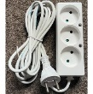
18-Jun-2024 | Germany | Mouse Pad | Electrical Appliances | Chemical Hazard | 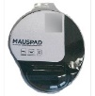
18-Jun-2024 | The Netherlands | Fireworks | Outdoor Living Items | Burn Hazard, Fire Hazard, Injury Hazard | 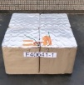
18-Jun-2024 | The Netherlands | Fireworks | Outdoor Living Items | Burn Hazard, Damage to Hearing, Fire Hazard, Injury Hazard | 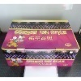
18-Jun-2024 | The Netherlands | Fireworks | Outdoor Living Items | Burn Hazard, Damage to Hearing, Fire Hazard, Injury Hazard | 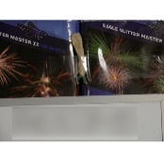
18-Jun-2024 | The Netherlands | Fireworks | Outdoor Living Items | Injury Hazard | 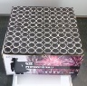
18-Jun-2024 | Hungary | Perfume | Bodycare / Cosmetics | Chemical Hazard | 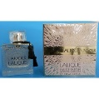
18-Jun-2024 | Poland | USB Charger | Electrical Appliances | Burn Hazard, Fire Hazard | 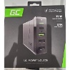
18-Jun-2024 | Lithuania | Bracelet | Jewelry | Chemical Hazard | 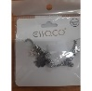
18-Jun-2024 | Lithuania | Rings | Jewelry | Chemical Hazard | 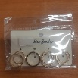
18-Jun-2024 | Lithuania | Toy Gun Set | Toys and Childcare Products | Choking Hazard | 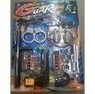
18-Jun-2024 | Czechia | Doll | Toys and Childcare Products | Chemical Hazard | 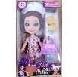
18-Jun-2024 | Sweden | Electric Toy Horse | Toys and Childcare Products | Environmental Hazard | 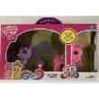
19-Jun-2024 | Italy | Aftershave | Bodycare / Cosmetics | Chemical Hazard | 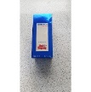
19-Jun-2024 | The Netherlands | Fireworks | Outdoor Living Items | Damage to Hearing, Injury Hazard | 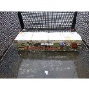
19-Jun-2024 | France | Baby Cot | Toys and Childcare Products | Injury Hazard | 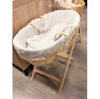  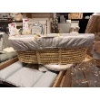
19-Jun-2024 | Slovakia | Electric Scooter | Sporting Goods / Equipment | Injury Hazard | 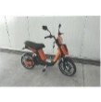
19-Jun-2024 | The Netherlands | Fireworks | Outdoor Living Items | Burn Hazard , Damage to Hearing, Fire Hazard, Injury Hazard | 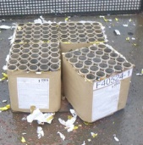
19-Jun-2024 | Sweden | Climbing Arch / Rocking Chair | Toys and Childcare Products | Injury Hazard, Strangulation Hazard | 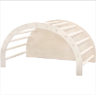  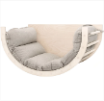
19-Jun-2024 | The Netherlands | Fireworks | Outdoor Living Items | Burn Hazard, Injury Hazard | 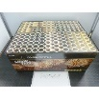
21-Jun-2024 | Italy | Soap | Bodycare / Cosmetics | Chemical Hazard | 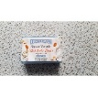
21-Jun-2024 | Italy | Hand Cream | Bodycare / Cosmetics | Chemical Hazard | 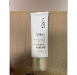
21-Jun-2024 | Italy | Hair Conditioner | Bodycare / Cosmetics | Chemical Hazard | 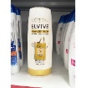
21-Jun-2024 | The Netherlands | Playpen | Toys and Childcare Products | Choking Hazard, Injury Hazard, Strangulation Hazard | 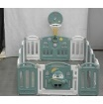
21-Jun-2024 | Italy | Perfume | Bodycare / Cosmetics | Chemical Hazard | 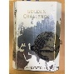
21-Jun-2024 | Italy | Hairspray | Bodycare / Cosmetics | Chemical Hazard | 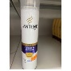
21-Jun-2024 | Italy | Cosmetic Products Set | Bodycare / Cosmetics | Chemical Hazard | 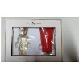
21-Jun-2024 | Italy | Cosmetic Products Set | Bodycare / Cosmetics | Chemical Hazard | 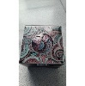
21-Jun-2024 | Italy | Hair Conditioner | Bodycare / Cosmetics | Chemical Hazard | 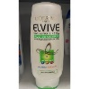
21-Jun-2024 | Italy | Hair Conditioner | Bodycare / Cosmetics | Chemical Hazard | 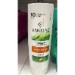
21-Jun-2024 | Italy | Body Cream | Bodycare / Cosmetics | Chemical Hazard | 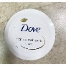
21-Jun-2024 | The Netherlands | Fireworks | Outdoor Living Items | Burn Hazard, Damage to Hearing, Fire Hazard, Injury Hazard | 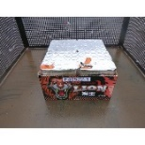
21-Jun-2024 | Finland | Key Ring with Soft Toy | Toys and Childcare Products | Choking Hazard | 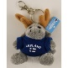  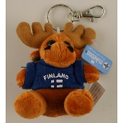
21-Jun-2024 | Ireland | Disposable Electronic Cigarette | Chemicals | Chemical Hazard | 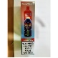
21-Jun-2024 | Sweden | Jewelry Beads | Jewelry | Chemical Hazard | 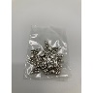
21-Jun-2024 | Sweden | Pendant Ring | Jewelry | Chemical Hazard | 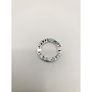
21-Jun-2024 | Hungary | Children's Sandals | Footwear | Choking Hazard | 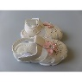
21-Jun-2024 | Hungary | Plastic Doll | Toys and Childcare Products | Chemical Hazard | 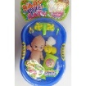
21-Jun-2024 | Hungary | Hair Dryer | Home Electrical Appliances | Burn Hazard, Fire Hazard | 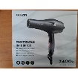
25-Jun-2024 | Italy | Hair Conditioner | Bodycare / Cosmetics | Chemical Hazard | 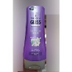
25-Jun-2024 | Italy | Hair Conditioner | Bodycare / Cosmetics | Chemical Hazard | 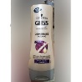
25-Jun-2024 | Italy | Hair Dye | Bodycare / Cosmetics | Chemical Hazard | 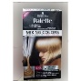
25-Jun-2024 | Italy | Perfume | Bodycare / Cosmetics | Chemical Hazard | 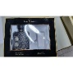
25-Jun-2024 | France | Extension Cord | Electrical Appliances | Burn Hazard, Electric Shock Hazard, Fire Hazard | 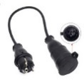
25-Jun-2024 | France | Extension Cord | Electrical Appliances | Electric Shock Hazard | 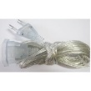
25-Jun-2024 | France | Toy Telephone | Toys and Childcare Products | Chemical Hazard, Choking Hazard | 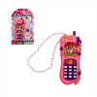
25-Jun-2024 | Malta | Inflatable Swim Seat | Sporting Goods / Equipment | Drowning Hazard | 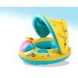
25-Jun-2024 | France | Plastic Toy | Toys and Childcare Products | Choking Hazard | 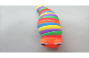  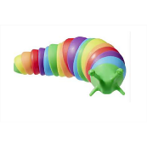
25-Jun-2024 | Sweden | Lighting Chain | Electrical Appliances | Chemical Hazard, Environmental Hazard | 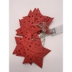
25-Jun-2024 | Sweden | Lamp | Electrical Appliances | Chemical Hazard | 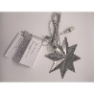
25-Jun-2024 | Italy | Eau De Toilette | Bodycare / Cosmetics | Chemical Hazard | 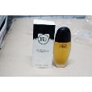
25-Jun-2024 | Lithuania | Toy Gun Set | Toys and Childcare Products | Choking Hazard | 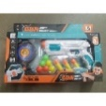
25-Jun-2024 | Romania | Perfume | Bodycare / Cosmetics | Chemical Hazard | 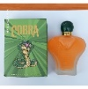
25-Jun-2024 | Romania | Shower Gel | Bodycare / Cosmetics | Chemical Hazard | 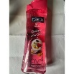
26-Jun-2024 | Italy | Hair Dye | Bodycare / Cosmetics | Chemical Hazard | 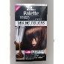
26-Jun-2024 | Italy | Hair Gel | Bodycare / Cosmetics | Chemical Hazard | 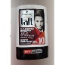
26-Jun-2024 | Italy | Deodorant | Bodycare / Cosmetics | Chemical Hazard | 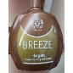
26-Jun-2024 | Italy | Deodorant | Bodycare / Cosmetics | Chemical Hazard | 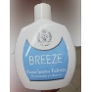
26-Jun-2024 | Italy | Aftershave | Bodycare / Cosmetics | Chemical Hazard | 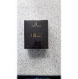
26-Jun-2024 | Italy | Deodorant Spray | Bodycare / Cosmetics | Chemical Hazard | 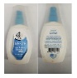
26-Jun-2024 | The Netherlands | Fireworks | Outdoor Living Items | Burn Hazard, Damage to Hearing, Fire Hazard, Injury Hazard | 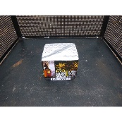
26-Jun-2024 | Sweden | LED Light | Electrical Appliances | Environmental Hazard | 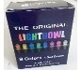  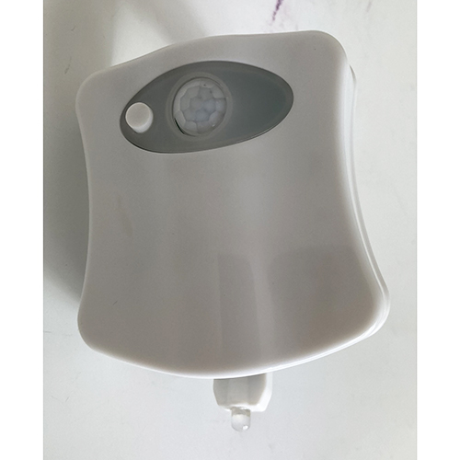
26-Jun-2024 | Ireland | Soft Toy | Toys and Childcare Products | Choking Hazard | 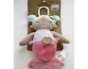  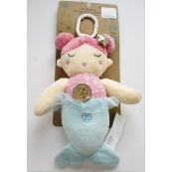
26-Jun-2024 | Sweden | Basketball Set for Trampoline | Toys and Childcare Products | Injury Hazard | 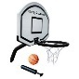
26-Jun-2024 | Sweden | Hair Ties | Accessories | Chemical Hazard | 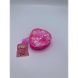
26-Jun-2024 | Hungary | Lighting Chain | Electrical Appliances | Electric Shock Hazard | 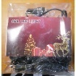
26-Jun-2024 | Czechia | Thermal Paper for Cash Register | Stationery | Chemical Hazard | 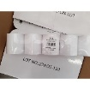
26-Jun-2024 | Malta | Inflatable Swim Seat | Sporting Goods / Equipment | Drowning Hazard | 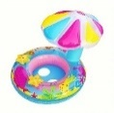
27-Jun-2024 | Italy | Shower Gel | Bodycare / Cosmetics | Chemical Hazard | 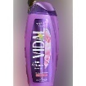
27-Jun-2024 | Finland | Ballpoint Pen | Stationery | Chemical Hazard | 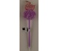  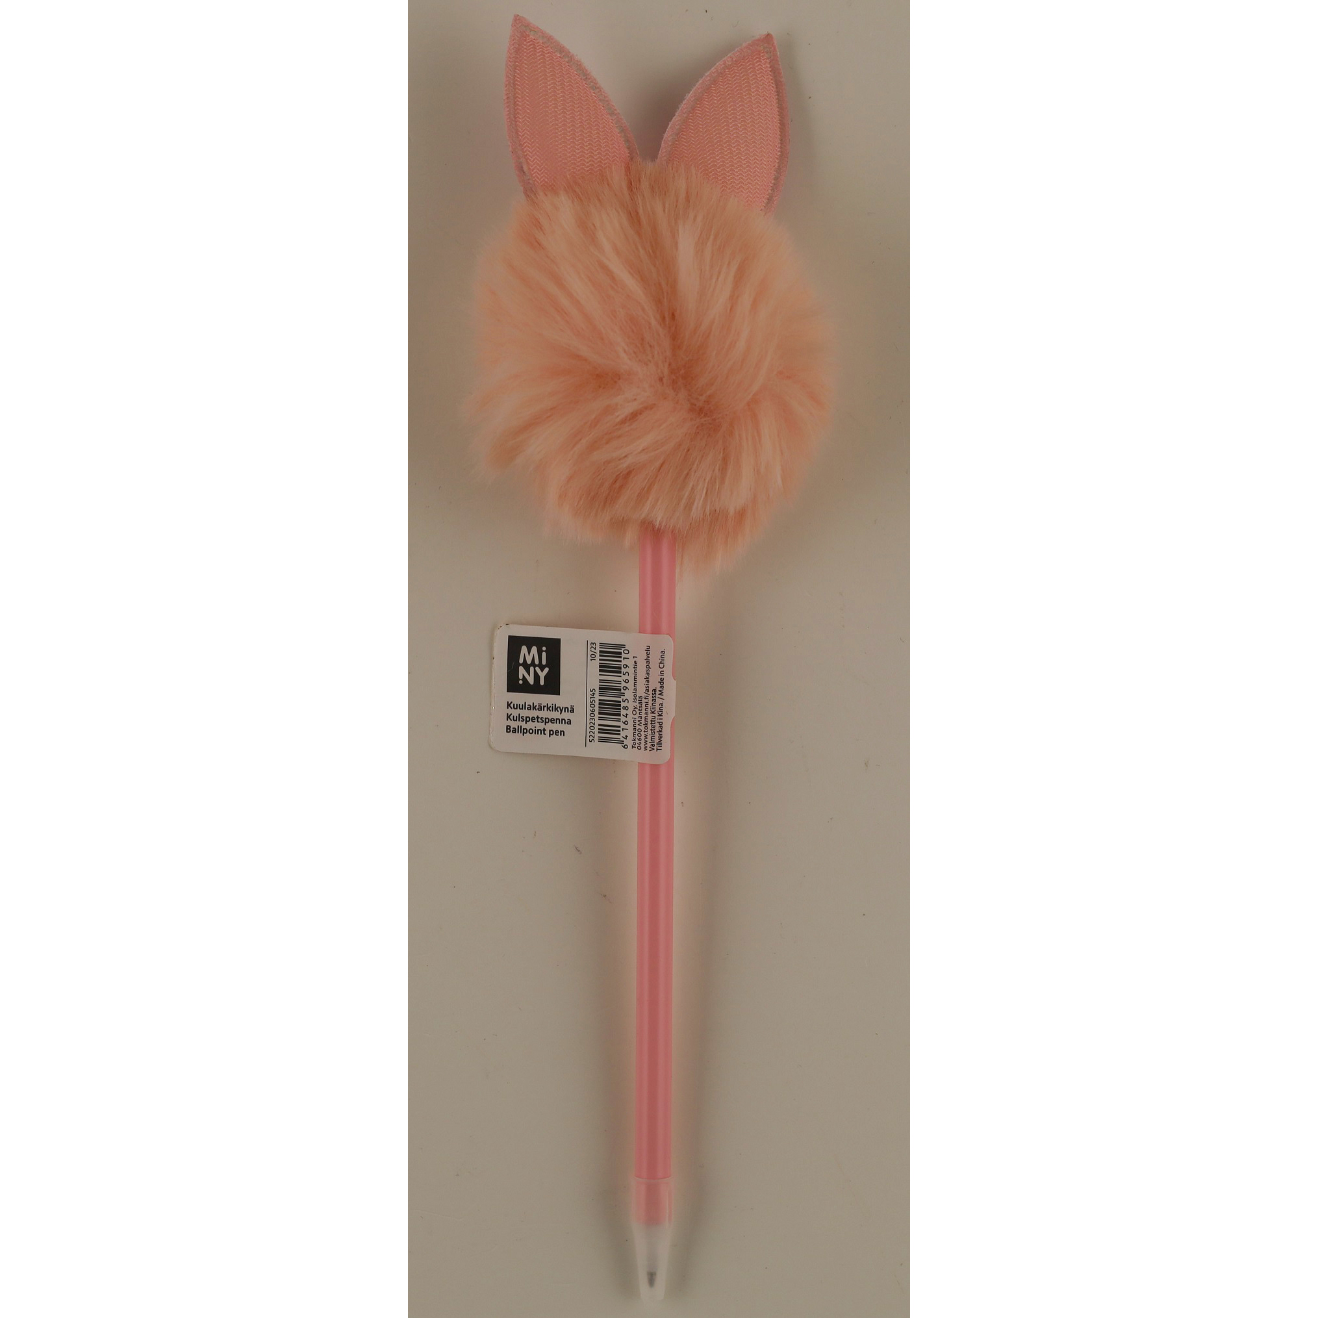
27-Jun-2024 | France | Toy Rattle | Toys and Childcare Products | Choking Hazard, Cut Hazard, Injury Hazard | 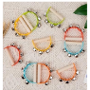
27-Jun-2024 | Italy | Deodorant | Bodycare / Cosmetics | Chemical Hazard | 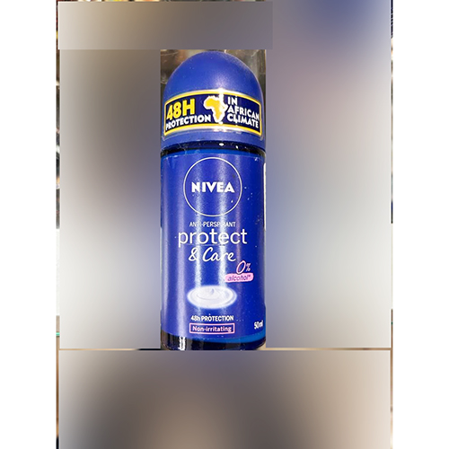
27-Jun-2024 | Ireland | Disposable Electronic Cigarette | Chemicals | Chemical Hazard | 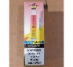  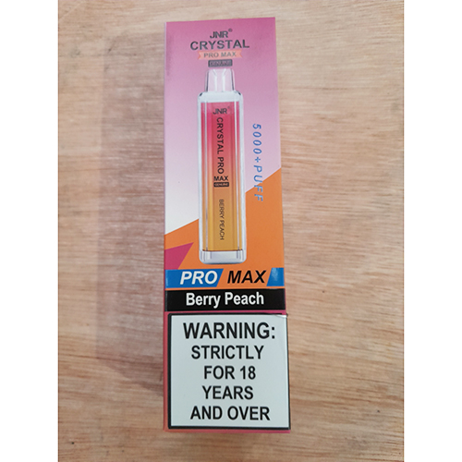
27-Jun-2024 | Romania | Deodorant | Bodycare / Cosmetics | Chemical Hazard | 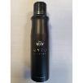
27-Jun-2024 | Italy | Shower Foam | Bodycare / Cosmetics | Chemical Hazard | 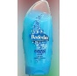
27-Jun-2024 | Italy | Shower Foam | Bodycare / Cosmetics | Chemical Hazard | 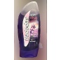
27-Jun-2024 | Italy | Perfume | Bodycare / Cosmetics | Chemical Hazard | 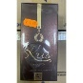
27-Jun-2024 | Italy | Aftershave | Bodycare / Cosmetics | Chemical Hazard | 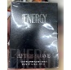
27-Jun-2024 | Italy | Shampoo | Bodycare / Cosmetics | Chemical Hazard | 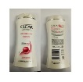
27-Jun-2024 | Italy | Body Cream | Bodycare / Cosmetics | Chemical Hazard | 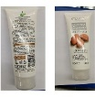
27-Jun-2024 | France | Solar Batteries | Electrical Appliances | Fire Hazard | 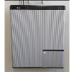
27-Jun-2024 | France | Fancy-Dress Costume | Fabric / Textile / Garment / Home Textile | Chemical Hazard | 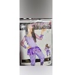
27-Jun-2024 | Italy | Eau De Toilette | Bodycare / Cosmetics | Chemical Hazard | 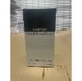
27-Jun-2024 | Italy | Eau De Toilette | Bodycare / Cosmetics | Chemical Hazard | 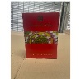
27-Jun-2024 | Italy | Eau De Toilette | Bodycare / Cosmetics | Chemical Hazard | 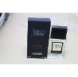
27-Jun-2024 | Italy | Eau De Toilette | Bodycare / Cosmetics | Chemical Hazard | 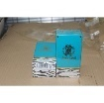
27-Jun-2024 | Italy | Eau De Toilette | Bodycare / Cosmetics | Chemical Hazard | 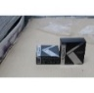
27-Jun-2024 | France | Soft Toy | Toys and Childcare Products | Choking Hazard | 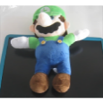
27-Jun-2024 | Slovakia | Children's Scooter | Toys and Childcare Products | Injury Hazard | 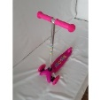
27-Jun-2024 | Slovakia | Puzzle Mat | Toys and Childcare Products | Choking Hazard | 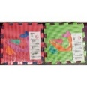
27-Jun-2024 | France | Toy Bow | Toys and Childcare Products | Choking Hazard | 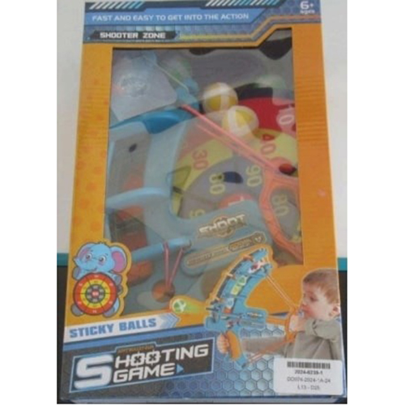
27-Jun-2024 | Ireland | Bedrest Cushion | Fabric / Textile / Garment / Home Textile | Burn Hazard, Fire Hazard | 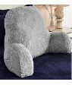
27-Jun-2024 | Poland | Attachment for Brush Cutter | Machinery | Injury Hazard | 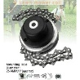
27-Jun-2024 | Poland | Attachment for Brush Cutter | Machinery | Injury Hazard | 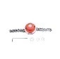
27-Jun-2024 | The Netherlands | Baby Travel Cot | Toys and Childcare Products | Injury Hazard | 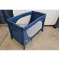
27-Jun-2024 | Lithuania | Hair Conditioner | Bodycare / Cosmetics | Chemical Hazard | 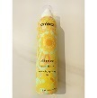
28-Jun-2024 | France | Fancy Dress Costume | Fabric / Textile / Garment / Home Textile | Choking Hazard | 