Recall Cases Summary – US (Last Update Date: 30 June 2024)

Date | Product | Categories | Hazard | Image
6-Jun-2024 | Conditioner | Bodycare / Cosmetics | Microbiological Hazard | 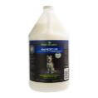
6-Jun-2024 | Sling Carriers | Toys and Childcare Products | Suffocation Hazard, Fall Hazard | 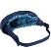  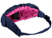  
6-Jun-2024 | Rechargeable Integrated Lights | Electrical Appliances | Fire Hazard, Burn Hazard | 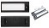  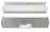  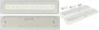  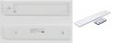  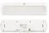  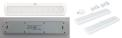  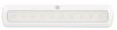  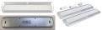  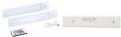  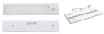  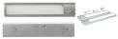  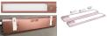  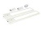
6-Jun-2024 | Sanctuary Quick Access and Sports Afield Biometric Gun Safes | Household Items | Injury Hazard, Risk of Death | 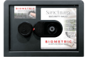  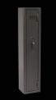
6-Jun-2024 | Wild Country Ropeman 1 Ascenders | Tools and Hardware | Safety Risk Hazard | 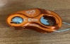  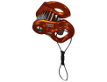
13-Jun-24 | Lawn and Garden Equipment | Machinery | Fire Hazard, Burn Hazard | 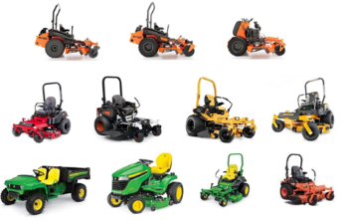
13-Jun-24 | Air Conditioning and Heat Pump | Electrical Appliances | Fire Hazard | 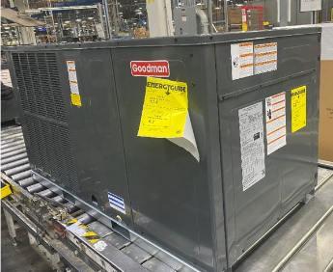
13-Jun-2024 | Beaumont Plus ST Bikes with Disc Brakes | Sporting Goods / Equipment | Crash Hazard, Injury Hazard | 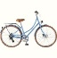  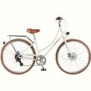  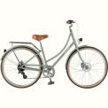
13-Jun-2024 | Neve Strap Crampons and Accessory Kits | Sporting Goods / Equipment | Fall Hazard | 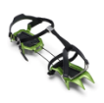
13-Jun-2024 | Lomi Roll-On Waxing Kits | Electrical Appliances | Fire Hazard, Burn Hazard, Electric Shock Hazard | 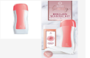
13-Jun-2024 | Magnetic Chess Games | Toys and Childcare Products | Ingestion Hazard | 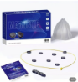
13-Jun-2024 | Hybrid Mattresses | Fabric / Textile / Garment / Home Textile | Fire Hazard | 
13-Jun-2024 | 3D Printers | Electrical Appliances | Electric Shock Hazard, Fire Hazard | 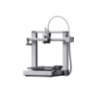
20-Jun-2024 | Six-Drawer Dressers | Furniture | Tip-Over Hazard, Entrapment Hazard, Injury Hazard, Risk of Death | 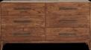
20-Jun-2024 | Lavender Scented Candles in a Round Wooden Bread Bowl | Household Items | Fire Hazard, Burn Hazard | 
20-Jun-2024 | TRUBLUE iQ Auto Belay Devices | Sporting Goods / Equipment | Fall Hazard, Injury Hazard, Risk of Death | 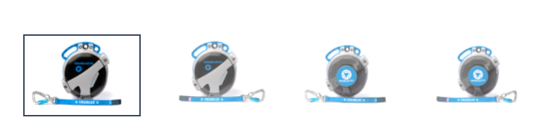
20-Jun-2024 | Instinct Cordless Hair Clippers | Home Electrical Appliances | Fire Hazard, Burn Hazard | 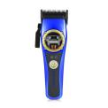
20-Jun-2024 | Yeti Link Modules with EC8 Cables | Electrical Appliances | Fire Hazard, Burn Hazard | 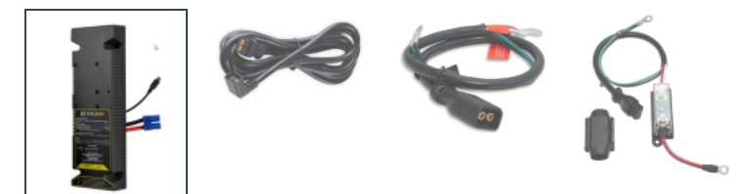  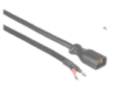
20-Jun-2024 | Blending Containers and Blade Bases | Home Electrical Appliances | Laceration Hazard | 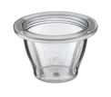  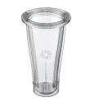  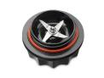
20-Jun-2024 | Portable Chargers | Electrical Appliances | Fire Hazard, Burn Hazard | 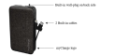
20-Jun-2024 | Glass Coffee Mugs | Food Contact Material | Burn Hazard, Laceration Hazard | 
20-Jun-2024 | Cargo Bicycles | Sporting Goods / Equipment | Fall Hazard | 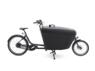  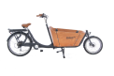
20-Jun-2024 | Frontgate Chaise Lounge Chairs | Furniture | Amputation Hazard | 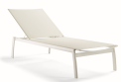  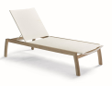
20-Jun-2024 | Gardening Tools Sets | Toys and Childcare Products | Chemical Hazard | 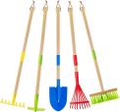
27-Jun-2024 | Bookcase | Furniture | Tip-Over Hazard, Entrapment Hazard, Injury Hazard, Risk of Death | 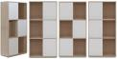
27-Jun-2024 | Children’s Bicycles with Training Wheels | Sporting Goods / Equipment | Fall Hazard, Injury Hazard | 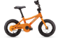  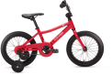  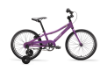
27-Jun-2024 | Toy Trunk Storage Chests | Toys and Childcare Products | Entrapment Hazard, Suffocation Hazard | 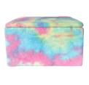
27-Jun-2024 | Handheld Rechargeable Vacuums | Home Electrical Appliances | Fire Hazard | 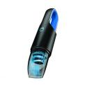
27-Jun-2024 | Magnetic Wireless Charging Power Banks | Electrical Appliances | Fire Hazard | 