召回案件总结 - 加拿大（最后更新日期：2020年11月）
Date | Product | Categories | Hazard | Image
June 5, 2020 | Rechargeable Battery Packs | Computer / Audio / Video / Other Electronics & Accessories | Burn Hazard | 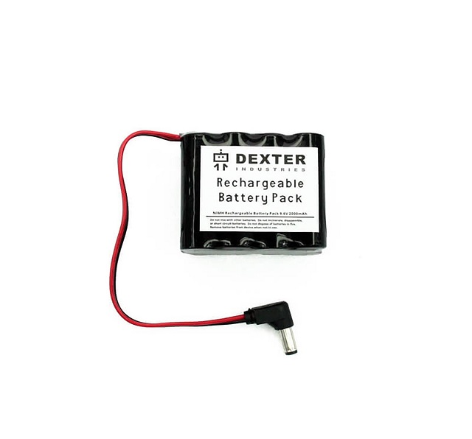
June 5, 2020 | Children's Table and Stool Set | Toys and Childcare Articles | Chemical Hazard | 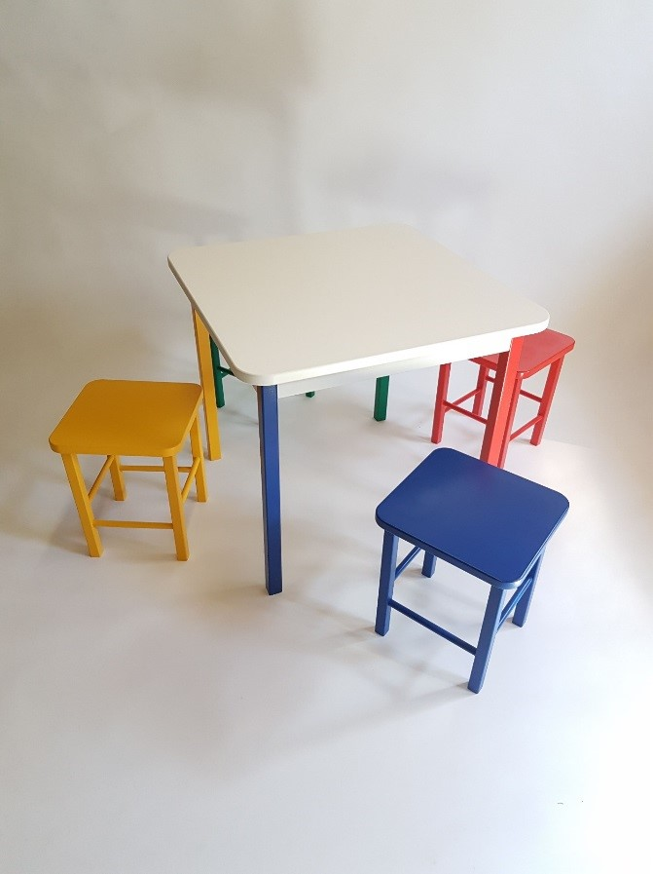
June 16, 2020 | Pilates Balls | Sporting Goods / Equipment | Fall Hazard | 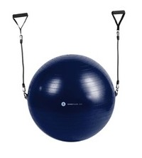
June 17, 2020 | Vacuums | Home Electrical Appliances (Hair Dryer, Iron, etc.) | Fire Hazard | 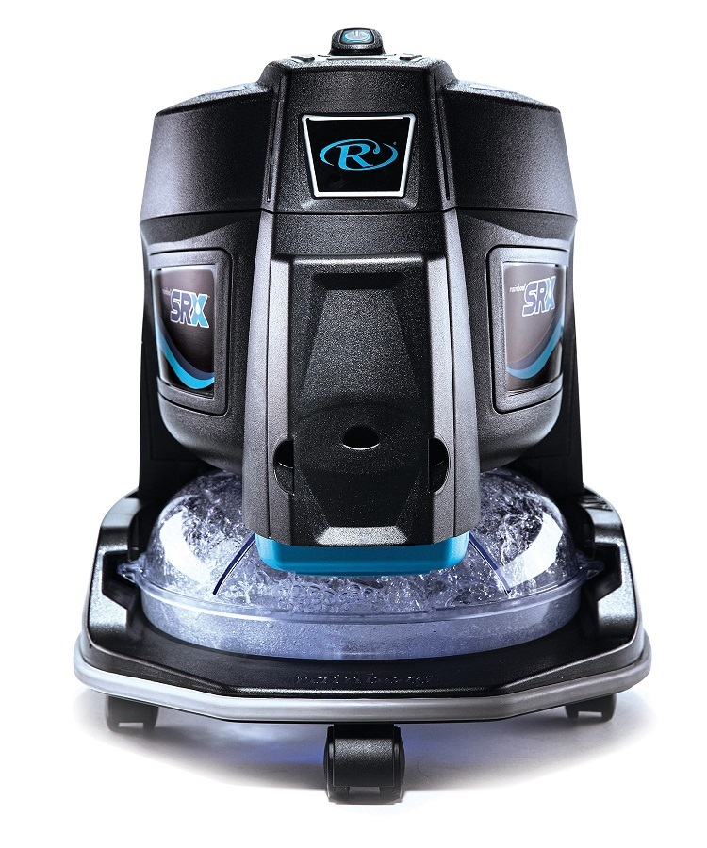
June 18, 2020 | Gas Boilers | Home Electrical Appliances (Hair Dryer, Iron, etc.) | Poisoning Hazard
June 19, 2020 | Liquid Gasket | Chemicals | Lack of labelling Hazard | 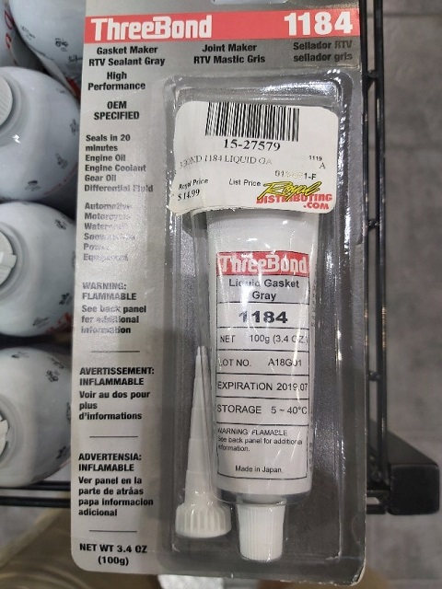
June 22, 2020 | Pram 2-in-1 Walker | Juvenile Products | Choking Hazard | 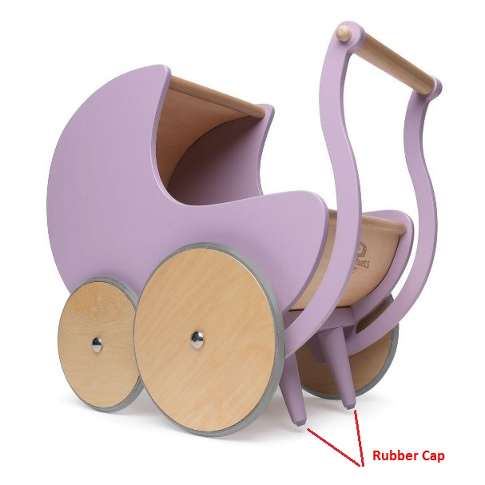
June 23, 2020 | Concealer | Cosmetics / Bodycare | Mold Contamination | 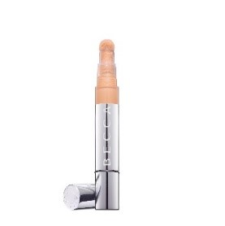
June 24, 2020 | Teething Spoons | Toys & Childcare Articles | Choking Hazard | 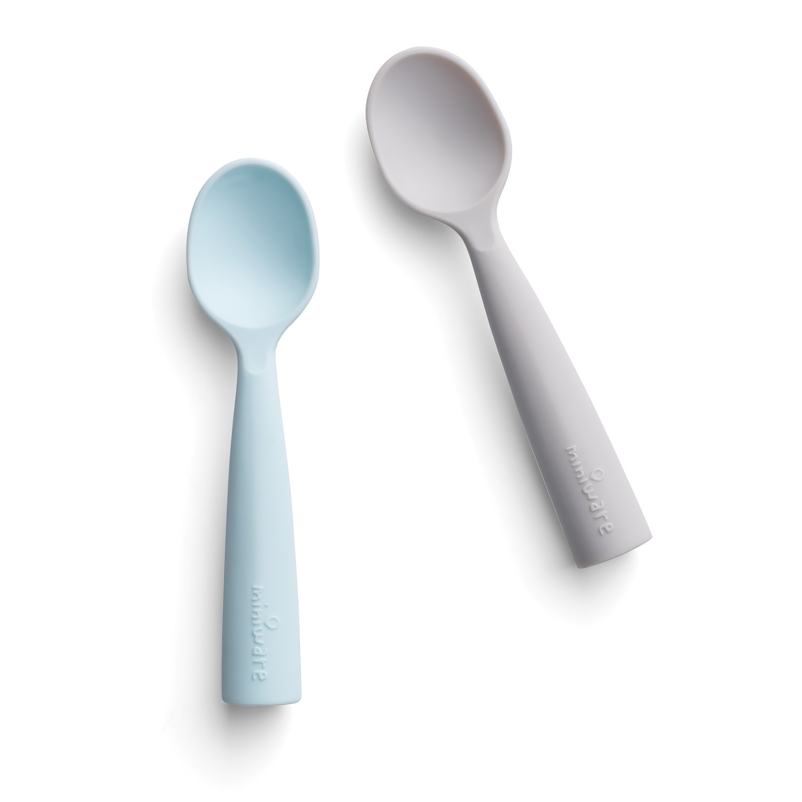
June 24, 2020 | Portable Bioethanol Fireplaces | Chemicals | Chemical Hazard | 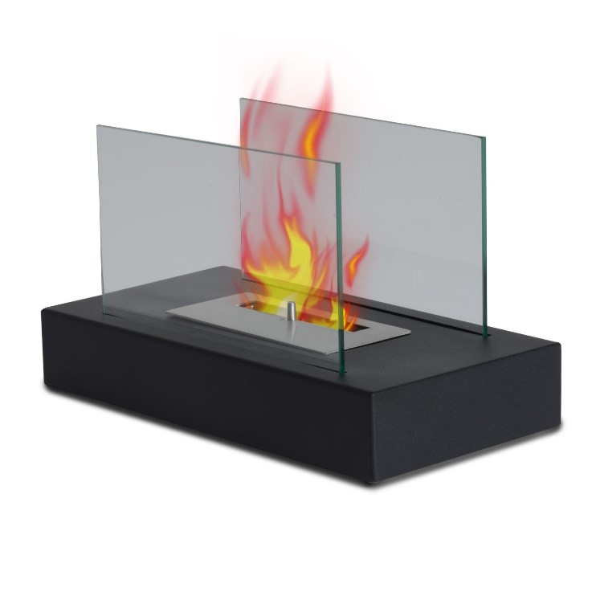
July 9, 2020 | Bassinets | Juvenile Products | Entrapment Hazard | 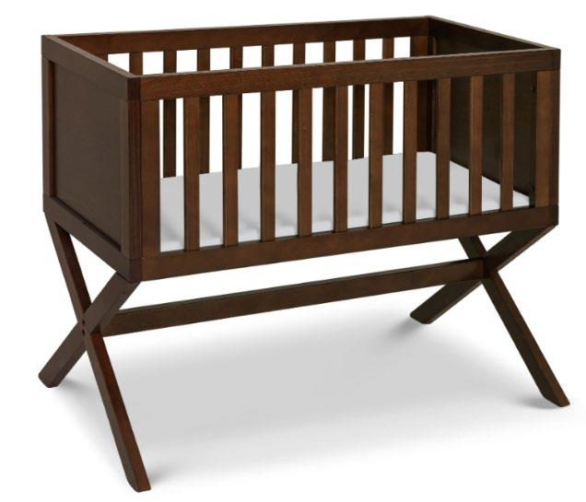
July 9, 2020 | Ceiling Fans | Lighting Equipment | Injury Hazard | 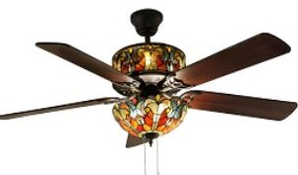
July 9, 2020 | Floor Lamp | Lighting Equipment | Fire Hazard | 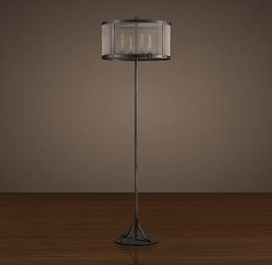
July 14, 2020 | LED Lamps | Lighting Equipment | Injury Hazard | 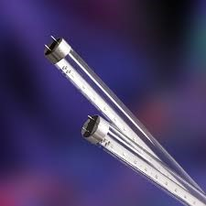
July 14, 2020 | Lanyard | Accessories | Injury Hazard | 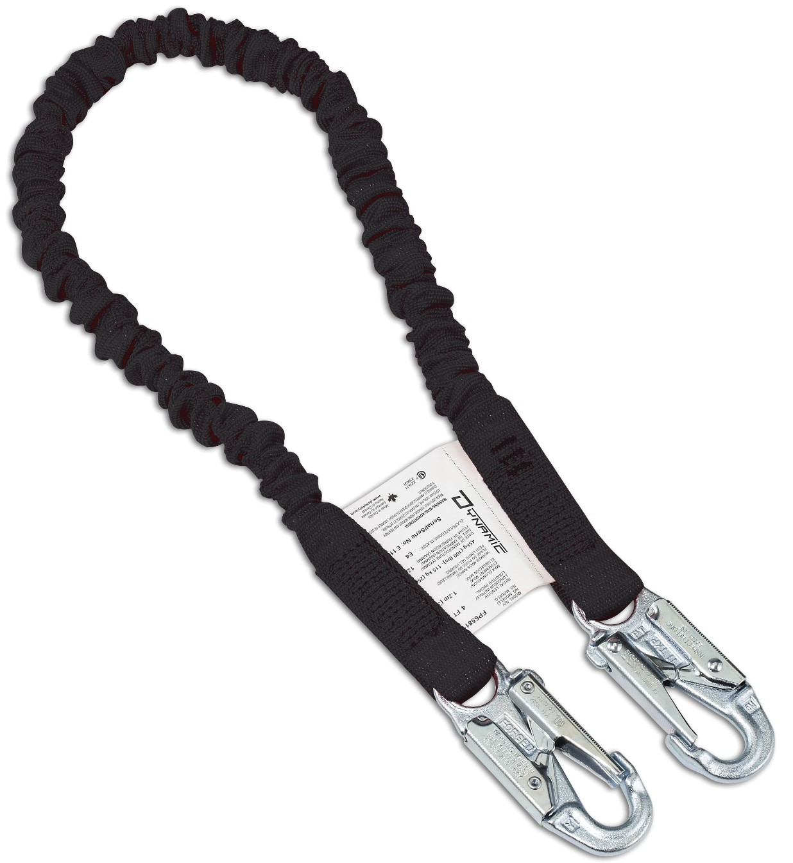
July 16, 2020 | Mountain Bicycles | Sporting Goods / Equipment | Fall Hazard | 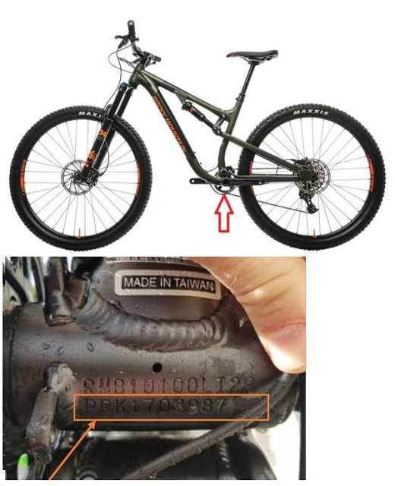
July 21, 2020 | Children's Sleepwear Sets | Fabric / Textile / Garment / Home Textile | Flammability Hazard | 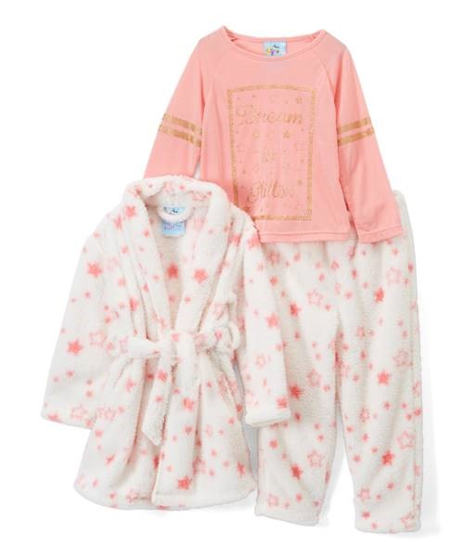
July 23, 2020 | Artificial Christmas Trees | Household Items | Burn Hazard & Fire Hazard | 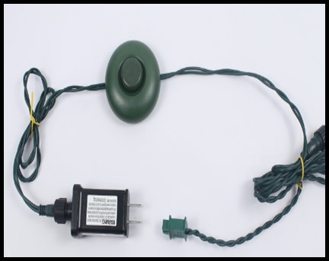
July 23, 2020 | Trampoline | Sporting Goods / Equipment | Injury Hazard | 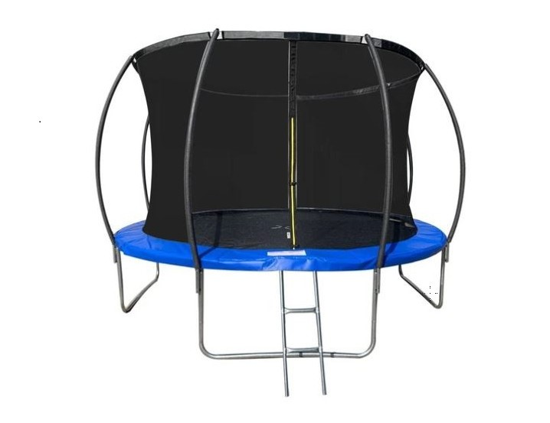
July 23, 2020 | Electric Kettle | Home Electrical Appliances (Hair Dryer, Iron, etc.) | Burn Hazard | 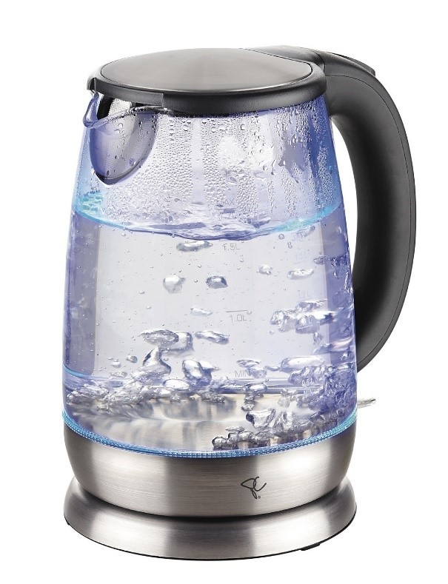
July 29, 2020 | Gas Boilers | Home Electrical Appliances (Hair Dryer, Iron, etc.) | Poisoning Hazard | 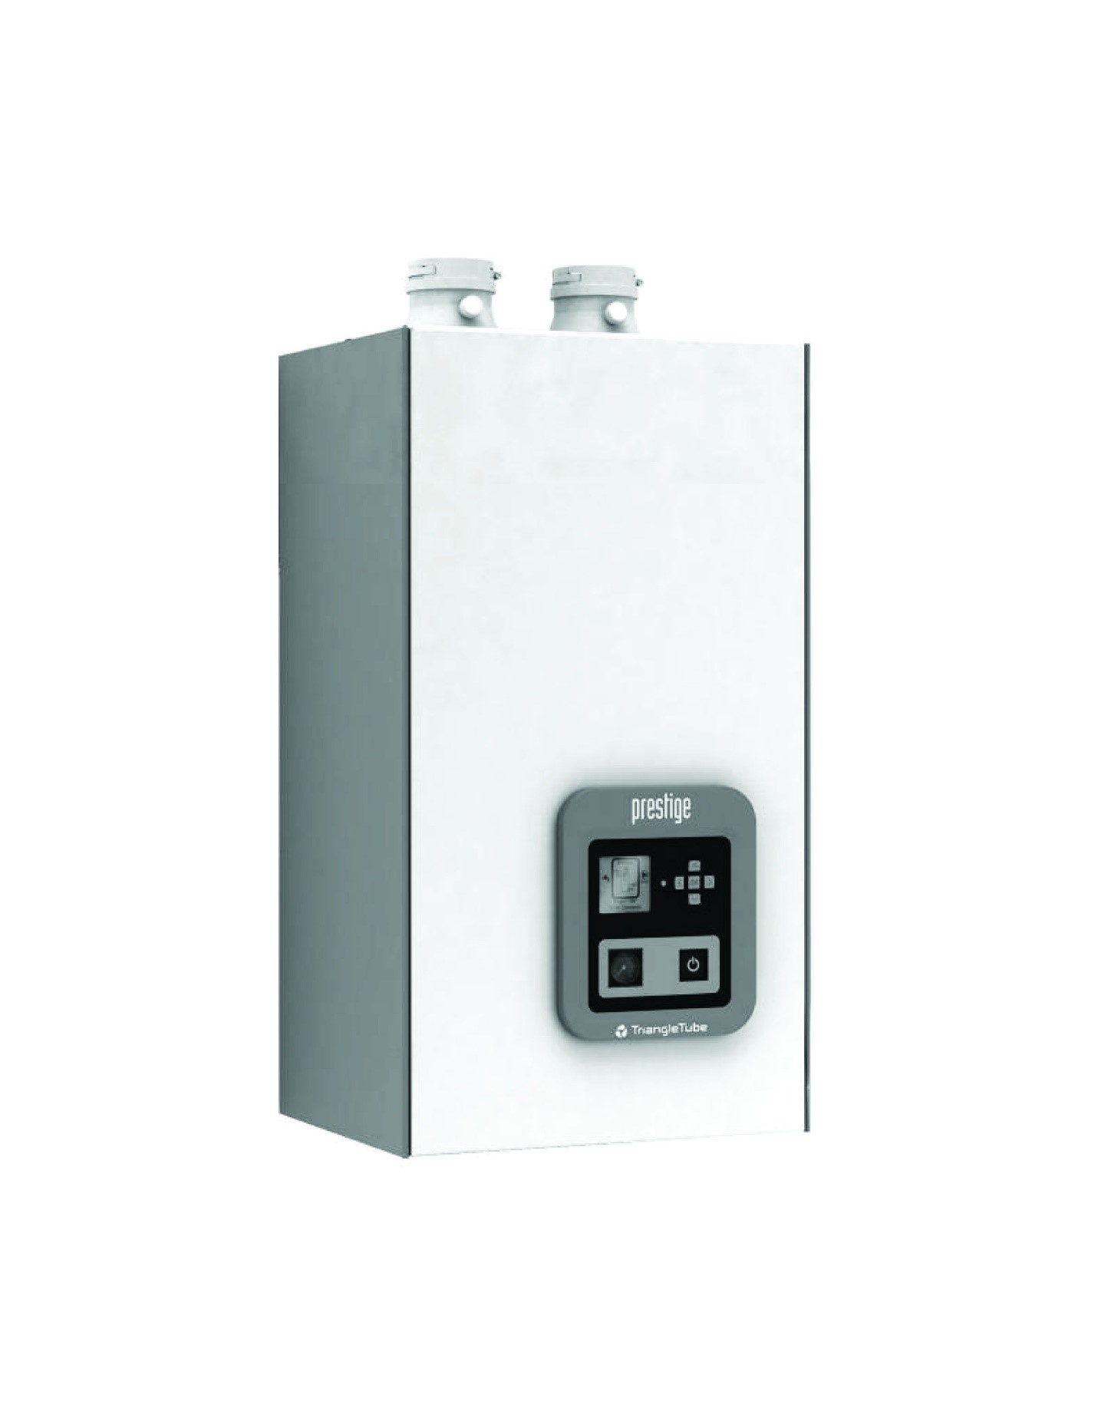
July 29, 2020 | Ladder | Household Items | Laceration Hazard | 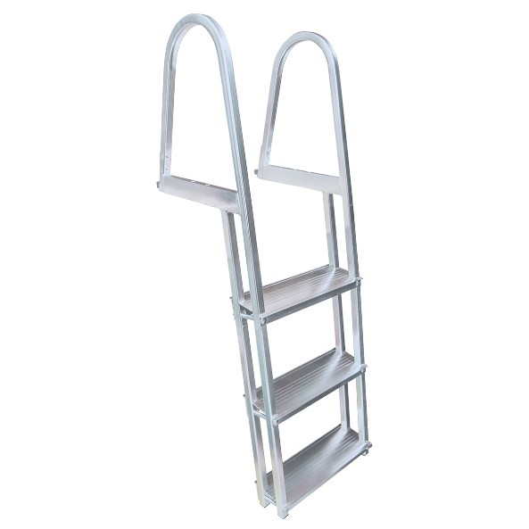
July 30, 2020 | Fireplaces | Household Items | Laceration Hazard | 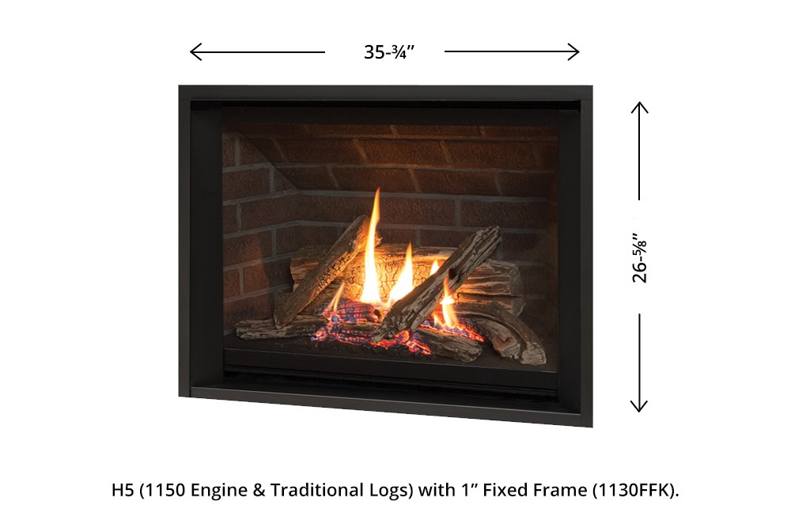
August 12, 2020 | Strollers | Juvenile Products | Fall Hazard | 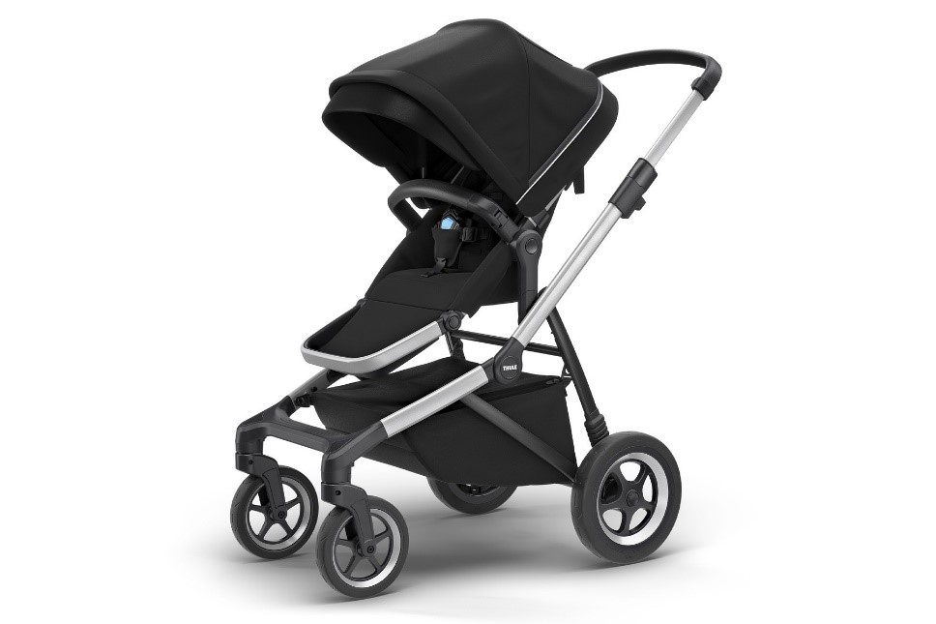
August 12, 2020 | Blower Fans | Tools | Fire Hazard | 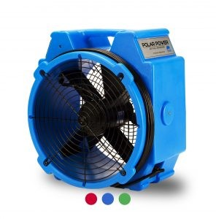
August 12, 2020 | Lawn Dart Sets | Sporting Goods / Equipment | Injury Hazard | 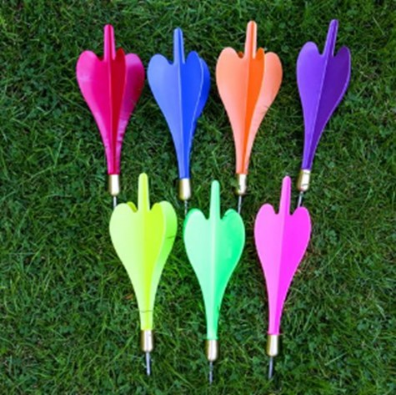
August 13, 2020 | Magnet Sets | Toys and Childcare Articles | Ingestion Hazard | 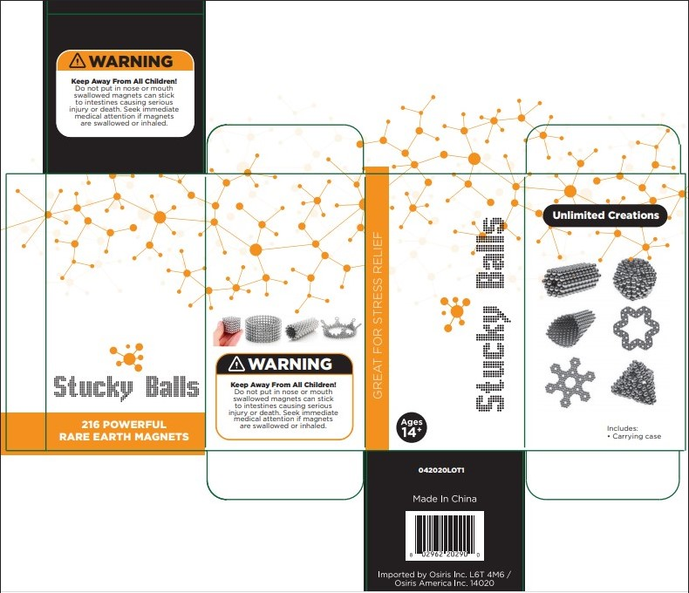
August 19, 2020 | Mounting Brackets | Tools | Injury Hazard | 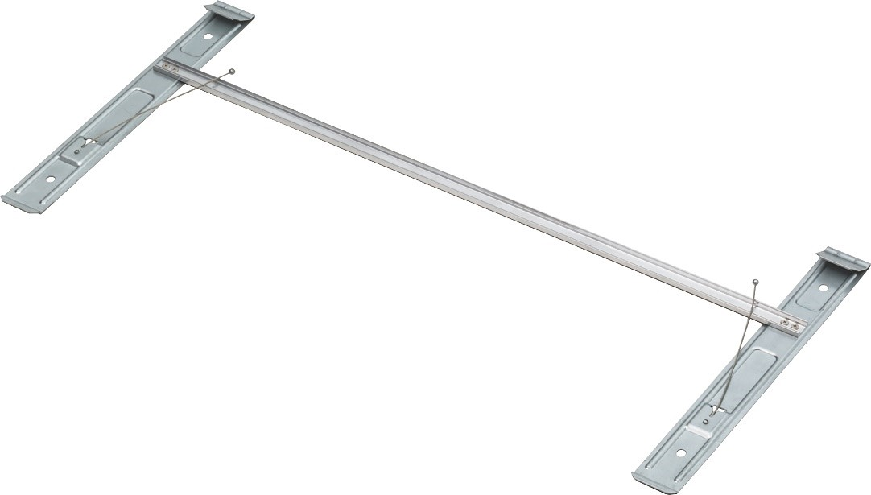
August 25, 2020 | Razors | Cosmetics / Bodycare | Laceration Hazard | 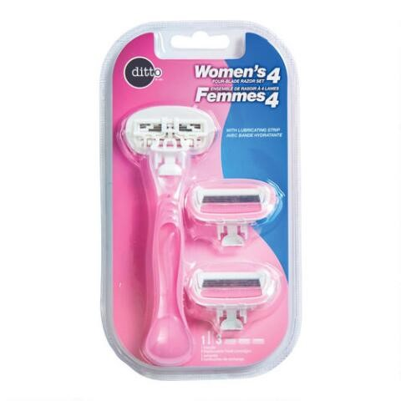
August 28, 2020 | Hair Balm | Cosmetics / Bodycare | Mold Contamination | 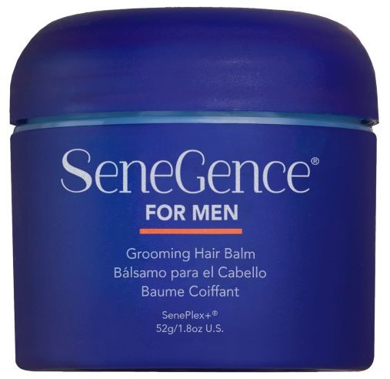
August 28, 2020 | USB Port | Computer / Audio / Video / Other Electronics & Accessories | Lack of Certification | 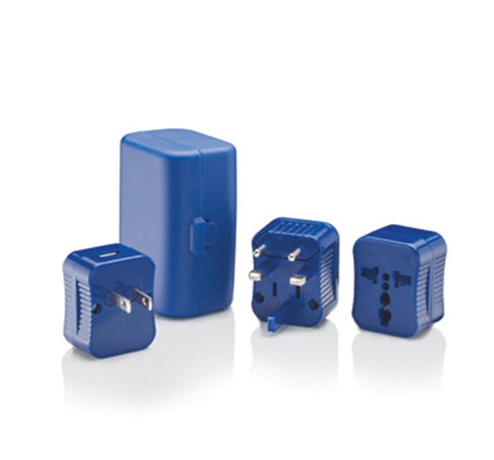
September 02, 2020 | Neck Pillows | Toys and Childcare Articles | Chemical Hazard | 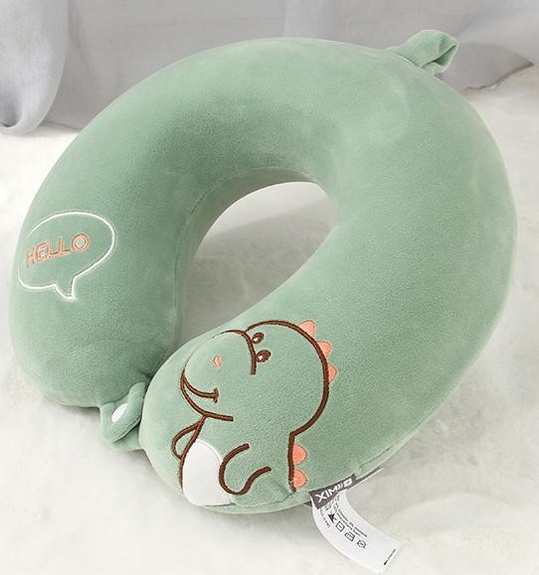
September 02, 2020 | 4-Port Charger | Computer / Audio / Video / Other Electronics & Accessories | Fire Hazard | 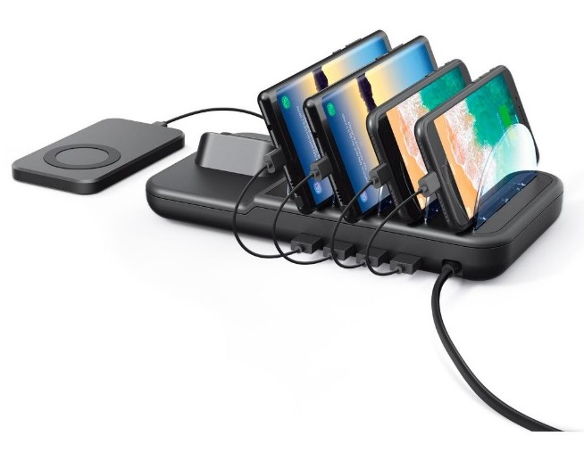
September 03, 2020 | Hi-Lift Storage Hoist | Sporting Goods / Equipment | Injury Hazard | 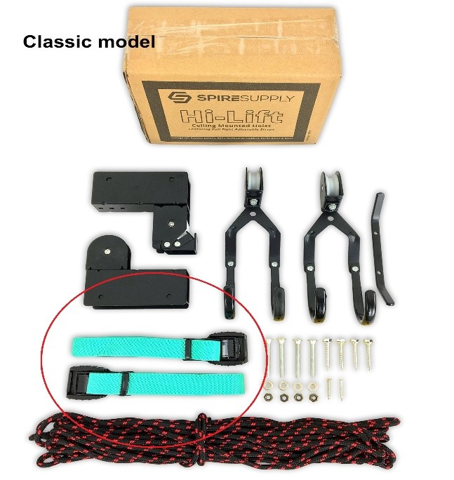
September 04, 2020 | Swim Snorkel | Sporting Goods / Equipment | Choking Hazard | 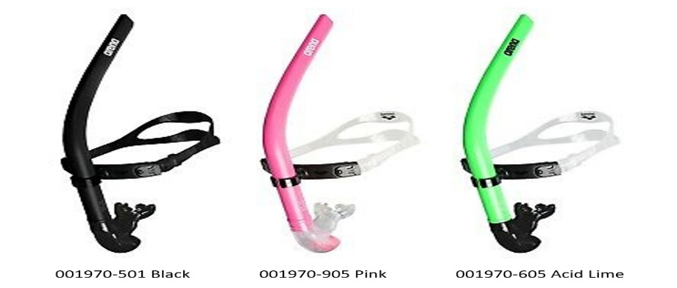
September 04, 2020 | Plant Hangers | Household Goods | Fall Hazard | 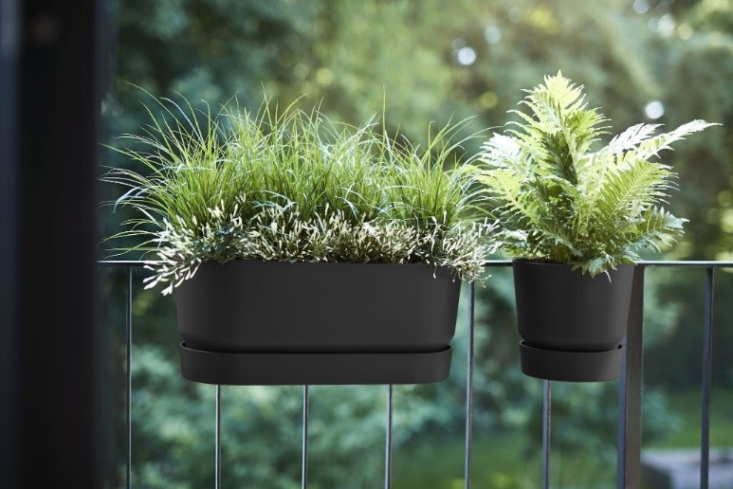
September 09, 2020 | Front Bicycle Rack with Bamboo Tray | Sporting Goods / Equipment | Fall Hazard | 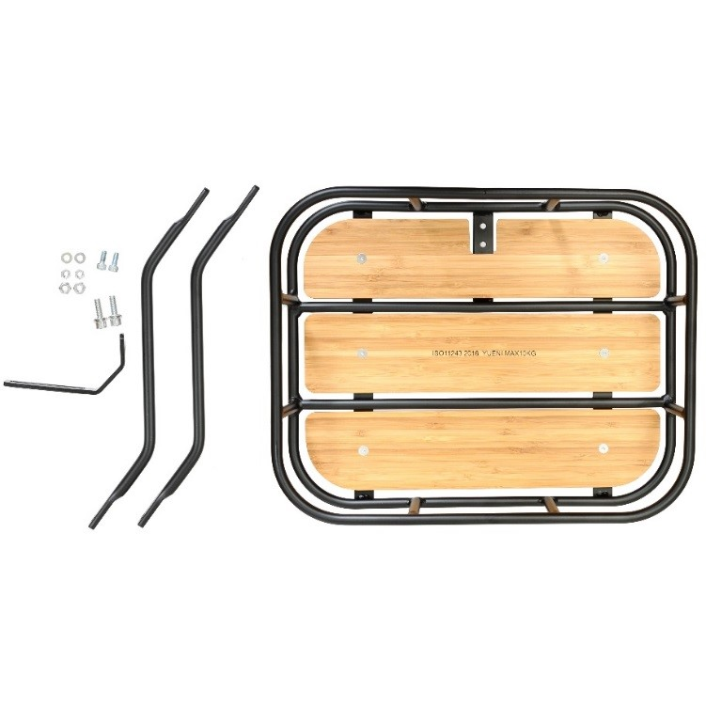
September 16, 2020 | Bicycles | Sporting Goods / Equipment | Fall Hazard | 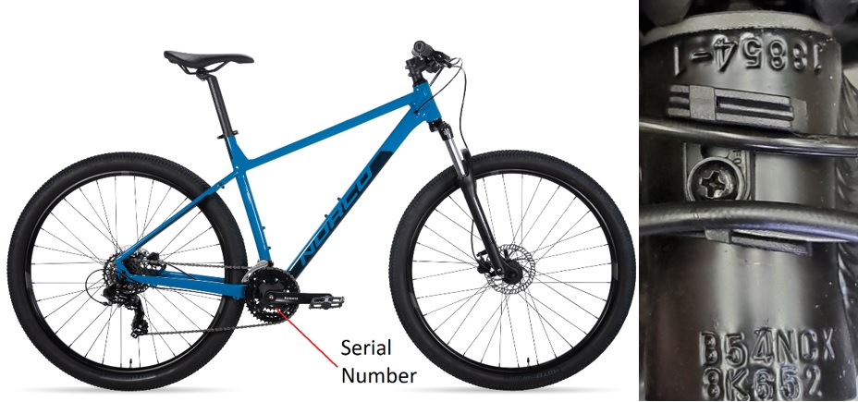
September 16, 2020 | Cable | Computer / Audio / Video / Other Electronics & Accessories | Fire Hazard | 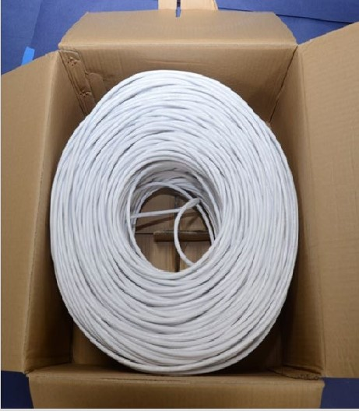
September 23, 2020 | Bicycles | Sporting Goods / Equipment | Fall Hazard | 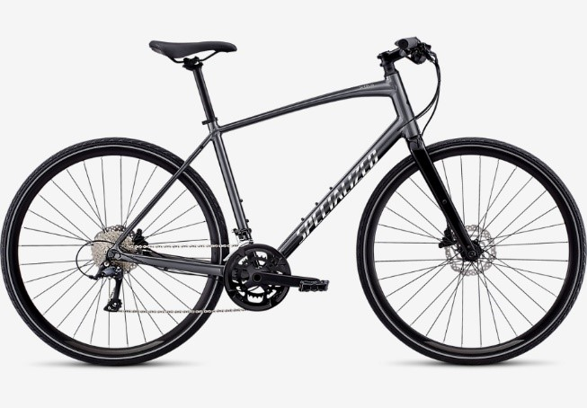
September 23, 2020 | Electric Pole Saw | Tools | Laceration Hazard | 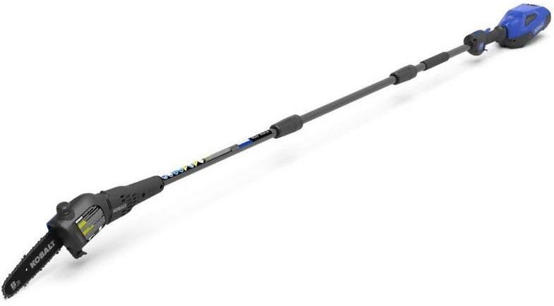
September 23, 2020 | Chainsaw | Tools | Laceration Hazard | 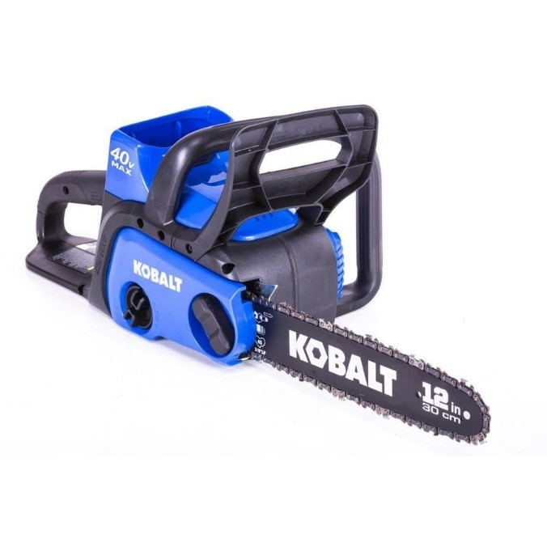
September 25, 2020 | Antioxidant Mouthwash | Cosmetics / Bodycare | Microbial Hazard | 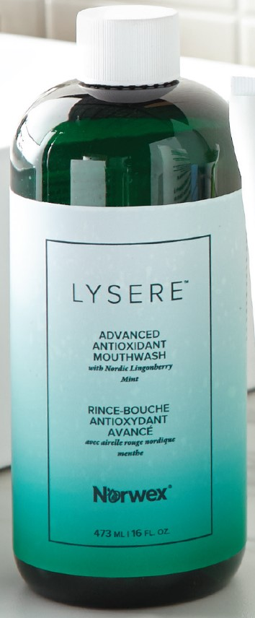
September 30, 2020 | Ropes | Sporting Goods / Equipment | Fall Hazard | 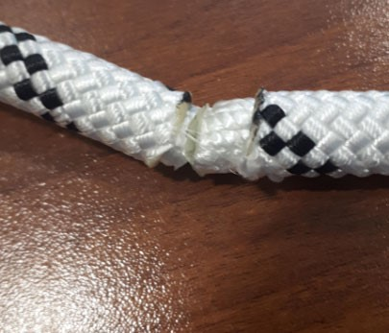
October 1, 2020 | Swivel Rockers | Furniture | Fall Hazard | 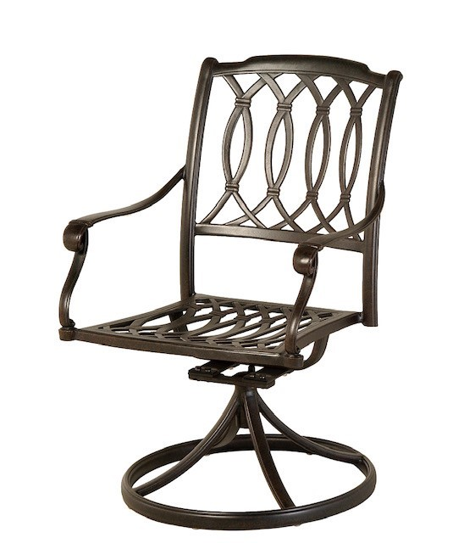
October 7, 2020 | Tables | Furniture | Injury Hazard | 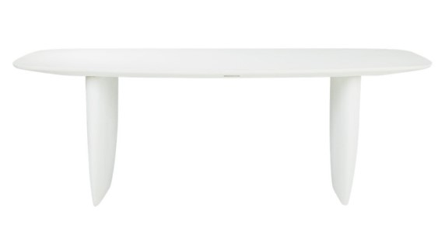
October 9, 2020 | Halloween Candles | Candles & Burning Items and Accessories | Fire Hazard & Burn Hazard | 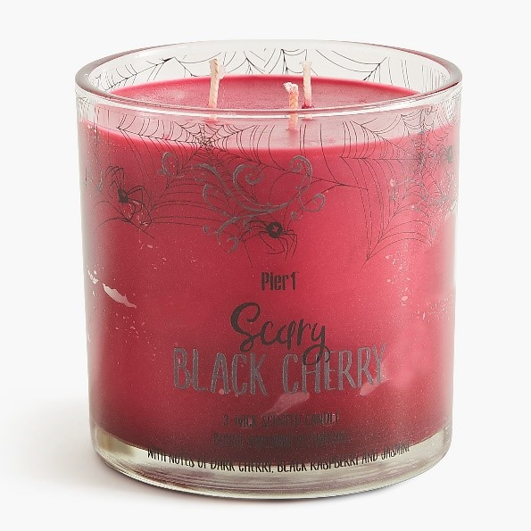
October 21, 2020 | Lounge Chairs | Furniture | Fall Hazard | 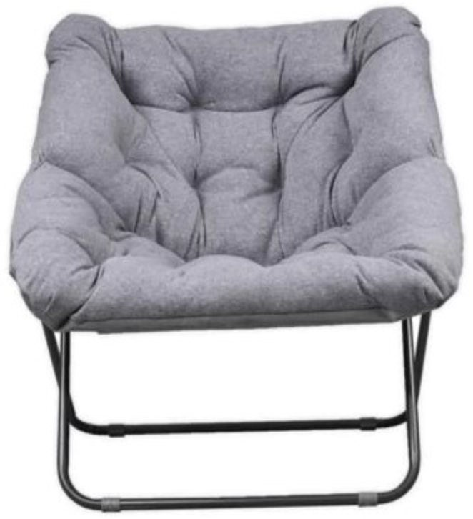
October 21, 2020 | Wipes | Cosmetics / Bodycare | Mould Contamination | 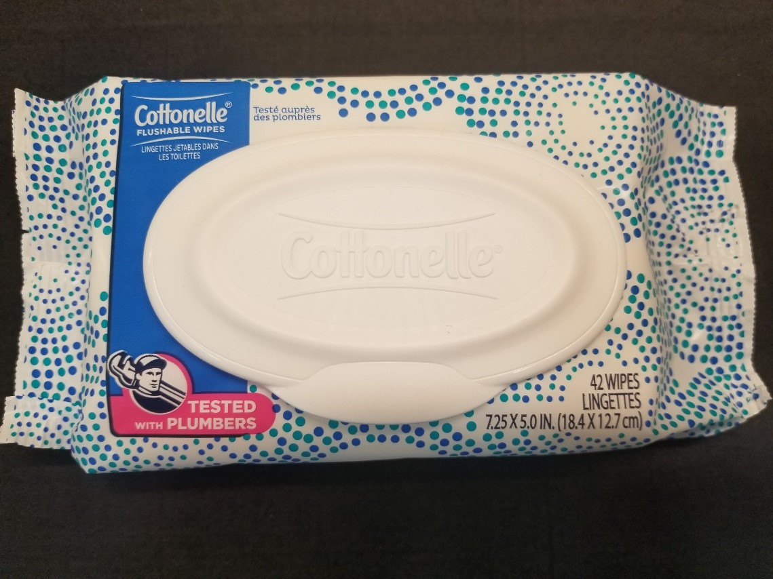
October 21, 2020 | Bookcase | Furniture | Injury Hazard | 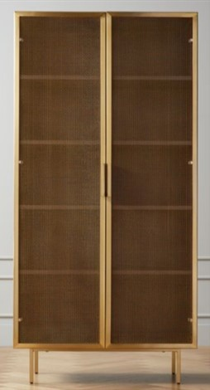
October 22, 2020 | Chemicals Epoxy Products | Chemicals | Chemical Hazard | 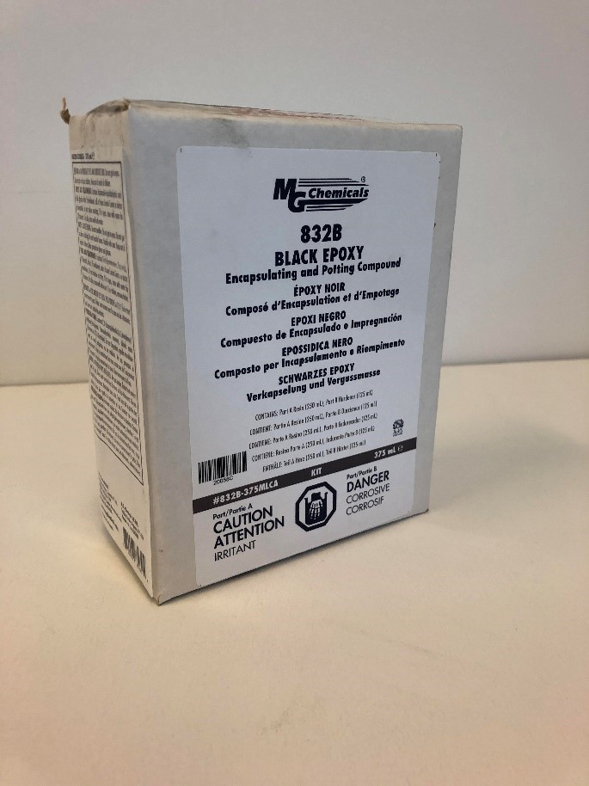
October 30, 2020 | Fondue Fuel | Chemicals | Fire Hazard & Burn Hazard | 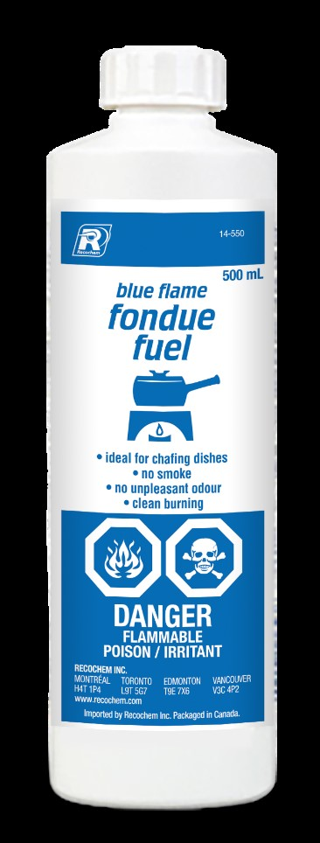
November 4, 2020 | Drawer Chests | Furniture | Tip-Over Hazard & Entrapment Hazard | 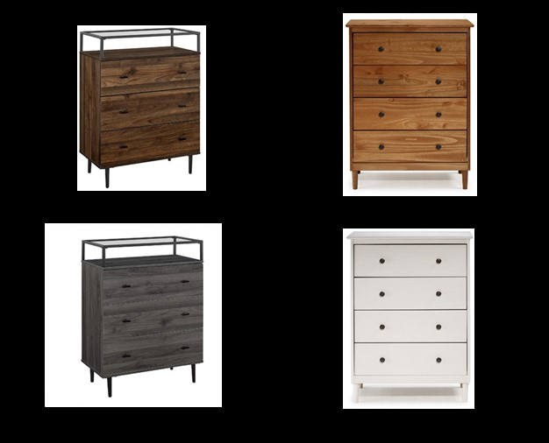
November 5, 2020 | Lighter Fluid | Chemicals | Fire Hazard & Burn Hazard | 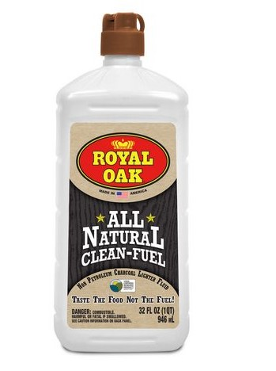
November 10, 2020 | Power Supply Units | Computer / Audio / Video / Other Electronics & Accessories | Electric Shock Hazard | 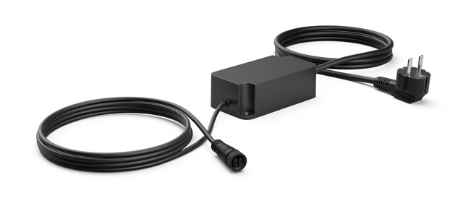
November 10, 2020 | Bicycles | Sporting Goods / Equipment | Fall Hazard | 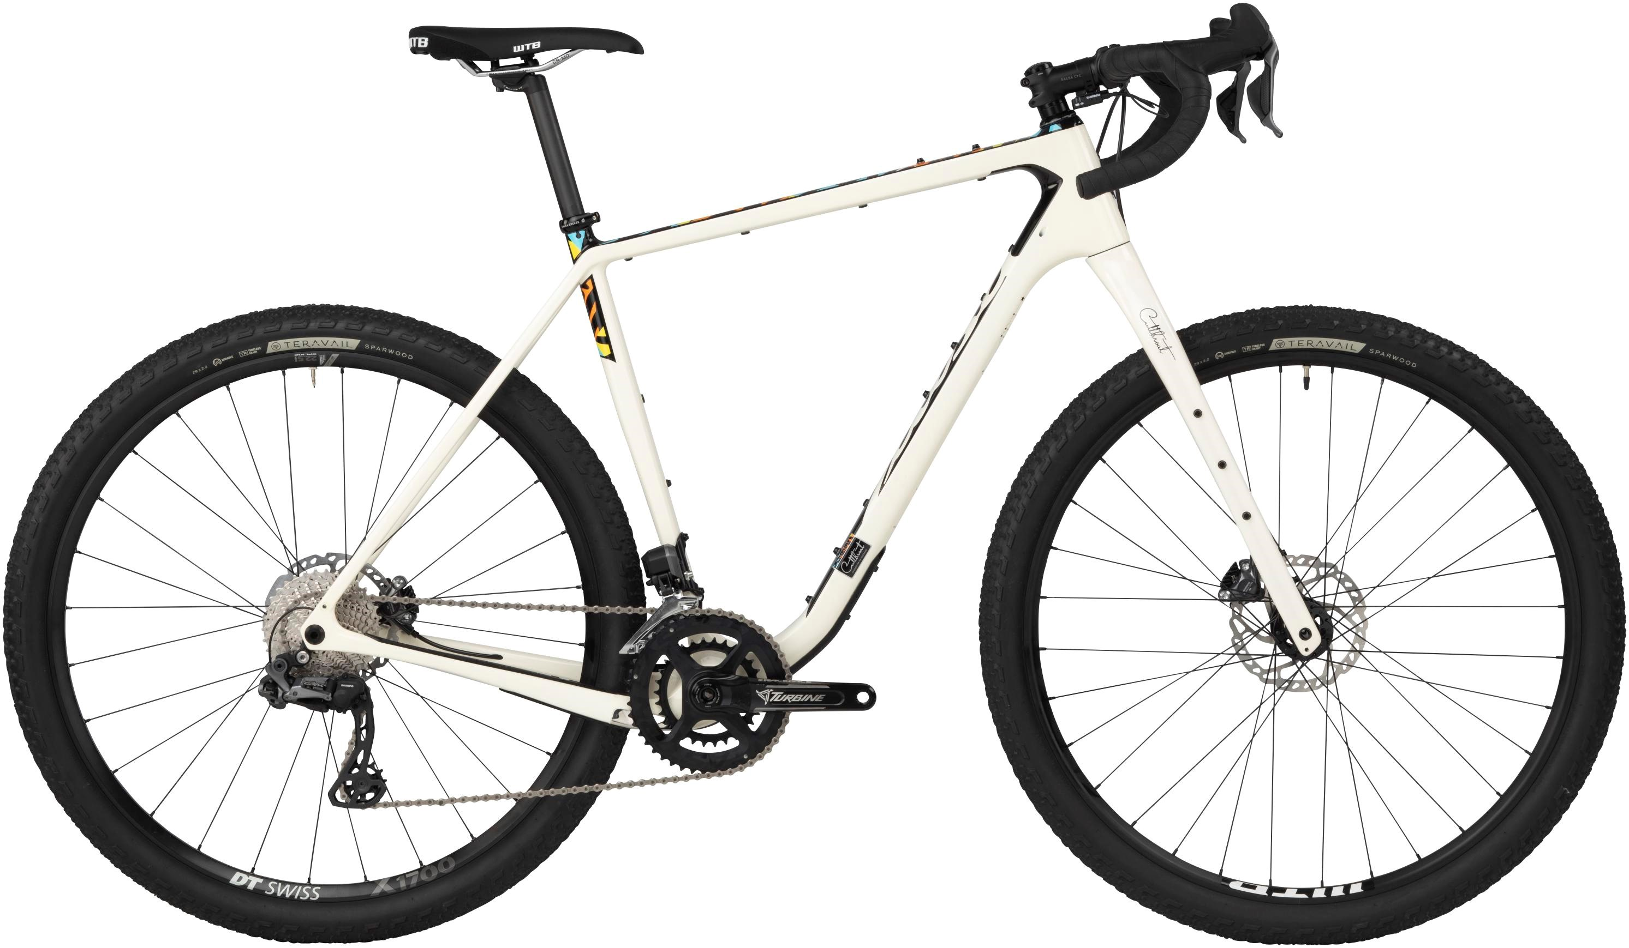
November 10, 2020 | Video Doorbell | Computer / Audio / Video / Other Electronics & Accessories | Fire Hazard | 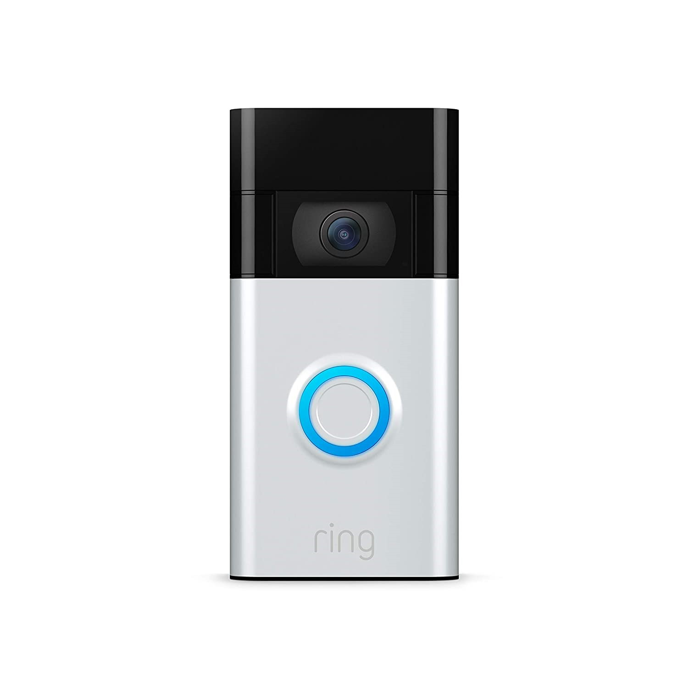
November 10, 2020 | Bath Toy | Toys and Childcare Articles | Choking Hazard | 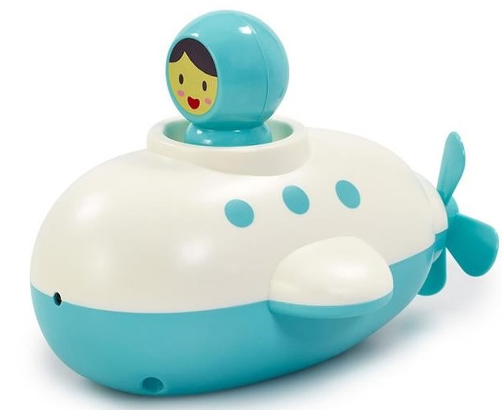
November 13, 2020 | Bike | Sporting Goods / Equipment | Fall Hazard | 