召回案件总结 - 欧洲（最后更新日期：2020年11月）
Reference Number | Notifying Country | Product | Product Category | Hazard | Image
A12/00932/20 | United Kingdom | Toy Tea Set | Toys and Childcare Articles | Choking Hazard & Suffocation Hazard | 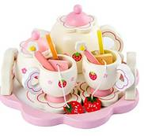
A12/00933/20 | Slovakia | Faciliar Hair Care Oil | Cosmetics | Chemical Hazard | 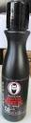
A12/00934/20 | Lithuania | Multiplug Socket | Electrical Appliances and Equipment | Burning Hazard, Electric Shock Hazard & Fire Hazard | 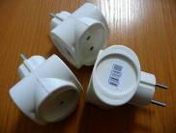
A12/00935/20 | Austria | Toy Hand Grenade | Toys and Childcare Articles | Damage to Hearing Hazard | 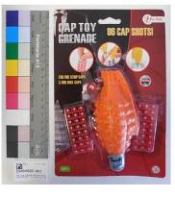
A12/00936/20 | Germany | Necklace | Jewellery | Chemical Hazard | 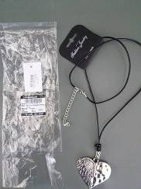
A12/00938/20 | Czechia | Pressure Cooker | Food Contact Material | Burning Hazard & Injury Hazard | 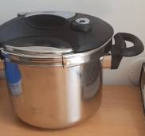
A12/00939/20 | Finland | Children's High Chair | Toys and Childcare Articles | Injury Hazard | 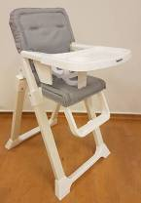
A12/00940/20 | Germany | Skin Lightening Product | Cosmetics | Chemical Hazard | 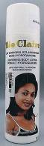
A12/00941/20 | Romania | False Nails | Cosmetics | Chemical Hazard | 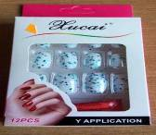
A12/00942/20 | Belgium | Particle Filtration Mask | Personal Protective Equipment | Health risk Hazard | 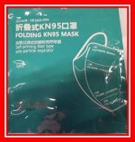
A12/00943/2 | Romania | Extension Cord | Electrical Appliances and Equipment | Burning Hazard & Fire Hazard | 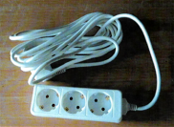
A12/00945/20 | Sweden | Children's High Chair | Toys and Childcare Articles | Injury Hazard & Strangulation Hazard | 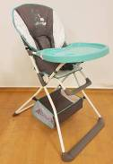
A12/00946/20 | Romania | Swimming Pool Thermometer | General Use Articles | Choking Hazard | 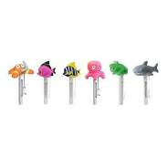
A12/00947/20 | Belgium | Particle Filtration Mask | Personal Protective Equipment | Health risk Hazard | 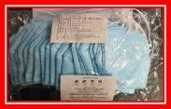
A12/00948/20 | Luxembourg | Plastic Doll with Accessories | Toys and Childcare Articles | Chemical Hazard | 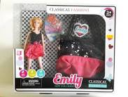
A12/00950/20 | Ireland | Soldering Wire | Chemical Products | Chemical Hazard | 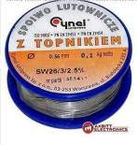
A12/00951/20 | Lithuania | Hair Dye | Cosmetics | Chemical Hazard | 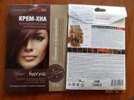
A12/00952/20 | Greece | Toy Slime | Toys and Childcare Articles | Chemical Hazard | 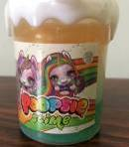
A12/00953/20 | Greece | Toy Slime | Toys and Childcare Articles | Chemical Hazard | 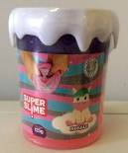
A12/00955/20 | Romania | Children's Wearing Apparel | Clothing, Textiles and Fashion Items | Injury Hazard & Strangulation Hazard | 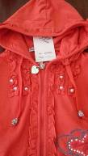
A12/00956/20 | Germany | Ladies’ Lederhosen | Clothing, Textiles and Fashion Items | Chemical Hazard | 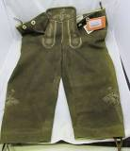
A12/00957/20 | Germany | Dog Leash | Pet Equipment | Chemical Hazard | 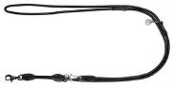
A12/00958/20 | Finland | Light Pad | Electrical Appliances and Equipment | Burning Hazard, Electric Shock Hazard & Fire Hazard | 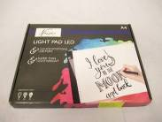
A12/00959/20 | Romania | False Nails | Cosmetics | Chemical Hazard | 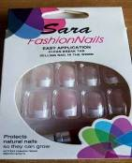
A12/00960/20 | United Kingdom | UV Sterilizer | Electrical Appliances and Equipment | Health Risk Hazard | 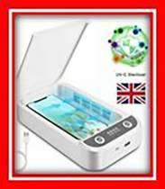
A12/00961/20 | United Kingdom | Portable UV light | Electrical Appliances and Equipment | Burning Hazard, Damage to Sight Hazard & Health Risk Hazard | 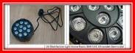
A12/00962/20 | Greece | Toy Slime | Toys and Childcare Articles | Chemical Hazard | 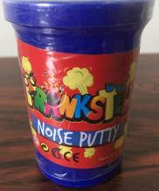
A12/00963/20 | United Kingdom | Baby Teether | Toys and Childcare Articles | Injury Hazard | 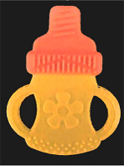
A12/00964/20 | Greece | Toy Slime | Toys and Childcare Articles | Chemical Hazard | 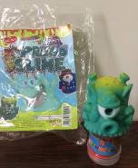
A12/00965/20 | Greece | Toy Slime | Toys and Childcare Articles | Chemical Hazard | 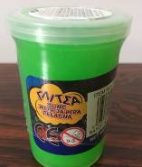
A12/00966/20 | United Kingdom | UV Light Bulb | Electrical Appliances and Equipment | Health Risk Hazard | 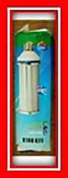
A12/00967/20 | United Kingdom | Portable UV Light | Electrical Appliances and Equipment | Burning Hazard, Damage to Sight Hazard & Health Risk Hazard | 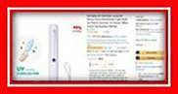
A12/00968/20 | United Kingdom | Portable UV Light | Electrical Appliances and Equipment | Health Risk Hazard | 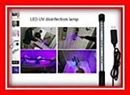
A12/00969/20 | United Kingdom | Portable UV Light | Electrical Appliances and Equipment | Burning Hazard, Damage to Sight Hazard & Health Risk Hazard | 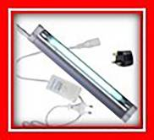
A12/00970/20 | United Kingdom | Particle Filtration Mask | Personal Protective Equipment | Health Risk Hazard | 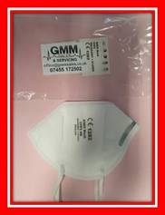
A12/00971/20 | Denmark | Liquid for e-cigarettes | Chemical Products | Chemical Hazard | 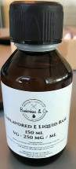
A12/00972/20 | Lithuania | Paint and Varnish Stripper | Chemical Products | Chemical Hazard | 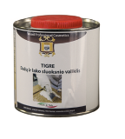
A12/00973/20 | Germany | Balloons | Toys and Childcare Articles | Chemical Hazard | 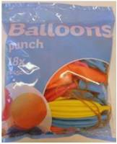
A12/00978/20 | Belgium | Particle Filtration Mask | Personal Protective Equipment | Health Risk Hazard | 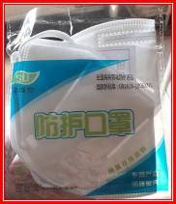
A12/00979/20 | Belgium | Particle Filtration Mask | Personal Protective Equipment | Health Risk Hazard | 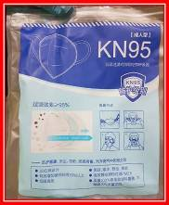
A12/00980/20 | Belgium | Particle Filtration Mask | Personal Protective Equipment | Health Risk Hazard | 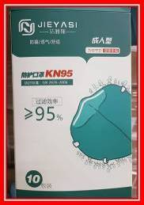
A12/00981/20 | Belgium | Particle Filtration Mask | Personal Protective Equipment | Health Risk Hazard | 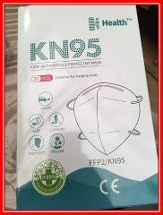
A12/00982/20 | Belgium | Particle Filtration Mask | Personal Protective Equipment | Health Risk Hazard | 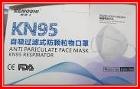
A12/00983/20 | Belgium | Particle Filtration Mask | Personal Protective Equipment | Health Risk Hazard | 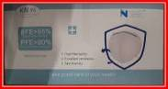
A12/00984/20 | Belgium | Particle Filtration Mask | Personal Protective Equipment | Health Risk Hazard | 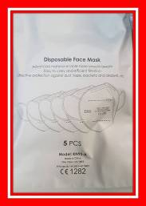
A12/00985/20 | Belgium | Particle Filtration Mask | Personal Protective Equipment | Health Risk Hazard | 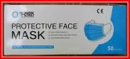
A12/00986/20 | United Kingdom | Portable UV Light | Electrical Appliances and Equipment | Burning Hazard, Damage to Sight Hazard & Health Risk Hazard | 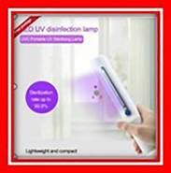
A12/00987/20 | United Kingdom | Portable UV Light | Electrical Appliances and Equipment | Burning Hazard, Damage to Sight Hazard & Health Risk Hazard | 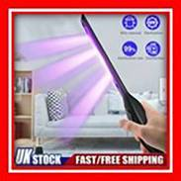
A12/00988/20 | Germany | Bicycle | Sporting Goods / Equipment | Injury Hazard | 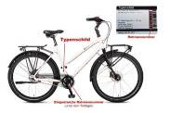
A12/00989/20 | Romania | Children's Blouse | Clothing, Textiles and Fashion Items | Strangulation Hazard | 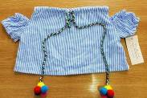
A12/00999/20 | United Kingdom | Baby Teether | Toys and Childcare Articles | Choking Hazard & Injury Hazard | 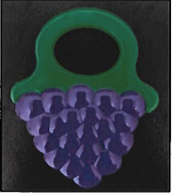
A12/01001/20 | Belgium | Particle Filtration Mask | Personal Protective Equipment | Health Risk Hazard | 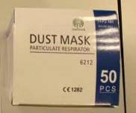
A12/01002/20 | Belgium | Particle Filtration Mask | Personal Protective Equipment | Health Risk Hazard | 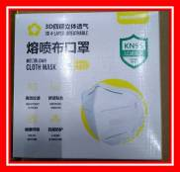
A12/01003/20 | Belgium | Particle Filtration Mask | Personal Protective Equipment | Health Risk Hazard | 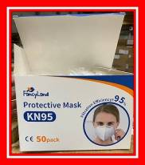  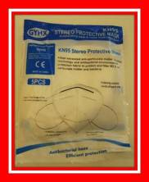
A12/01004/20 | Belgium | Particle Filtration Mask | Personal Protective Equipment | Health Risk Hazard | 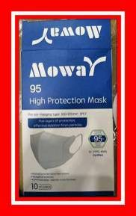
A12/01005/20 | Belgium | Particle Filtration Mask | Personal Protective Equipment | Health Risk Hazard | 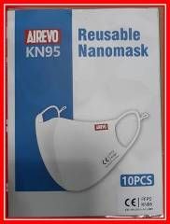
A12/01006/20 | Belgium | Particle Filtration Mask | Personal Protective Equipment | Health Risk Hazard | 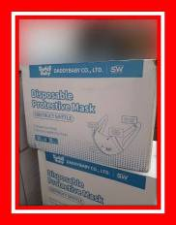
A12/01008/20 | Belgium | Particle Filtration Mask | Personal Protective Equipment | Health Risk Hazard | 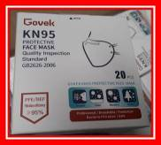
A12/01010/20 | France | Hand Disinfectant | Chemical Products | Fire Hazard & Health Risk Hazard | 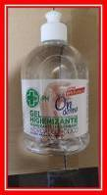
A12/01012/20 | Germany | Men’s Slippers | Footwear | Chemical Hazard | 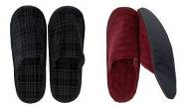
A12/01013/20 | United Kingdom | LED Bath Lights | Toys and Childcare Articles | Chemical Hazard & Choking Hazard | 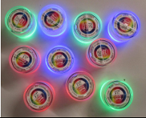
A12/01014/20 | Germany | Leather Jacket | Clothing, Textiles and Fashion Items | Chemical Hazard | 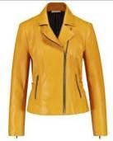
A12/01015/20 | United Kingdom | Hair Curler | Electrical Appliances and Equipment | Electric Shock Hazard | 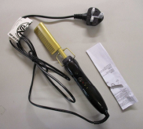
A12/01016/20 | United Kingdom | Nail Lamp | Lighting Equipment | Electric Shock Hazard | 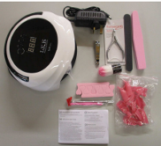
A12/01017/20 | Czechia | Plastic Doll with Accessories | Toys and Childcare Articles | Chemical Hazard | 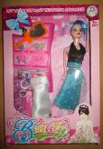
A12/01018/20 | Finland | LED Ceiling Light | Lighting Equipment | Electric Shock Hazard | 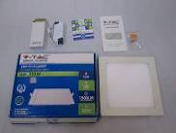
A12/01019/20 | United Kingdom | Wax Warmer | Electrical Appliances and Equipment | Electric Shock Hazard | 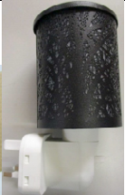
A12/01020/20 | United Kingdom | LED Floodlight | Electrical Appliances and Equipment | Electric Shock Hazard | 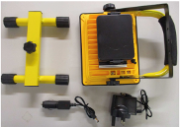
A12/01022/20 | Czechia | Plastic Doll | Toys and Childcare Articles | Chemical Hazard | 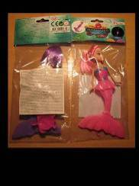
A12/01023/20 | Lithuania | Toy Gun Set | Toys and Childcare Articles | Choking Hazard | 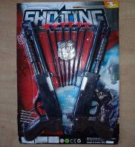
A12/01026/20 | Belgium | Particle Filtration Mask | Personal Protective Equipment | Health Risk Hazard | 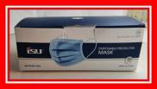
A12/01027/21 | Belgium | Particle Filtration Mask | Personal Protective Equipment | Health Risk Hazard | 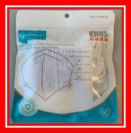
A12/01028/20 | United Kingdom | Finger Light Up Toy | Toys and Childcare Articles | Chemical Hazard | 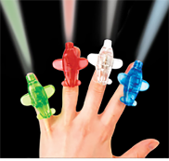
A12/01029/20 | United Kingdom | Finger Light Up Toy | Toys and Childcare Articles | Chemical Hazard | 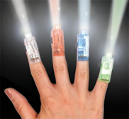
A12/01030/20 | Belgium | Particle Filtration Mask | Personal Protective Equipment | Health Risk Hazard | 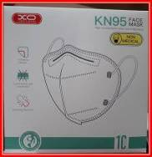
A12/01031/20 | Belgium | Particle Filtration Mask | Personal Protective Equipment | Health Risk Hazard | 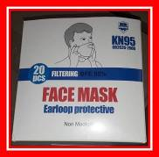
A12/01032/20 | Belgium | Particle Filtration Mask | Personal Protective Equipment | Health Risk Hazard | 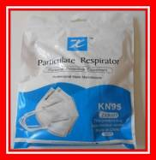
A12/01033/20 | Belgium | Particle Filtration Mask | Personal Protective Equipment | Health Risk Hazard | 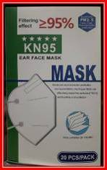
A12/01034/20 | Romania | Children Clothing Set | Clothing, Textiles and Fashion Items | Injury Hazard & Strangulation Hazard | 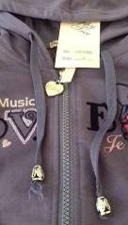
A12/01035/20 | Latvia | Plastic Duck | Toys and Childcare Articles | Chemical Hazard | 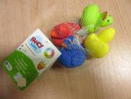
A12/01042/20 | Greece | Toy Slime | Toys and Childcare Articles | Chemical Hazard | 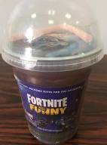
A12/01043/20 | Poland | Battery-Operated Toy | Toys and Childcare Articles | Chemical Hazard | 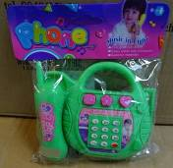
A12/01045/20 | France | Hair Growth Gel | Cosmetics | Chemical Hazard | 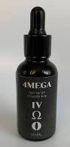
A12/01051/20 | France | Nightlight for Children | Lighting Equipment | Chemical Hazard & Choking Hazard | 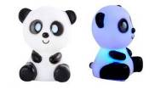
A12/01055/20 | Belgium | Particle Filtration Mask | Personal Protective Equipment | Health Risk Hazard | 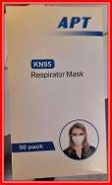
A12/01057/20 | Belgium | Particle Filtration Mask | Personal Protective Equipment | Health Risk Hazard | 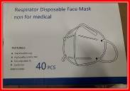
A12/01059/20 | Hungary | Lighting String | Lighting Equipment | Burning Hazard,  Electric Shock Hazard  &  Fire Hazard | 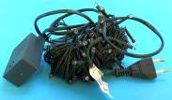
A12/01060/20 | Belgium | Particle Filtration Mask | Personal Protective Equipment | Health Risk Hazard | 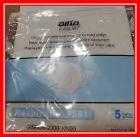
A12/01061/20 | Belgium | Particle Filtration Mask | Personal Protective Equipment | Health Risk Hazard | 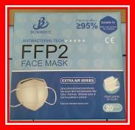
A12/01062/20 | Belgium | Particle Filtration Mask | Personal Protective Equipment | Health Risk Hazard | 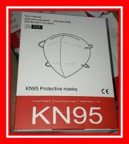
A12/01064/20 | United Kingdom | Portable UV Light | Electrical Appliances and Equipment | Health Risk Hazard | 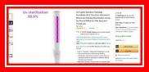
A12/01066/20 | Finland | Power Bank | Electrical Appliances and Equipment | Electric Shock Hazard | 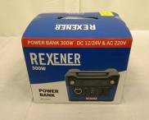
A12/01070/20 | Poland | Toy Police Set | Toys and Childcare Articles | Choking Hazard &  Damage to Sight Hazard | 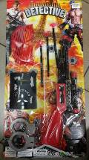
A12/01071/20 | Austria | Hair Dye | Cosmetics | Chemical Hazard | 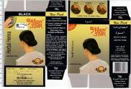
A12/01072/20 | Belgium | Particle Filtration Mask | Personal Protective Equipment | Health Risk Hazard | 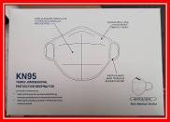
A12/01073/20 | Belgium | Particle Filtration Mask | Personal Protective Equipment | Health Risk Hazard | 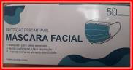
A12/01074/20 | Belgium | Particle Filtration Mask | Personal Protective Equipment | Health Risk Hazard | 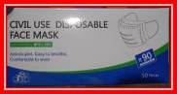
A12/01075/20 | Belgium | Particle Filtration Mask | Personal Protective Equipment | Health Risk Hazard | 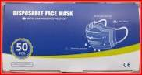
A12/01076/20 | Belgium | Particle Filtration Mask | Personal Protective Equipment | Health Risk Hazard | 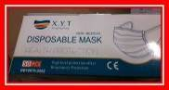
A12/01077/20 | Slovakia | Lighting Chain | Lighting Equipment | Electric Shock Hazard & Fire Hazard | 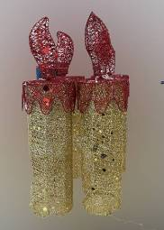
A12/01078/20 | Slovakia | Pyramid-shaped Luminaire | Lighting Equipment | Electric Shock Hazard & Fire Hazard | 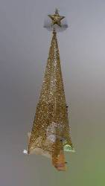
A12/01079/20 | Slovakia | Lighting String | Lighting Equipment | Electric Shock Hazard & Fire Hazard | 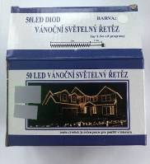
A12/01080/20 | Poland | Particle Filtration Mask | Personal Protective Equipment | Health Risk Hazard | 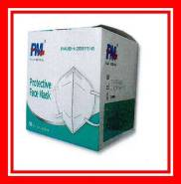
A12/01081/20 | Poland | Plastic Ball | Toys and Childcare Articles | Chemical Hazard | 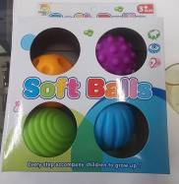
A12/01082/20 | Austria | Toy Revolver | Toys and Childcare Articles | Damage to Hearing Hazard | 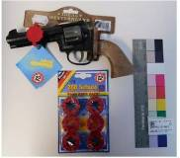
A12/01083/20 | Austria | Whistle Toy | Toys and Childcare Articles | Choking Hazard | 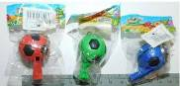
A12/01084/20 | Poland | Stone Polisher | Tool | Electric Shock Hazard | 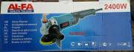
A12/01085/20 | United Kingdom | Toy Putty | Toys and Childcare Articles | Chemical Hazard | 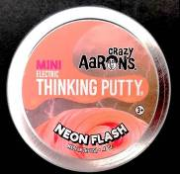
A12/01086/20 | United Kingdom | Toy Putty | Toys and Childcare Articles | Chemical Hazard | 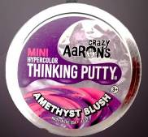
A12/01087/20 | Finland | LED Power Supply | Electrical Appliances and Equipment | Electric Shock Hazard | 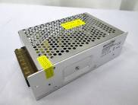
A12/01088/20 | United Kingdom | Portable Immersion Heater | Electrical Appliances and Equipment | Burning Hazard & Electric Shock Hazard | 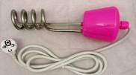
A12/01089/20 | Finland | Control Gear for LED Power Pack | Lighting Equipment | Electric Shock Hazard & Fire Hazard | 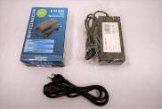
A12/01091/20 | Finland | Squeezable Toy | Toys and Childcare Articles | Microbiological Hazard | 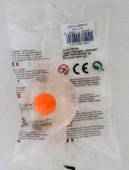
A12/01092/20 | Poland | Travel Adaptor | Computer / Audio / Video / Other Electronics & Accessories | Electric Shock Hazard | 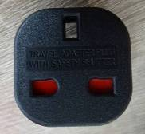
A12/01093/20 | Finland | Squeezable Toy | Toys and Childcare Articles | Microbiological Hazard | 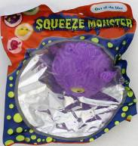
A12/01094/20 | Belgium | Particle Filtration Mask | Personal Protective Equipment | Health Risk Hazard | 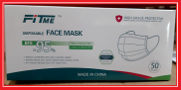
A12/01097/20 | Lithuania | Folding Stool | Furniture | Injury Hazard | 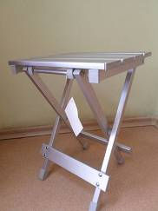
A12/01098/20 | Belgium | Particle Filtration Mask | Personal Protective Equipment | Health Risk Hazard | 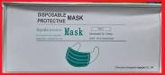
A12/01099/20 | Belgium | Particle Filtration Mask | Personal Protective Equipment | Health Risk Hazard | 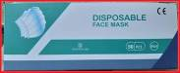
A12/01100/20 | United Kingdom | LED Light Bulb | Lighting Equipment | Electric Shock Hazard | 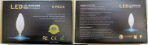
A12/01101/20 | Belgium | Particle Filtration Mask | Personal Protective Equipment | Health Risk Hazard | 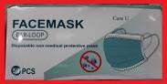
A12/01102/20 | Belgium | Particle Filtration Mask | Personal Protective Equipment | Health Risk Hazard | 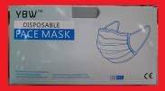
A12/01103/20 | Poland | Bicycle | Sporting Goods / Equipment | Injury Hazard | 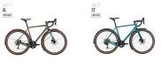
A12/01108/20 | Belgium | Particle Filtration Mask | Personal Protective Equipment | Health Risk Hazard | 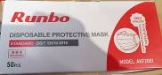
A12/01109/20 | Belgium | Particle Filtration Mask | Personal Protective Equipment | Health Risk Hazard | 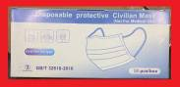
A12/01110/20 | United Kingdom | Heated Hair Styler | Electrical Appliances and Equipment | Burning Hazard & Fire Hazard | 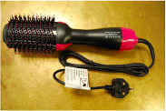
A12/01111/20 | Austria | Toy Flute | Toys and Childcare Articles | Choking Hazard &  Damage to Hearing Hazard | 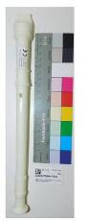
A12/01126/20 | Germany | Tattoo Ink | Chemical Products | Chemical Hazard | 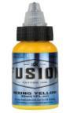
A12/01127/20 | Germany | Tattoo Ink | Chemical Products | Chemical Hazard | 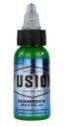
A12/01130/20 | Slovakia | Lighting String | Lighting Equipment | Electric Shock Hazard | 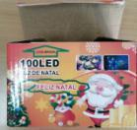
A12/01131/20 | Slovakia | Lighting String | Lighting Equipment | Electric Shock Hazard | 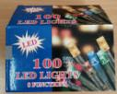
A12/01132/20 | Slovakia | Lighting String | Lighting Equipment | Electric Shock Hazard | 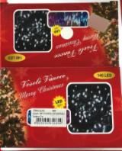
A12/01112/20 | Bulgaria | Children’s Potty | Children's Product | Injury Hazard | 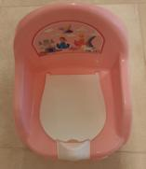
A12/01124/20 | Latvia | Plastic Doll | Toys | Chemical Hazard | 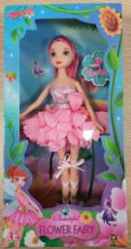
A12/01113/20 | Germany | Hand Cream | Cosmetics | Microbiological Hazard | 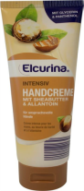
A12/01120/20 | Finland | LED Overhead Light | Electrical Appliances and Equipment | Electric Shock Hazard | 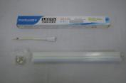
A12/01129/20 | Germany | Power Strip | Electrical Appliances and Equipment | Electric Shock Hazard | 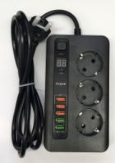
A11/00069/20 | Germany | Waterproof Bath Book | Toys | Chemical Hazard | 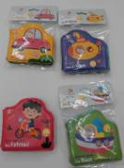
INFO/00109/20 | Bulgaria | Novelty Lighter | Novelties | Electric Shock Hazard | 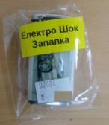
INFO/00110/20 | Bulgaria | Toy Gum | Novelties | Electric Shock Hazard | 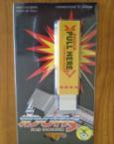
INFO/00111/20 | Bulgaria | Novelty Lighter | Novelties | Electric Shock Hazard, Fire Hazard | 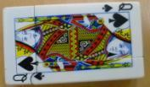
A12/01142/20 | Latvia | Toy Gun Set | Toys | Choking Hazard, Injury Hazard | 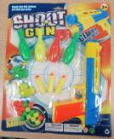
A12/01134/20 | Denmark | Children's Jacket | Clothing, Textiles and Fashion Items | Strangulation Hazard | 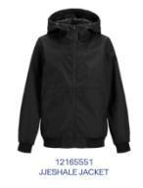
A12/01135/20 | Denmark | Children's Jacket | Clothing, Textiles and Fashion Items | Strangulation Hazard | 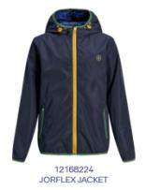
A12/01133/20 | Denmark | USB Charger | Electrical Appliances and Equipment | Burn Hazard, Electric Shock Hazard, Fire Hazard | 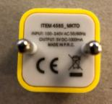
A12/01136/20 | Finland | Power Supply Adaptor | Electrical Appliances and Equipment | Electric Shock Hazard | 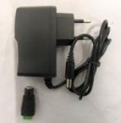
A12/01151/20 | Poland | Table Lamp | Electrical Appliances and Equipment | Electric Shock Hazard | 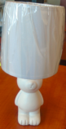
A12/01152/20 | Poland | Table Lamp | Electrical Appliances and Equipment | Electric Shock Hazard | 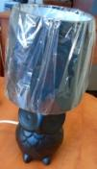
A11/00070/20 | Romania | Baby Stroller | Toys and Childcare Articles | Injury Hazard | 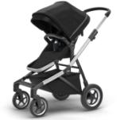
A12/01155/20 | Hungary | Lighting String | Lighting Equipment | Burn Hazard, Electric Shock Hazard, Fire Hazard | 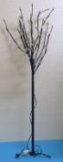
A12/01168/20 | Hungary | Lighting String | Lighting Equipment | Burn Hazard, Electric Shock Hazard, Fire Hazard | 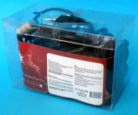
A12/01154/20 | Hungary | Portable LED Lamp | Lighting Equipment | Burn Hazard, Electric Shock Hazard, Fire Hazard | 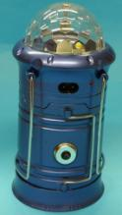
A12/01164/20 | Hungary | Portable LED Lamp/Torch | Lighting Equipment | Burn Hazard, Electric Shock Hazard, Fire Hazard | 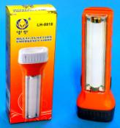
A12/01166/20 | Hungary | Portable LED Lamp | Lighting Equipment | Burn Hazard, Electric Shock Hazard, Fire Hazard | 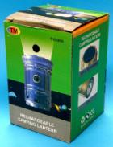
A12/01167/20 | Hungary | Play Yard | Toys and Childcare Articles | Injury Hazard | 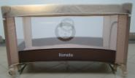
A12/01153/20 | Denmark | Teeth Whitening Product | Cosmetics | Chemical Hazard | 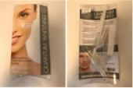
A11/00071/20 | Hungary | Plastic Step Stool | Housewares | Injury Hazard | 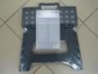
A11/00072/20 | Hungary | Plastic Step Stool | Housewares | Injury Hazard | 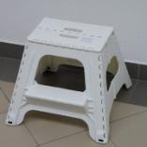
A11/00073/20 | Ireland | Plug Adapter | Electrical Appliances and Equipment | Electric Shock Hazard | 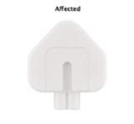
INFO/00118/20 | Latvia | Particle Filtration Mask | Personal Protective Equipment | Health risk Hazard, Other Hazard | 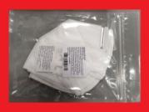
A12/01187/20 | Germany | Wristwatch | Jewellery | Chemical Hazard | 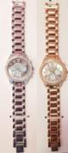
A12/01173/20 | Hungary | Lighting String | Lighting Equipment | Burn Hazard, Electric Shock Hazard, Fire Hazard | 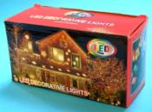
A12/01177/20 | Hungary | Lighting String | Lighting Equipment | Burn Hazard, Electric Shock Hazard, Fire Hazard | 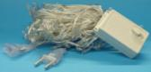
A12/01174/20 | Hungary | Children's High Chair | Toys and Childcare Articles | Injury Hazard | 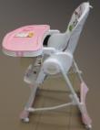
A12/01181/20 | Czechia | Wooden Swing Seat | Toys | Injury Hazard | 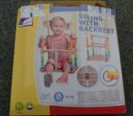
A12/01183/20 | Lithuania | Plastic Toy | Toys | Choking Hazard, Suffocation Hazard | 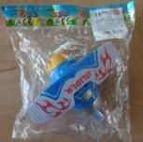
A12/01185/20 | Lithuania | Plastic Toy | Toys | Choking Hazard | 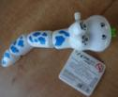
A12/01186/20 | Lithuania | Plastic Toy | Toys | Choking Hazard | 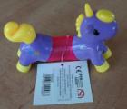
A12/01188/20 | Finland | Teether | Toys and Childcare Articles | Choking Hazard | 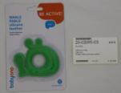
A12/01175/20 | Denmark | Teeth Whitening Product | Cosmetics | Chemical Hazard | 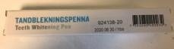
A11/00074/20 | Denmark | Children's Raincoat | Clothing, Textiles and Fashion Items | Chemical Hazard | 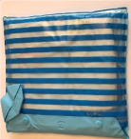
A11/00075/20 | Poland | Extension Cord | Electrical Appliances and Equipment | Burn Hazard | 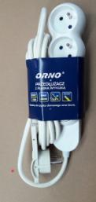
INFO/00120/20 | France | Pressure Cooker | Kitchen/Cooking accessories | Burn Hazard, Injury Hazard | 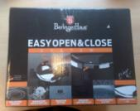
A12/01197/20 | Poland | Plastic Doll | Toys | Chemical Hazard | 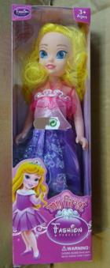
A12/01202/20 | Poland | Plastic Doll | Toys | Chemical Hazard | 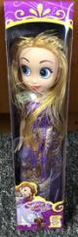
A12/01203/20 | Poland | Set of Rubber Ducks | Toys | Chemical Hazard | 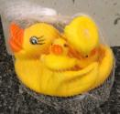
A12/01209/20 | Poland | Toy Gun | Toys | Choking Hazard | 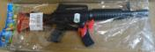
A11/00076/20 | United Kingdom | Toy Water Gun | Toys | Chemical Hazard | 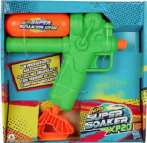
A11/00077/20 | Finland | Activity Play Mat | Toys | Choking Hazard | 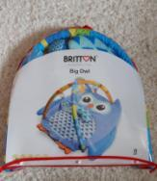
A12/01216/20 | Ireland | Epoxy Putty | Chemical Products | Chemical Hazard | 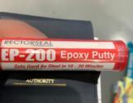
A12/01214/20 | Luxembourg | Particle Filtration Mask | Personal Protective Equipment | Health Risk Hazard / Other Hazard | 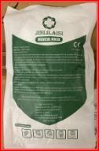
A12/01217/20 | Luxembourg | Particle Filtration Mask | Personal Protective Equipment | Health Risk Hazard / Other Hazard | 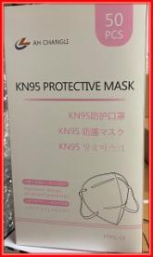
A12/01212/20 | Poland | Plastic Toy | Toys | Chemical Hazard | 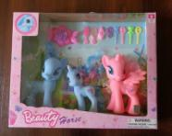
A12/01213/20 | Poland | Plastic Doll | Toys | Chemical Hazard | 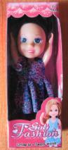
A12/01218/20 | Latvia | Toy Slime | Toys | Chemical Hazard | 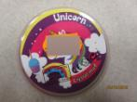
A12/01229/20 | Poland | Plastic Doll | Toys | Chemical Hazard | 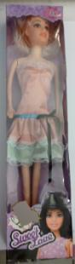
A12/01227/20 | Ireland | Water Heater | Electrical Appliances and Equipment | Fire Hazard | 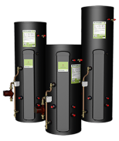
INFO/00125/20 | Latvia | Particle Filtration Mask | Personal Protective Equipment | Health Risk Hazard / Other Hazard | 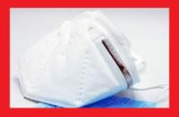
A12/01231/20 | Poland | Ice Making Cubes | Kitchen/Cooking Accessories | Choking Hazard | 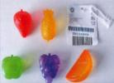
A12/01241/20 | Poland | Ice Making Cubes | Kitchen/Cooking accessories | Choking Hazard | 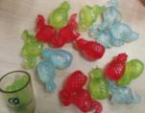
A12/01237/20 | Hungary | Lighting String | Lighting Equipment | Burn Hazard, Electric Shock Hazard, Fire Hazard | 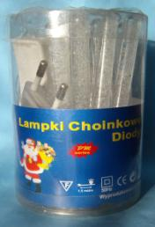
A12/01238/20 | Hungary | Lighting String | Lighting Equipment | Burn Hazard, Electric Shock Hazard, Fire Hazard | 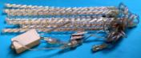
A12/01252/20 | United Kingdom | Floor Lamp | Lighting Equipment | Electric Shock Hazard
A12/01254/20 | United Kingdom | Desk Lamp | Lighting Equipment | Electric Shock Hazard | 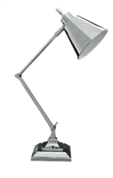
A12/01232/20 | Poland | Plastic Ball | Toys and Childcare Articles | Chemical Hazard | 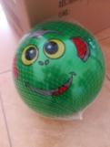
A12/01249/20 | Slovenia | Plush Toy | Toys and Childcare Articles | Choking Hazard | 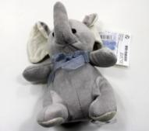
A12/01250/20 | Poland | Baby Teether | Toys and Childcare Articles | Choking Hazard | 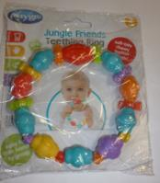
A12/01244/20 | Cyprus | Girls' Clothing Set | Clothing, Textiles and Fashion Items | Injury Hazard | 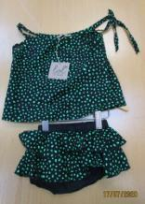
A12/01245/20 | Cyprus | Child's dress | Clothing, Textiles and Fashion Items | Injury Hazard | 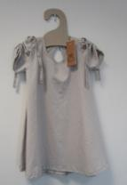
A12/01246/20 | Cyprus | Child's Ruffle Romper | Clothing, Textiles and Fashion Items | Injury Hazard | 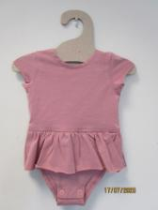
A12/01248/20 | Cyprus | Child's Jumpsuit | Clothing, Textiles and Fashion Items | Injury Hazard | 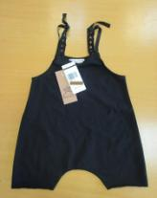
A12/01251/20 | Cyprus | Child's Dress | Clothing, Textiles and Fashion Items | Injury Hazard | 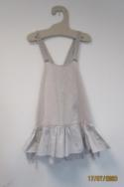
A12/01288/20 | Germany | Earrings | Jewellery | Chemical Hazard | 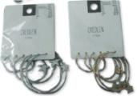
A12/01257/20 | Hungary | Lighting String | Lighting Equipment | Burn Hazard, Electric Shock Hazard, Fire Hazard | 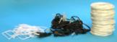
A12/01258/20 | Poland | Toy Slime | Toys and Childcare Articles | Chemical Hazard | 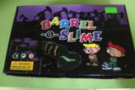
A12/01260/20 | Poland | Set of Plastic Rattles | Toys and Childcare Articles | Choking Hazard | 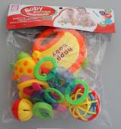
A12/01264/20 | Lithuania | Toy Police Set | Toys and Childcare Articles | Choking Hazard, Injury Hazard, SuffocationHazard | 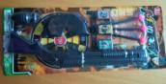
A12/01267/20 | Poland | Plastic Toy Gun | Toys and Childcare Articles | Chemical Hazard | 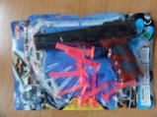
A12/01269/20 | Germany | Leather Gloves | Clothing, Textiles and Fashion Ttems | Chemical Hazard | 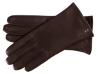
A12/01272/20 | Romania | Child's Sweatshirt | Clothing, Textiles and Fashion Items | Injury Hazard, Strangulation Hazard | 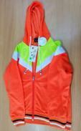
A12/01273/20 | Germany | Leather Jacket | Clothing, Textiles and Fashion Items | Chemical Hazard | 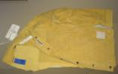
A11/00078/20 | Hungary | Lighting String | Lighting Equipment | Burn Hazard, Electric Shock Hazard, Fire Hazard | 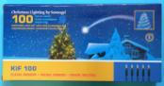
A12/01293/20 | Hungary | Ring Set | Jewellery | Chemical Hazard | 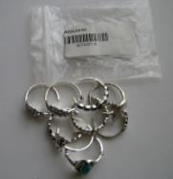
A12/01309/20 | Germany | Earrings/Ear Studs | Jewellery | Chemical Hazard | 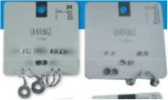
A12/01300/20 | Slovakia | Warning Triangle | Car Accessories | Injury Hazard | 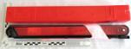
A12/01291/20 | Lithuania | Plastic Doll | Toys and Childcare Articles | Chemical Hazard | 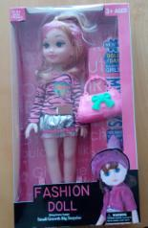
A12/01312/20 | Romania | Baby T-shirt | Clothing, Textiles and Fashion Items | Choking Hazard | 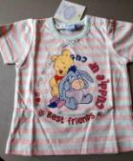
A12/01310/20 | Germany | Hair Treatment Cream | Cosmetics | Chemical Hazard | 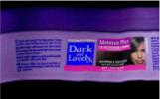
A12/01321/20 | Ireland | Nicotine Containing Liquid Cartridges | Chemical Products | Chemical Hazard | 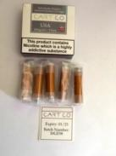
A12/01327/20 | Ireland | Soldering Wire | Chemical Products | Chemical Hazard | 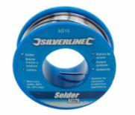
A12/01322/20 | Czechia | Plastic Ball | Toys and Childcare Articles | Chemical Hazard | 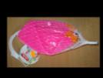
A12/01323/20 | Czechia | Plastic Doll | Toys and Childcare Articles | Chemical Hazard | 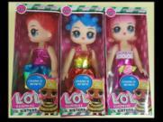
A12/01324/20 | Czechia | Plastic Doll | Toys and Childcare Articles | Chemical Hazard | 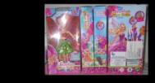
A12/01325/20 | Austria | Baby Doll Pull-along Toy | Toys and Childcare Articles | Choking Hazard | 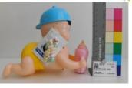
A12/01330/20 | Poland | Toy Slime | Toys and Childcare Articles | Chemical Hazard | 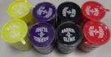
A12/01332/20 | Poland | Toy Slime | Toys and Childcare Articles | Chemical Hazard | 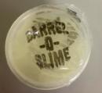
A12/01335/20 | United Kingdom | Battery Operated Toy | Toys and Childcare Articles | Chemical, Injuries Hazard | 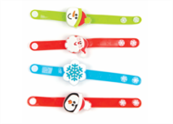
A12/01345/20 | United Kingdom | Flashing Swing Ball | Toys and Childcare Articles | Strangulation Hazard | 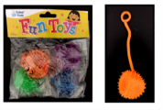
A12/01328/20 | United Kingdom | LED Bulb | Electrical Appliances and Equipment | Electric Shock Hazard | 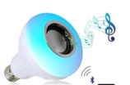
A11/00079/20 | Slovakia | Keychain | Toys | Choking Hazard, Injury Hazard | 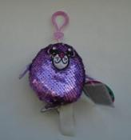
A12/01370/20 | Finland | Feeding Spoon | Toys and Childcare Articles | Choking Hazard | 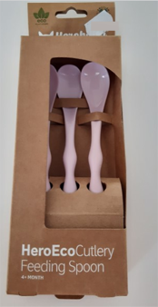
A12/01351/20 | Slovakia | Plush Toy | Toys and Childcare Articles | Choking Hazard | 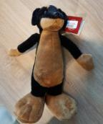
A12/01352/20 | Cyprus | Rattle Toy Set | Toys and Childcare Articles | Choking Hazard | 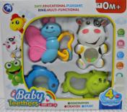
A12/01354/20 | Poland | Wooden Toy Drum | Toys and Childcare Articles | Damage to Hearing Hazard, Strangulation Hazard | 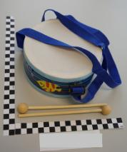
A12/01355/20 | Poland | Toy Slime | Toys and Childcare Articles | Chemical Hazard | 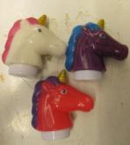
A12/01356/20 | Cyprus | Toy Bow and Arrow set | Toys and Childcare Articles | Choking Hazard | 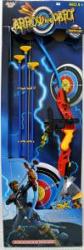
A12/01365/20 | Slovakia | Rag Doll | Toys and Childcare Articles | Choking Hazard | 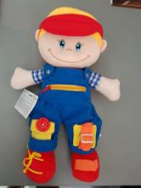
A12/01366/20 | Hungary | Bath Toy Set | Toys and Childcare Articles | Chemical Hazard | 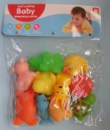
A12/01368/20 | Hungary | Plastic Doll | Toys and Childcare Articles | Chemical Hazard | 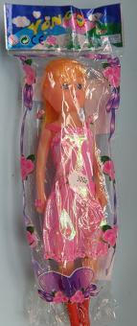
A12/01369/20 | Cyprus | Rattle Toy Set | Toys and Childcare Articles | Choking Hazard, Injury Hazard | 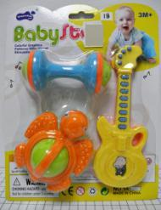
A12/01377/20 | Poland | Toy Scooter | Toys and Childcare Articles | Injury Hazard | 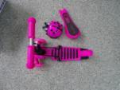
A12/01379/20 | Poland | Toy Telephone | Toys and Childcare Articles | Damage to Hearing Hazard | 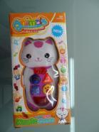
A12/01381/20 | Poland | Plastic Swing | Toys and Childcare Articles | Injury Hazard | 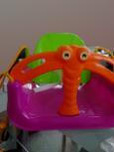
A12/01357/20 | Cyprus | Childrens' Clothing Set | Clothing, Textiles and Fashion Items | Injury Hazard | 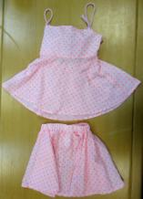
A12/01350/20 | United Kingdom | Water Heater | Electrical Appliances and Equipment | Electric Shock Hazard | 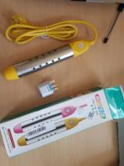
A12/01361/20 | France | Electrical Adapter | Electrical Appliances and Equipment | Electric Shock Hazard | 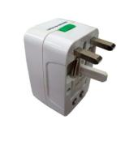
A12/01362/20 | United Kingdom | Smart Plug Adaptor | Electrical Appliances and Equipment | Burn Hazard, Fire Hazard | 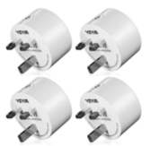
A12/01374/20 | Finland | Battery Charger | Electrical Appliances and Equipment | Electric Shock Hazard | 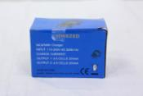
A12/01380/20 | Finland | Power Adapter | Electrical Appliances and Equipment | Electric Shock Hazard | 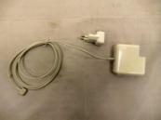
INFO/00132/20 | Latvia | Particle Filtration Mask | Protective Equipment | Health Risk Hazard / Other Hazard | 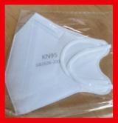
INFO/00131/20 | United Kingdom | Power Strip | Electrical Appliances and Equipment | Electric Shock Hazard | 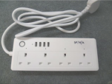
A12/01397/20 | Germany | Dog leash | Pet Accessories | Chemical Hazard | 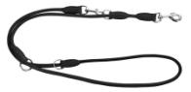
A12/01390/20 | Iceland | Particle Filtration Mask | Personal Protective equipment | Health Risk Hazard / Other Hazard | 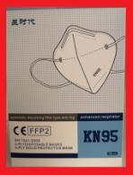
A12/01405/20 | Sweden | Children's High Chair | Toys and Childcare articles | Injury Hazard, Strangulation Hazard | 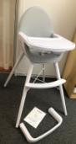
A12/01407/20 | France | Children’s Bamboo Spoon/Fork Cutlery Set | Toys and Childcare articles | Choking Hazard, Injury Hazard | 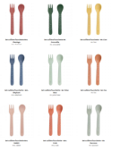
A11/00084/20 | Austria | Plastic Car | Toys and Childcare Articles | Choking Hazard | 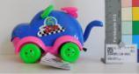
A12/01392/20 | Hungary | Plastic Doll | Toys and Childcare Articles | Chemical Hazard | 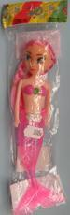
A12/01394/20 | Slovakia | Children’s Keychain | Toys and Childcare Articles | Choking Hazard | 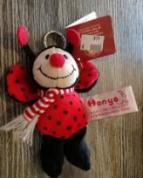
A12/01399/20 | Cyprus | Plastic Toy Dinosaur | Toys and Childcare Articles | Choking Hazard | 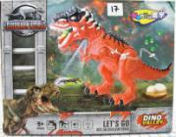
A12/01402/20 | Slovakia | Soft Doll | Toys and Childcare Articles | Choking Hazard | 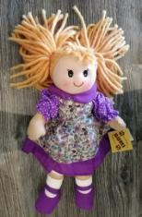
A12/01410/20 | Poland | Plush Toy | Toys and Childcare Articles | Injury Hazard | 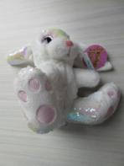
A12/01411/20 | United Kingdom | Toy Doll | Toys and Childcare Articles | Chemical Hazard | 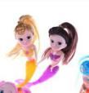
A12/01421/20 | Lithuania | Battery-operated Toy | Toys and Childcare Articles | Choking Hazard, Cut Hazard | 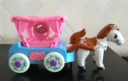
A12/01391/20 | Finland | Cardigan Sweater | Clothing, Textiles and Fashion Items | Choking Hazard | 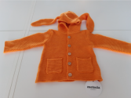
A12/01415/20 | Iceland | Children's Hoodie | Clothing, Textiles and Fashion Items | Strangulation Hazard | 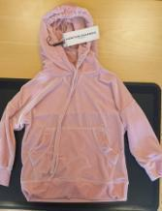
A12/01398/20 | France | Electrical Adaptor | Electrical Appliances and Equipment | Electric Shock Hazard | 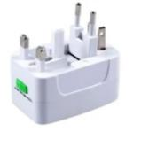
A12/01406/20 | France | Universal Charger | Electrical Appliances and Equipment | Burn Hazard, Fire Hazard | 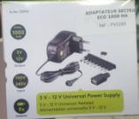
A12/01414/20 | Hungary | Extension Cord | Electrical Appliances and Equipment | Burn Hazard, Electric Shock Hazard, Fire Hazard | 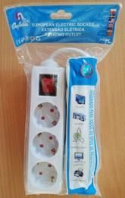
A12/01422/20 | United Kingdom | Heated Air Brush | Electrical Appliances and Equipment | Fire Hazard | 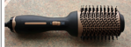
A11/00083/20 | Germany | Modeling Clay | Toys and Childcare Articles | Chemical Hazard | 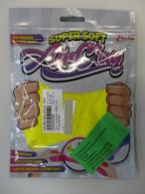
A12/01424/20 | Austria | Plush Toy | Toys and Childcare Articles | Choking Hazard | 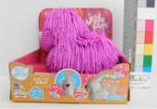
A12/01426/20 | France | Baby Teether | Toys and Childcare Articles | Choking Hazard | 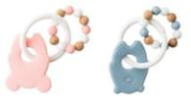
A12/01436/20 | Poland | Toy Musical Instrument Set | Toys and Childcare Articles | Choking Hazard, Cut Hazard, Strangulation Hazard | 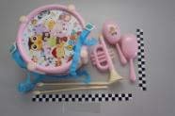
A12/01428/20 | France | Electrical Adaptor | Electrical Appliances and Equipment | Electric Shock Hazard | 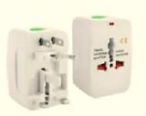
A12/01432/20 | United Kingdom | Pool Immersion Heater | Electrical Appliances and Equipment | Burn Hazard, Electric Shock Hazard | 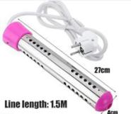
A12/01433/20 | United Kingdom | Pool Immersion Heater | Electrical Appliances and Equipment | Burn Hazard | 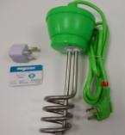
A12/01434/20 | United Kingdom | Pool Immersion Heater | Electrical Appliances and Equipment | Burn Hazard | 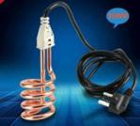
INFO/00134/20 | Iceland | Particle Filtration Mask | Personal Protective Equipment | Health Risk Hazard / Other Hazard | 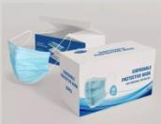
A12/01455/20 | Sweden | Bracelet | Jewellery | Chemical Hazard | 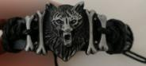
A12/01457/20 | Cyprus | Novelty Lighter | Lighters | Burn Hazard, Fire Hazard | 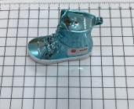
A12/01458/20 | Cyprus | Novelty Lighters | Lighters | Burn Hazard, Fire Hazard | 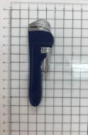
A12/01453/20 | Luxembourg | Motorcycle Helmet | Personal Protective Equipment | Injury Hazard | 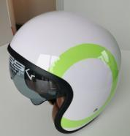
A12/01456/20 | Slovakia | Child’s Safety Vest | Personal Protective Equipment | Injury Hazard | 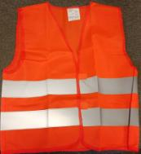
A12/01461/20 | Belgium | Particle Filtration Mask | Personal Protective Equipment | Health Risk Hazard / Other Hazard | 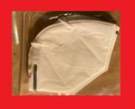
A12/01447/20 | Poland | Plastic Wind-up Toy | Toys and Childcare Articles | Choking Hazard | 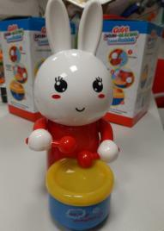
A12/01448/20 | Poland | Toy Police Set | Toys and Childcare Articles | Chemical Hazard | 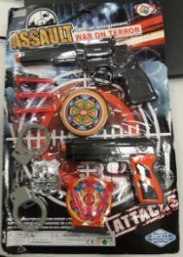
A12/01450/20 | Cyprus | Toy Gun Set | Toys and Childcare Articles | Choking Hazard | 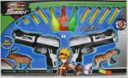
A12/01459/20 | Hungary | Plastic Doll with Accessories | Toys and Childcare Articles | Chemical Hazard | 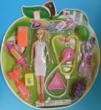
A12/01460/20 | Hungary | Doctor Play Set with Doll | Toys and Childcare Articles | Chemical Hazard | 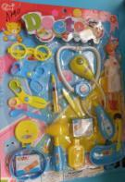
A12/01468/20 | Hungary | Plastic Bouncing Ball | Toys and Childcare Articles | Chemical Hazard | 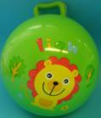
A12/01471/20 | Czechia | Plastic Doll | Toys and Childcare Articles | Chemical Hazard | 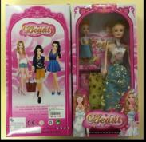
A12/01472/20 | Czechia | Plastic Doll | Toys and Childcare Articles | Chemical Hazard | 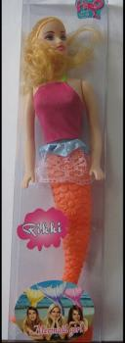
A12/01473/20 | Czechia | Plastic Doll with Accessories | Toys and Childcare Articles | Chemical Hazard | 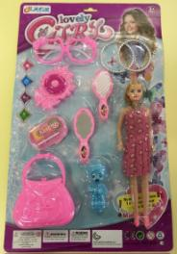
A12/01474/20 | Czechia | Plastic Doll with Accessories | Toys and Childcare Articles | Chemical Hazard | 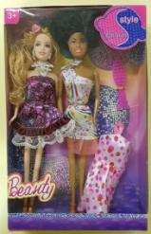
A12/01469/20 | Sweden | Candle Holders -Lanterns | Candles and Lighting Accessories | Chemical Hazard | 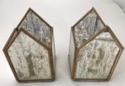
A12/01470/20 | Sweden | Bowl | Housewares | Chemical Hazard | 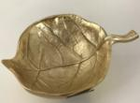
A11/00087/20 | Austria | Shower Gel | Cosmetics | Health Risk Hazard / Other Hazard | 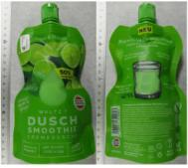
INFO/00137/20 | United Kingdom | Outlet Adaptor | Electrical Appliances and Equipment | Burn Hazard, Electric Shock Hazard, Fire Hazard | 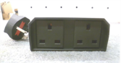
A12/01486/20 | Poland | Self-Balancing Scooter (hoverboard) | Sporting Goods | Electric Shock Hazard, Fire Hazard | 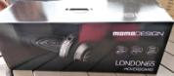
A12/01475/20 | Sweden | Earrings | Jewellery | Chemical Hazard | 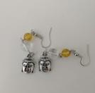
A12/01481/20 | Sweden | Jewellery charms | Jewellery | Chemical Hazard | 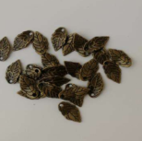
A12/01476/20 | Hungary | Toy Slime | Toys Candles and Lighting Accessories | Chemical Hazard | 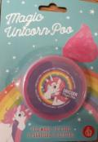
A12/01478/20 | Germany | Stress Ball | Toys Candles and Lighting Accessories | Microbiological Hazard | 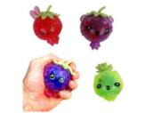
A12/01485/20 | Hungary | Doctor Play Set | Toys Candles and Lighting Accessories | Chemical Hazard | 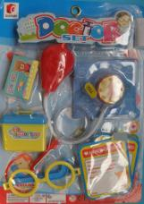
A12/01488/20 | The Netherlands | Wooden Toy | Toys Candles and Lighting Accessories | Choking Hazard | 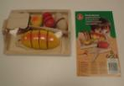
A12/01492/20 | The Netherlands | Wooden Toy | Toys Candles and Lighting Accessories | Choking Hazard | 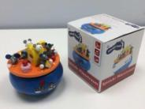
A12/01493/20 | Hungary | Toy Slime | Toys and Childcare Articles | Chemical Hazard | 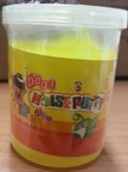
A12/01495/20 | France | Toy Crossbow Set | Toys and Childcare Articles | Injury Hazard | 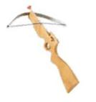
A12/01498/20 | Croatia | Toy Slime | Toys and Childcare Articles | Chemical Hazard | 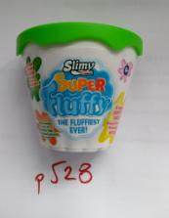
A12/01477/20 | France | Electrical Adaptor | Electrical Appliances and Equipment | Electric Shock Hazard | 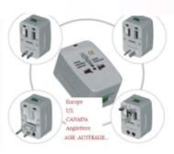
A12/01479/20 | France | Electrical Adaptor | Electrical Appliances and Equipment | Electric Shock Hazard | 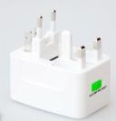
A12/01480/20 | France | Electrical Adaptor | Electrical Appliances and Equipment | Electric Shock Hazard | 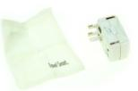
A12/01487/20 | The Netherlands | Lighting Stringn | E Lighting Equipment | Electric Shock Hazard | 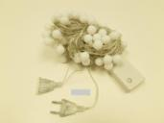
A12/01496/20 | The Netherlands | USB Charger | Electrical Appliances and Equipment | Electric Shock Hazard | 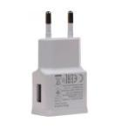
A12/01499/20 | The Netherlands | USB Charger | Electrical Appliances and Equipment | Electric Shock Hazard | 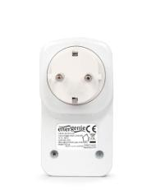
A12/01500/20 | The Netherlands | USB Charger | Electrical Appliances and Equipment | Electric Shock Hazard | 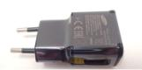
A11/00088/20 | Hungary | Lighting Strings | Lighting Equipment | Electric Shock Hazard | 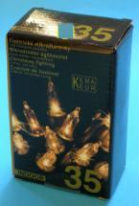
INFO/00140/20 | Romania | Particle Filtration Mask | Personal Protective Equipment | Health Risk Hazard / Other Hazard | 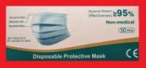
INFO/00141/20 | Latvia | Particle Filtration Mask | Personal Protective Equipment | Health Risk Hazard / Other Hazard | 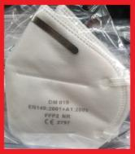
A12/01538/20 | Sweden | Bracelet | Jewellery | Chemical Hazard | 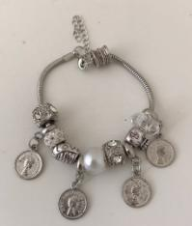
A12/01539/20 | Sweden | Necklace | Jewellery | Chemical Hazard | 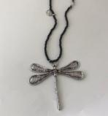
A12/01540/20 | Sweden | Necklace | Jewellery | Chemical Hazard | 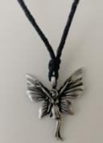
A12/01541/20 | Sweden | Bracelet | Jewellery | Chemical Hazard | 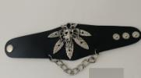
A12/01543/20 | Sweden | Necklace | Jewellery | Chemical Hazard | 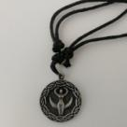
A12/01545/20 | Sweden | Necklace | Jewellery | Chemical Hazard | 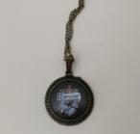
A12/01546/20 | Sweden | Bracelet | Jewellery | Chemical Hazard | 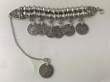
A12/01547/20 | Sweden | Necklace | Jewellery | Chemical Hazard | 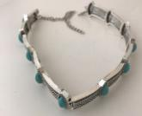
A12/01542/20 | Lithuania | Tire Repair Set | General Use Products | Chemical Hazard | 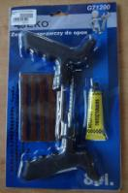
A12/01524/20 | Hungary | Desk Lamp | Lighting Equipment | Burn Hazard, Electric Shock Hazard, Fire Hazard
A12/01572/20 | Germany | Particle Filtration Mask | Personal Protective Equipment | Health Risk Hazard / Other Hazard | 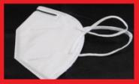
A12/01514/20 | Poland | Plastic Ball | Toys and Childcare Articles | Chemical Hazard | 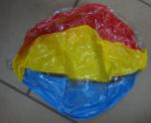
A12/01515/20 | Poland | Plastic Doll | Toys and Childcare Articles | Chemical Hazard | 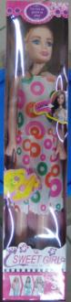
A12/01516/20 | Slovakia | Modeling Clay | Toys and Childcare Articles | Chemical Hazard | 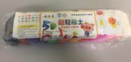
A12/01519/20 | Slovakia | Plush Toy | Toys and Childcare Articles | Choking Hazard | 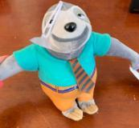
A12/01521/20 | Czechia | Plastic Doll | Toys and Childcare Articles | Chemical Hazard | 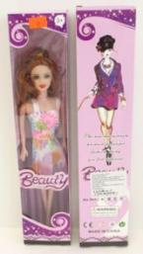
A12/01523/20 | Hungary | Toy Slime | Toys and Childcare Articles | Chemical Hazard | 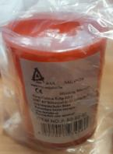
A12/01526/20 | The Netherlands | Wooden Toy | Toys and Childcare Articles | Strangulation Hazard | 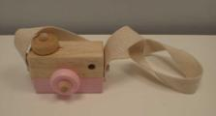
A12/01529/20 | The Netherlands | Teething Toy | Toys and Childcare Articles | Choking Hazard | 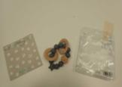
A12/01531/20 | The Netherlands | Rattle Toy | Toys and Childcare Articles | Choking Hazard | 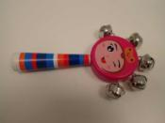
A12/01533/20 | Czechia | Floating Swim Ring | Toys and Childcare Articles | Chemical Hazard | 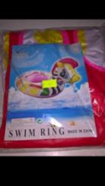
A12/01553/20 | Czechia | Plastic Doll with Accessories | Toys and Childcare Articles | Chemical Hazard | 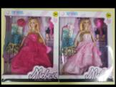
A12/01554/20 | Hungary | Toy Trumpet | Toys and Childcare Articles | Choking Hazard | 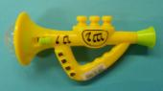
A12/01560/20 | Poland | Plastic Toy | Toys and Childcare Articles | Chemical Hazard | 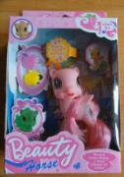
A12/01568/20 | United Kingdom | Toy Drum Set | Toys and Childcare Articles | Choking, Damage to Hearing Hazard | 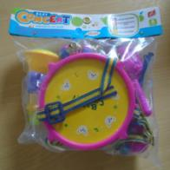
A12/01555/20 | Cyprus | Child's Bolero Costume | Clothing, Textiles and Fashion Items | Injury Hazard | 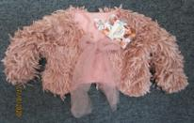
A12/01567/20 | Germany | Key ring | Clothing, Textiles and Fashion Items | Chemical Hazard | 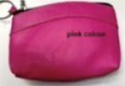
A12/01549/20 | The Netherlands | Skin-lightening Product | Cosmetics | Chemical, Health Risk Hazard / Other Hazard | 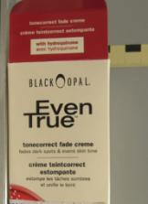
A12/01565/20 | Cyprus | Wet Wipes | Cosmetics | Chemical, Health Risk Hazard / Other Hazard | 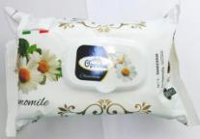
A12/01527/20 | France | Electrical Outlet Adaptor | Electrical Appliances and Equipment | Electric Shock Hazard | 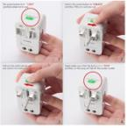
A12/01564/20 | Germany | Electric Nose Hair Trimmer | Electrical Appliances and Equipment | Chemical Hazard | 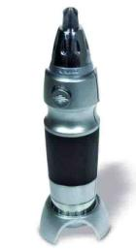
A11/00089/20 | Hungary | Lighting String | Lighting Equipment | Electric Shock Hazard | 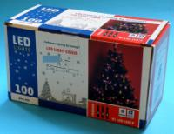
A11/00091/20 | Slovakia | Fabric Doll | Toys and Childcare Articles | Choking Hazard | 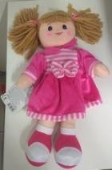
A11/00093/20 | Slovakia | Plush toy | Toys and Childcare Articles | Choking Hazard | 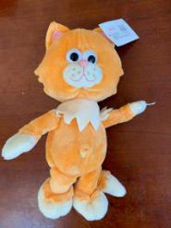
A11/00094/20 | The Netherlands | Wooden Toy | Toys and Childcare Articles | Choking Hazard | 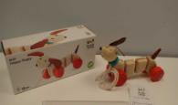
A11/00090/20 | Hungary | Extension Cord | Electrical Appliances and Equipment | Burn Hazard, Fire Hazard | 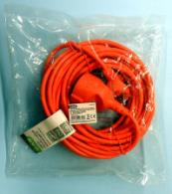
A11/00095/20 | Hungary | Electric Heater | Electrical Appliances and Equipment | Burn Hazard, Electric Shock Hazard | 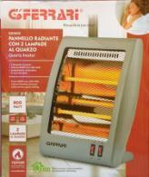
A11/00096/20 | United Kingdom | Macerator | Electrical Appliances and Equipment | Burn Hazard, Fire Hazard | 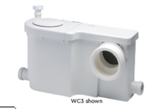
A11/00097/20 | Poland | Inverter Welding Machine | Electrical Appliances and Equipment | Electric Shock Hazard, Fire Hazard | 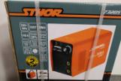
INFO/00143/20 | Latvia | Particle Filtration Mask | Personal Protective Equipment | Health Risk Hazard / Other Hazard | 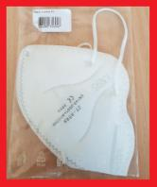
INFO/00144/20 | Romania | Particle Filtration Mask | Personal Protective Equipment | Health Risk Hazard / Other Hazard | 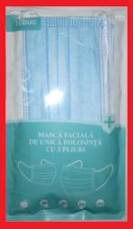
INFO/00145/20 | Romania | Particle Filtration Mask | Personal Protective Equipment | Health Risk Hazard / Other Hazard | 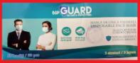
INFO/00146/20 | Romania | Particle Filtration Mask | Personal Protective Equipment | Health Risk Hazard / Other Hazard | 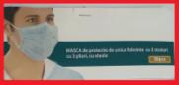
INFO/00147/20 | Romania | Particle Filtration Mask | Personal Protective Equipment | Health Risk Hazard / Other Hazard | 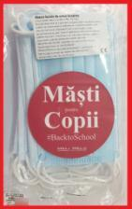
INFO/00148/20 | Romania | Particle Filtration Mask | Personal Protective Equipment | Health Risk Hazard / Other Hazard | 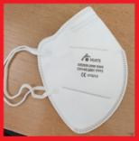
INFO/00149/20 | Romania | Particle Filtration Mask | Personal Protective Equipment | Health Risk Hazard / Other Hazard | 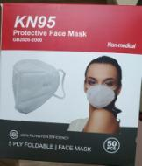
INFO/00150/20 | Hungary | Bouncing Unicorn | Toys and Childcare Articles | Chemical Hazard | 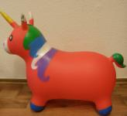
A12/01506/20 | Finland | AC Adaptor | Electrical Appliances and Equipment | Electric Shock Hazard | 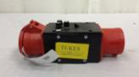
A12/01594/20 | Lithuania | Glue | Chemical Products | Chemical Hazard | 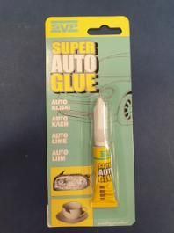
A12/01596/20 | United Kingdom | Hand Sanitizer | Chemical Products | Health Risk Hazard / Other Hazard | 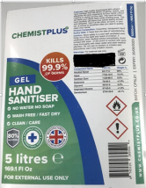
A12/01597/20 | Germany | Hand Sanitizer | Chemical Products | Chemical Hazard | 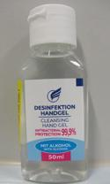
A12/01598/20 | Germany | Hand Sanitizer | Chemical Products | Chemical Hazard | 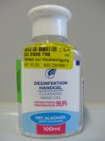
A12/01600/20 | France | Hand Sanitizer | Chemical Products | Fire, Health risk / other Hazard | 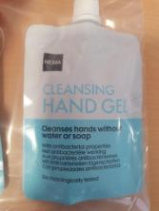
A12/01601/20 | France | Hand Sanitizer | Chemical Products | Burn Hazard, Health Risk Hazard / Other Hazard | 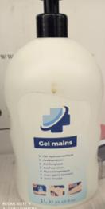
A12/01604/20 | France | Hand Sanitizer | Chemical Products | Fire Hazard, Health Risk Hazard / Other Hazard | 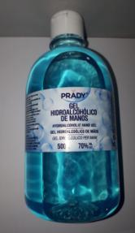
A12/01606/20 | France | Hand Sanitizer | Chemical Products | Fire Hazard, Health Risk Hazard / Other Hazard | 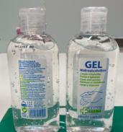
A12/01608/20 | France | Hand Sanitizer | Chemical Products | Chemical Hazard, Fire Hazard, Health Risk Hazard / Other Hazard | 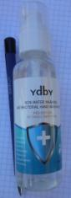
A12/01626/20 | Slovakia | Lighting Strings | Lighting Equipment | Electric Shock Hazard | 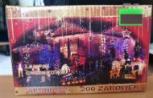
A12/01627/20 | Slovakia | Lighting Strings | Lighting Equipment | Electric Shock Hazard | 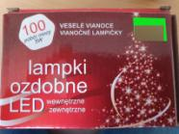
A12/01574/20 | Hungary | Desk Lamp | Lighting Equipment | Burn Hazard, Electric Shock Hazard | 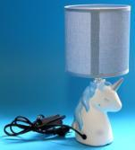
A12/01576/20 | Slovakia | Key-ring | General Use Products | Choking Hazard | 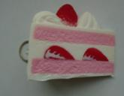
A12/01629/20 | Slovakia | Reflective Vest | Personal Protective Equipment | Injury Hazard | 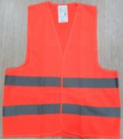
A12/01619/20 | Italy | Pacifier | Toys and Childcare Articles | Choking Hazard, Cut Hazard | 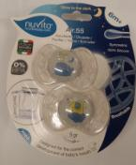
A12/01578/20 | Cyprus | Plastic Doll Set | Toys and Childcare Articles | Chemical Hazard | 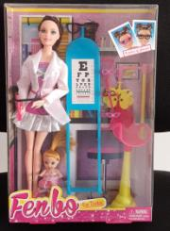
A12/01579/20 | Cyprus | Doll with Accessories | Toys and Childcare Articles | Chemical Hazard | 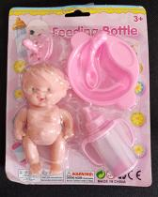
A12/01582/20 | Poland | Plastic Toy | Toys and Childcare Articles | Chemical Hazard | 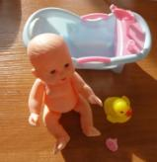
A12/01612/20 | United Kingdom | Plush Toy | Toys and Childcare Articles | Choking Hazard | 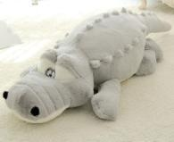
A12/01638/20 | The Netherlands | Wooden Toy | Toys and Childcare Articles | Suffocation Hazard | 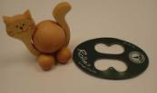
A12/01640/20 | The Netherlands | Wooden Toy | Toys and Childcare Articles | Choking Hazard | 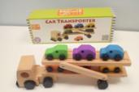
A12/01642/20 | The Netherlands | Wooden Toy | Toys and Childcare Articles | Choking Hazard, Strangulation Hazard, Suffocation Hazard | 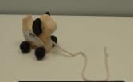
A12/01643/20 | The Netherlands | Wooden Toy | Toys and Childcare Articles | Strangulation Hazard | 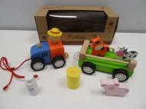
A12/01646/20 | The Netherlands | Wooden Toy | Toys and Childcare Articles | Suffocation Hazard | 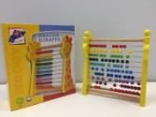
A12/01649/20 | The Netherlands | Wooden Toy | Toys and Childcare Articles | Choking Hazard | 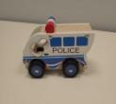
A12/01650/20 | The Netherlands | Wooden Toy | Toys and Childcare Articles | Choking Hazard | 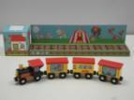
A12/01651/20 | The Netherlands | Wooden Toy | Toys and Childcare Articles | Choking Hazard | 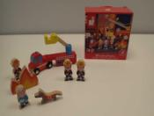
A12/01652/20 | The Netherlands | Wooden Toy | Toys and Childcare Articles | Choking Hazard | 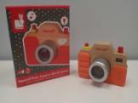
A12/01653/20 | The Netherlands | Wooden Toy | Toys and Childcare Articles | Choking Hazard | 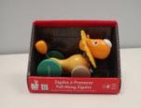
A12/01655/20 | The Netherlands | Wooden Toy | Toys and Childcare Articles | Choking Hazard | 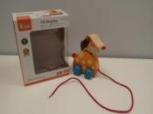
A12/01656/20 | The Netherlands | Wooden Toy | Toys and Childcare Articles | Choking Hazard | 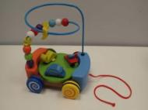
A12/01657/20 | The Netherlands | Wooden Toy | Toys and Childcare Articles | Choking Hazard | 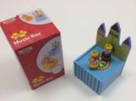
A12/01658/20 | The Netherlands | Wooden Toy | Toys and Childcare Articles | Choking Hazard | 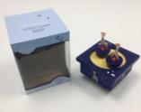
A12/01577/20 | Cyprus | Children's Sweatshirt | Clothing, Textiles and Fashion Items | Strangulation Hazard | 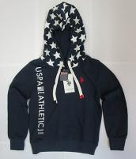
A12/01585/20 | Cyprus | Children’s Hooded Sweatshirt | Clothing, Textiles and Fashion Items | Strangulation Hazard | 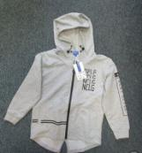
A12/01592/20 | Cyprus | Children's Hooded Jacket | Clothing, Textiles and Fashion Items | Strangulation Hazard | 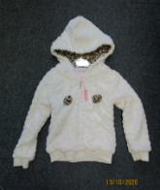
A12/01603/20 | Cyprus | Children's Clothing | Clothing, Textiles and Fashion Items | Injury Hazard, Strangulation Hazard | 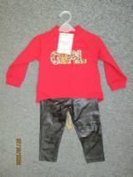
A12/01605/20 | Cyprus | Children's Hooded Jacket | Clothing, Textiles and Fashion Items | Injury Hazard, Strangulation Hazard | 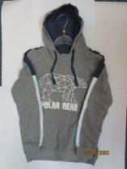
A12/01617/20 | Cyprus | Children's Vest | Clothing, Textiles and Fashion Items | Strangulation Hazard | 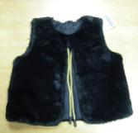
A12/01586/20 | Germany | Skin-lightening Product | Cosmetics | Chemical Hazard | 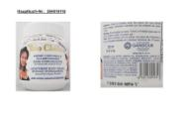
A12/01587/20 | Germany | Skin-lightening Product | Cosmetics | Chemical Hazard | 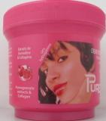
A12/01588/20 | Germany | Skin-lightening Product | Cosmetics | Chemical Hazard | 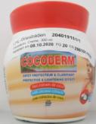
A12/01615/20 | Germany | Skin-lightening Product | Cosmetics | Chemical Hazard | 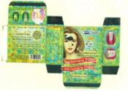
A12/01620/20 | United Kingdom | UV Sterilizer | Electrical Appliances and Equipment | Burn Hazard, Damage to Sight Hazard | 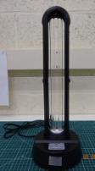
A12/01621/20 | United Kingdom | Portable UV Lamp | Electrical Appliances and Equipment | Burn Hazard, Damage to Sight Hazard, Health Risk Hazard / Other Hazard
A12/01622/20 | United Kingdom | UV Sterilizer | Electrical Appliances and Equipment | Burn Hazard, Damage to Sight Hazard | 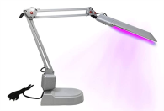
A12/01624/20 | United Kingdom | UV Sterilizer | Electrical Appliances and Equipment | Health Risk Hazard / Other Hazard | 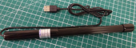
A12/01625/20 | United Kingdom | UV Sterilizer | Electrical Appliances and Equipment | Burn Hazard, Damage to Sight Hazard | 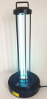
A12/01630/20 | United Kingdom | UV Sterilizer | Electrical Appliances and Equipment | Health Risk Hazard / Other Hazard | 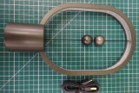
A12/01631/20 | United Kingdom | Portable UV Lamp | Electrical Appliances and Equipment | Health risk / other Hazard | 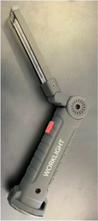
A12/01633/20 | Poland | Wireless Charger | Electrical Appliances and Equipment | Electric Shock Hazard, Fire Hazard | 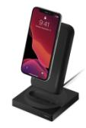
A12/01644/20 | France | Electrical Adaptor | Electrical Appliances and Equipment | Electric Shock Hazard | 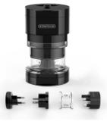
A12/01645/20 | France | Electrical Adaptor | Electrical Appliances and Equipment | Electric Shock Hazard | 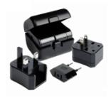
A12/01647/20 | United Kingdom | UV Sterilization Lamp | Electrical Appliances and Equipment | Burn Hazard, Damage to Sight Hazard | 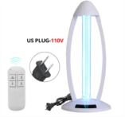
A12/01648/20 | United Kingdom | UV Sterilizer | Electrical Appliances and Equipment | Burn Hazard, Damage to Sight Hazard | 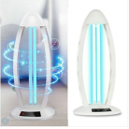
A11/00101/20 | Poland | Mountain Climbing Harness | Sports Equipment | Injury Hazard | 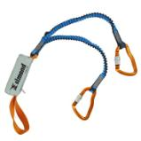
A11/00104/20 | France | Hand Sanitizer Gel | Chemical Products | Burn Hazard | 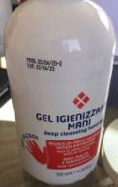
A11/00105/20 | United Kingdom | Portable UV Lamp | Electrical Appliances and Equipment | Burn Hazard, Damage to Sight Hazard, Health Risk Hazard / Other Hazard | 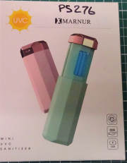
INFO/00160/20 | Romania | Particle Filtration Mask | Personal Protective Equipment | Health Risk Hazard / Other Hazard | 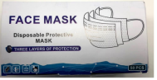
INFO/00161/20 | Romania | Particle Filtration Mask | Personal Protective Equipment | Health Risk Hazard / Other Hazard | 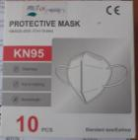
INFO/00162/20 | Romania | Particle Filtration Mask | Personal Protective Equipment | Health Risk Hazard / Other Hazard | 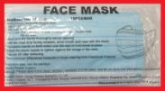
INFO/00163/20 | Romania | Particle Filtration Mask | Personal Protective Equipment | Health Risk Hazard / Other Hazard | 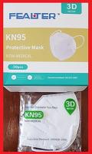
INFO/00164/20 | Romania | Particle Filtration Mask | Personal Protective Equipment | Health Risk Hazard / Other Hazard | 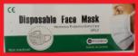
INFO/00165/20 | Romania | Particle Filtration Mask | Personal Protective Equipment | Health Risk Hazard / Other Hazard | 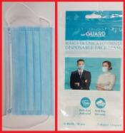
INFO/00166/20 | Romania | Particle Filtration Mask | Personal Protective Equipment | Health Risk Hazard / Other Hazard | 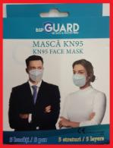
INFO/00158/20 | United Kingdom | UV Light Bulb | Electrical Appliances and Equipment | Health Risk Hazard / Other Hazard | 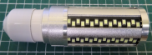
A12/01730/20 | Germany | Particle Filtration Mask | Personal Protective Equipment | Health Risk Hazard / Other Hazard | 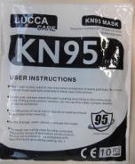
A12/01685/20 | The Netherlands | Baby Soother Holder | Toys and Childcare Articles | Choking Hazard, Entrapment Hazard, Strangulation Hazard | 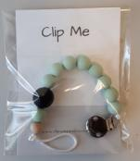
A12/01661/20 | The Netherlands | Wooden Toy | Toys and Childcare Articles | Choking Hazard | 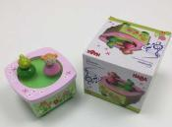
A12/01663/20 | The Netherlands | Wooden Toy | Toys and Childcare Articles | Choking Hazard | 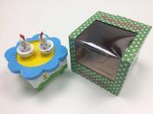
A12/01665/20 | United Kingdom | Baby Doll | Toys and Childcare Articles | Chemical Hazard, Choking Hazard | 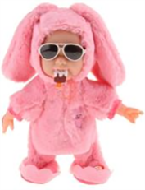
A12/01668/20 | United Kingdom | Magnet Toy | Toys and Childcare Articles | Choking Hazard, Injury Hazard | 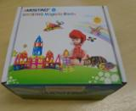
A12/01669/20 | The Netherlands | Wooden Toy | Toys and Childcare Articles | Choking Hazard | 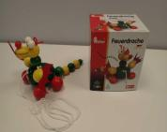
A12/01671/20 | The Netherlands | Wooden Toy | Toys and Childcare Articles | Choking Hazard, Injury Hazard | 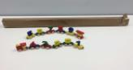
A12/01672/20 | The Netherlands | Wooden Toy | Toys and Childcare Articles | Choking Hazard | 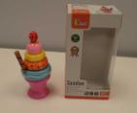
A12/01673/20 | The Netherlands | Pull Along Toy | Toys and Childcare Articles | Choking Hazard | 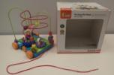
A12/01674/20 | The Netherlands | Wooden Toy | Toys and Childcare Articles | Choking Hazard | 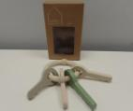
A12/01675/20 | The Netherlands | Wooden Toy | Toys and Childcare Articles | Strangulation Hazard | 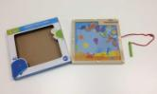
A12/01676/20 | The Netherlands | Wooden Toy | Toys and Childcare Articles | Choking Hazard | 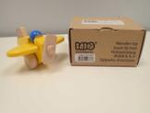
A12/01678/20 | The Netherlands | Wooden Toy | Toys and Childcare Articles | Choking Hazard | 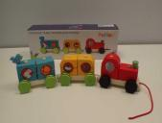
A12/01681/20 | The Netherlands | Wooden Toy | Toys and Childcare Articles | Choking Hazard | 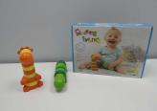
A12/01694/20 | United Kingdom | Wooden Toy | Toys and Childcare Articles | Strangulation Hazard | 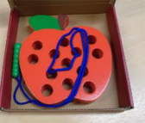
A12/01695/20 | United Kingdom | Baby Doll | Toys and Childcare Articles | Chemical Hazard | 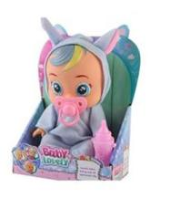
A12/01696/20 | United Kingdom | Bath Toy | Toys and Childcare Articles | Choking Hazard | 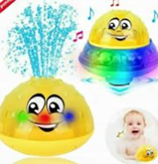
A12/01697/20 | United Kingdom | Maracas | Toys and Childcare Articles | Choking Hazard | 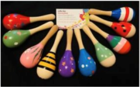
A12/01699/20 | United Kingdom | Teething Ring | Toys and Childcare Articles | Choking Hazard | 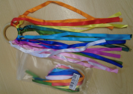
A12/01701/20 | United Kingdom | Baby Doll | Toys and Childcare Articles | Chemical Hazard | 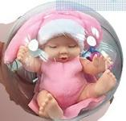
A12/01731/20 | Belgium | Set of Cardboard Books | Toys and Childcare Articles | Choking Hazard | 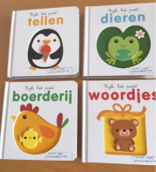
A12/01732/20 | The Netherlands | Soap Bubbles Toy | Toys and Childcare Articles | Microbiological Hazard | 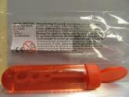
A12/01659/20 | Belgium | Children's Hooded Sweater | Clothing, Textiles and Fashion Items | Injury Hazard | 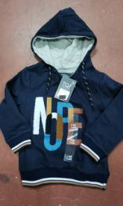
A12/01660/20 | Belgium | Children's Leggings | Clothing, Textiles and Fashion Items | Injury Hazard | 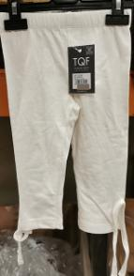
A12/01687/20 | Belgium | Swimming Trunks | Clothing, Textiles and Fashion Items | Injury Hazard | 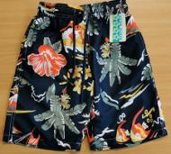
A12/01688/20 | Belgium | Children's Waterproof Hooded Jacket | Clothing, Textiles and Fashion Items | Injury Hazard | 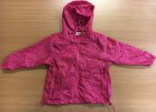
A12/01689/20 | Belgium | Swimming Trunks | Clothing, Textiles and Fashion Items | Injury Hazard | 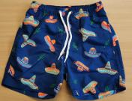
A12/01690/20 | Belgium | Child's Swimsuit | Clothing, Textiles and Fashion Items | Injury Hazard | 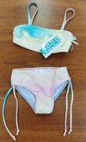
A12/01691/20 | Belgium | Swimming Trunks | Clothing, Textiles and Fashion Items | Injury Hazard | 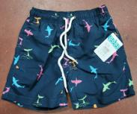
A12/01692/20 | Belgium | Children's Hooded Sweatshirt | Clothing, Textiles and Fashion Items | Strangulation Hazard | 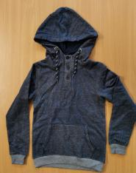
A12/01693/20 | Belgium | Children’s Jacket | Clothing, Textiles and Fashion Items | Strangulation Hazard | 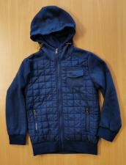
A12/01715/20 | Belgium | Children's dress | Clothing, Textiles and Fashion Items | Entrapment Hazard | 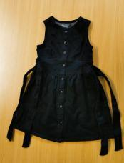
A12/01716/20 | Belgium | Children's Swimsuit | Clothing, Textiles and Fashion Items | Injury Hazard, Strangulation Hazard | 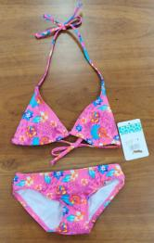
A12/01717/20 | Belgium | Children's Swimsuit | Clothing, Textiles and Fashion Items | Injury Hazard, Strangulation Hazard | 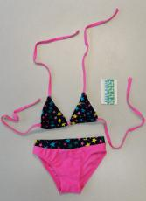
A12/01718/20 | Belgium | Children's Sweater | Clothing, Textiles and Fashion Items | Strangulation Hazard | 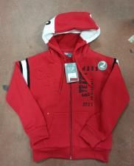
A12/01719/20 | Belgium | Orange Waterproof Jacket | Clothing, Textiles and Fashion Items | Strangulation Hazard | 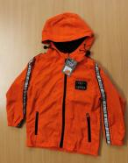
A12/01720/20 | Belgium | Children's Swimming Trunks | Clothing, Textiles and Fashion Items | Injury Hazard | 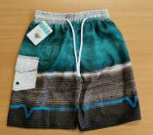
A12/01721/20 | Belgium | Children's Swimming Trunks | Clothing, Textiles and Fashion Items | Injury Hazard | 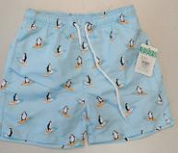
A12/01722/20 | Belgium | Children's Dress | Clothing, Textiles and Fashion Items | Strangulation Hazard | 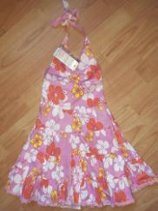
A12/01723/20 | Belgium | Children's Tracksuit | Clothing, Textiles and Fashion Items | Strangulation Hazard | 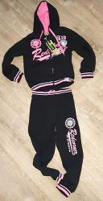
A12/01686/20 | France | Travel Adaptor | Electrical Appliances and equipment | Electric Shock Hazard | 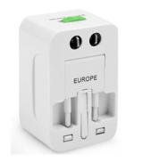
A12/01705/20 | France | USB Adaptor | Electrical Appliances and Equipment | Electric Shock Hazard | 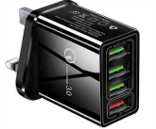
A12/01708/20 | United Kingdom | Hair Trimmer | Electrical Appliances and Equipment | Electric Shock Hazard, Fire Hazard | 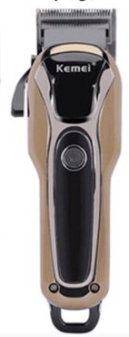
A12/01710/20 | France | Electrical Adaptor | Electrical Appliances and Equipment | Electric Shock Hazard | 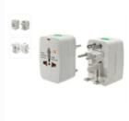
A11/00106/20 | France | Pressure Cooker | Kitchen/Cooking accessories | Burn Hazard, Injury Hazard | 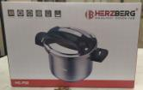
A11/00110/20 | Lithuania | Children's Jacket | Clothing, Textiles and Fashion Items | Injury Hazard, Strangulation Hazard | 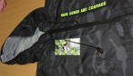
INFO/00168/20 | Iceland | Particle Filtration Mask | Personal Protective Equipment | Health Risk Hazard / Other Hazard | 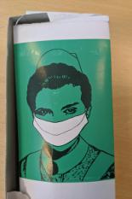
INFO/00169/20 | Romania | Particle Filtration Mask | Personal Protective Equipment | Health Risk Hazard / Other Hazard | 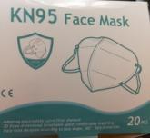
INFO/00170/20 | Romania | Particle Filtration Mask | Personal Protective Equipment | Health Risk Hazard / Other Hazard | 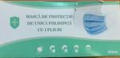
INFO/00171/20 | Romania | Particle Filtration Mask | Personal Protective Equipment | Health Risk Hazard / Other Hazard | 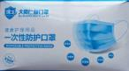
INFO/00172/20 | Romania | Particle Filtration Mask | Personal Protective Equipment | Health Risk Hazard / Other Hazard | 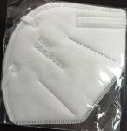
INFO/00174/20 | Romania | Particle Filtration Mask | Personal Protective Equipment | Health Risk Hazard / Other Hazard | 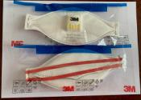
A12/01757/20 | Sweden | Earrings | Jewellery | Chemical Hazard | 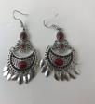
A12/01740/20 | The Netherlands | Safety Gate | Children’s Product | Injury Hazard | 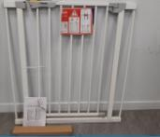
A12/01735/20 | The Netherlands | Rattle Toy | Toys and Childcare Articles | Choking Hazard, Suffocation Hazard | 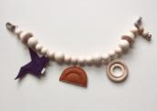
A12/01737/20 | The Netherlands | Teething Toy | Toys and Childcare Articles | Choking Hazard
A12/01738/20 | The Netherlands | Wooden Doll House | Toys and Childcare Articles | Choking Hazard | 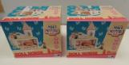
A12/01739/20 | Hungary | Whistle Toy | Toys and Childcare Articles | Choking Hazard | 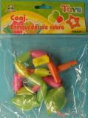
A12/01742/20 | The Netherlands | Plush Toy with Soother Holder | Toys and Childcare Articles | Strangulation Hazard | 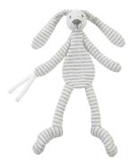
A12/01746/20 | Hungary | Slingshot Rocket | Toys and Childcare Articles | Injury Hazard | 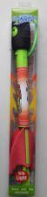
A12/01747/20 | The Netherlands | Soft-filled Toy | Toys and Childcare Articles | Choking Hazard | 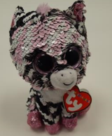
A12/01748/20 | The Netherlands | Soft-filled Toy | Toys and Childcare Articles | Choking Hazard | 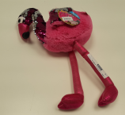
A12/01749/20 | The Netherlands | Soft-filled Toy | Toys and Childcare Articles | Choking Hazard | 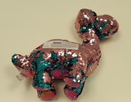
A12/01750/20 | The Netherlands | Soft-filled Toys | Toys and Childcare Articles | Choking Hazard | 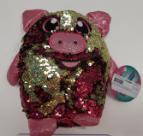
A12/01751/20 | The Netherlands | Soft-filled Toy | Toys and Childcare Articles | Choking Hazard | 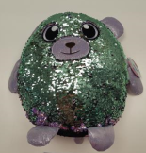
A12/01753/20 | Lithuania | Plastic Doll with Accessories | Toys and Childcare Articles | Chemical Hazard | 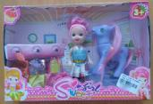
A12/01754/20 | Cyprus | Plastic Doll | Toys and Childcare Articles | Chemical Hazard | 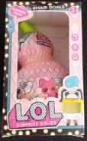
A12/01760/20 | The Netherlands | Soft-filled Toy | Toys and Childcare Articles | Choking Hazard | 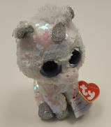
A12/01761/20 | The Netherlands | Soft-filled Toy | Toys and Childcare Articles | Choking Hazard | 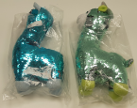
A12/01762/20 | The Netherlands | Wooden Toy | Toys and Childcare Articles | Choking Hazard | 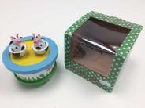
A12/01767/20 | United Kingdom | Plastic Doll | Toys and Childcare Articles | Chemical Hazard | 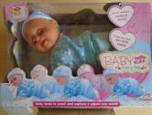
A12/01764/20 | Cyprus | Children's Clothing Set | Clothing, Textiles and Fashion Items | Injury Hazard, Strangulation Hazard | 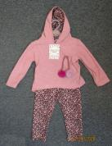
A12/01765/20 | Cyprus | Children's Clothing Set | Clothing, Textiles and Fashion Items | Injury Hazard, Strangulation Hazard | 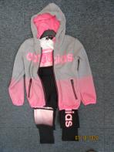
A12/01766/20 | Cyprus | Wet Wipes | Cosmetics | Chemical Hazard | 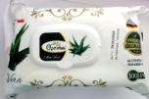
A11/00115/20 | The Netherlands | Safety Gate | Children's Products | Suffocation Hazard | 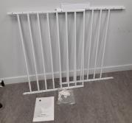
A11/00113/20 | The Netherlands | Soft-filled Toy | Toys and Childcare Articles | Choking Hazard | 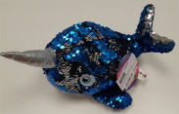
A11/00112/20 | Belgium | Children's Shorts | Clothing, Textiles and Fashion Items | Injury Hazard | 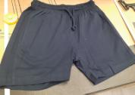
A12/01734/20 | The Netherlands | Soother Holder | Toys and Childcare Articles | Choking Hazard, Strangulation Hazard | 