Recall Cases Summary – Canada (Last Update Date: 31 January 2022)
‘
Date | Product | Categories | Hazard | Image
6-Jan-2022 | Equate Dry Mouth Oral Rinse | Bodycare / Cosmetics | Microbiological Hazard | 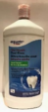
6-Jan-2022 | Tahini Sesame Seed Paste | Food | Microbiological Hazard | /
7-Jan-2022 | DEWALT ® Jobsite Pro Wireless Earphone | Computer / Audio / Video / Other Electronics & Accessories | Burn Hazard, Fire Hazard | 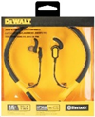
7-Jan-2022 | Certain Salad Products | Food | Microbiological Hazard | 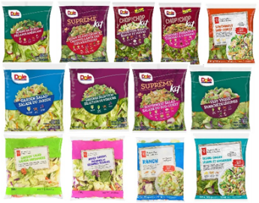
7-Jan-2022 | Pulled Chicken & Rice Burritos | Food | Microbiological Hazard | /
10-Jan-2022 | "La" Stimpson's Surf Clams | Food | Microbiological Hazard | 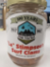  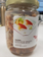
10-Jan-2022 | Tahineh – Ground Sesame 100% | Food | Microbiological Hazard | 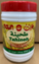
11-Jan-2022 | Tahineh – Ground Sesame 100% | Food | Microbiological Hazard
11-Jan-2022 | King Ranch Casserole | Food | Microbiological Hazard | /
12-Jan-2022 | Qualipièces Brand Rollerski® | Car Components | Injury Hazard | 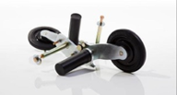
13-Jan-2022 | All Food Products Distributed By Bistak Enterprises Inc. and Bistak Groceries Inc. , 325 20th St West, Saskatoon, SK. | Food | Microbiological Hazard | /
17-Jan-2022 | Tiger Nut | Food | Microbiological Hazard | /
18-Jan-2022 | Halva with Black Seed | Food | Microbiological Hazard | 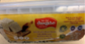  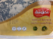
19-Jan-2022 | KidORCA Hard Shell Rain Jacket | Fabric / Textile / Garment / Home Textile | Entanglement Hazard | 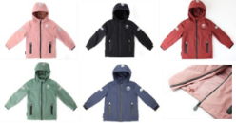
19-Jan-2022 | Kattnakken Junior Rain Jacket | Fabric / Textile / Garment / Home Textile | Strangulation Hazard | 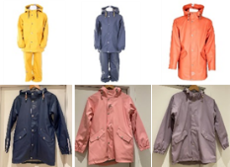
20-Jan-2022 | FRIGG Classic and Daisy Silicone Pacifier | Toys and Childcare Products | Choking Hazard | 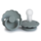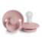
21-Jan-2022 | Dyna-One Energy Absorber Lanyard | Tools and Hardware | Injury Hazard | 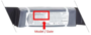  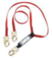
21-Jan-2022 | Immunity Super Functional Smoothie | Food | Poisoning Hazard | 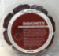
22-Jan-2022 | Unsweetened Oat M*lk Barista Friendly | Food | Risk of Allergy
22-Jan-2022 | Baked Red Bean Cake | Food | Risk of Allergy
22-Jan-2022 | Sauerkraut Fish (Szechuan Style) Spicy | Food | Risk of Allergy | 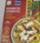
24-Jan-2022 | Carrément Beau Raincoat | Fabric / Textile / Garment / Home Textile | Entanglement Hazard | 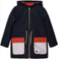
24-Jan-2022 | Certain Sandwiches | Food | Microbiological Hazard | 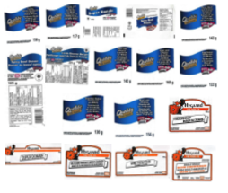
27-Jan-2022 | Hoppetta 2-Way Gauze Sleep Bag | Fabric / Textile / Garment / Home Textile | Burn Hazard | 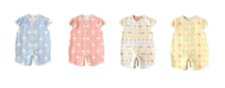
28-Jan-2022 | Matrix T1xe (TM522), Matrix T3x (TM509), and T3x (TM523) Treadmill | Sporting Goods / Equipment | Fire Hazard | 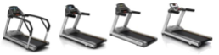
28-Jan-2022 | Original Kimchi | Food | Microbiological Hazard | 