召回案件总结 - 澳大利亚（最后更新日期：2021年1月13日）
Date | Product | Categories | Hazard | Photo
3-Aug-2020 | Children’s Nightwear | Fabric / Textile / Garment / Home Textile | Burn Hazard | 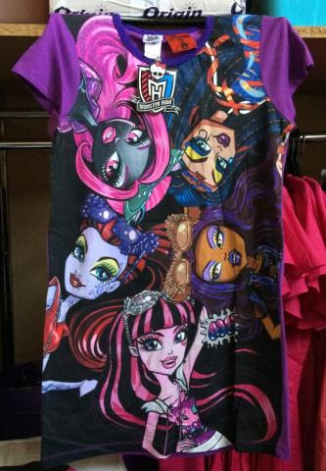
3-Aug-2020 | Memory Foam Pillow | Furniture | Choking Hazard and Suffocation Hazard | 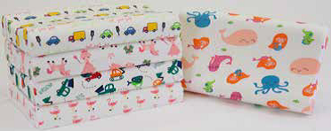
6-Aug-2020 | Teether | Toys and Childcare Articles | Choking Hazard and Suffocation Hazard | 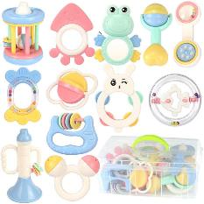
9-Aug-2020 | Leggings | Fabric / Textile / Garment / Home Textile | Choking Hazard and Suffocation Hazard | 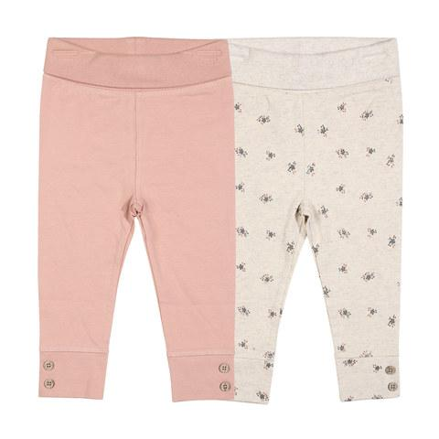
11-Aug-2020 | Air Conditioner System | Home Electrical Appliances (Hair Dryer, Iron, etc.) | Health Risk Hazard | 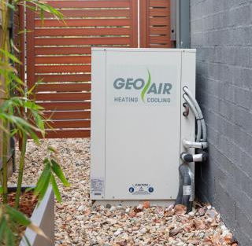
11-Aug-2020 | Darts Game | Toys and Childcare Articles | Injury Hazard | 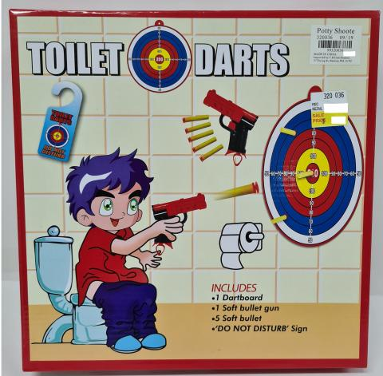
11-Aug-2020 | 4-Point Harness | Sporting Goods/ Equipment | Injury Hazard | 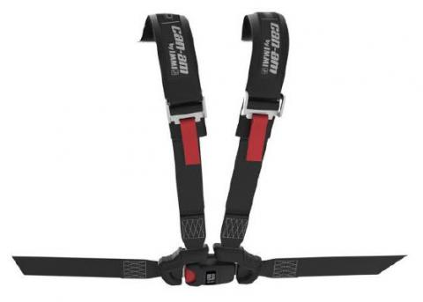
16-Aug-2020 | Bicycles | Sporting Goods/ Equipment | Injury Hazard | 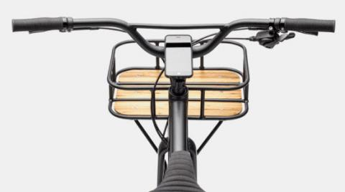
16-Aug-2020 | Wooden Barbell Rattle | Toys and Childcare Articles | Choking Hazard and Suffocation Hazard | 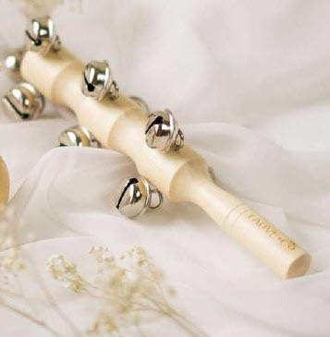
16-Aug-2020 | Blind Controller | Home Electrical Appliances (Hair Dryer, Iron, etc.) | Burn Hazard | 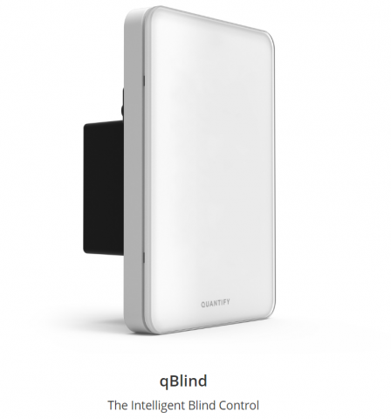
17-Aug-2020 | Gumboot | Footwear | Injury Hazard | 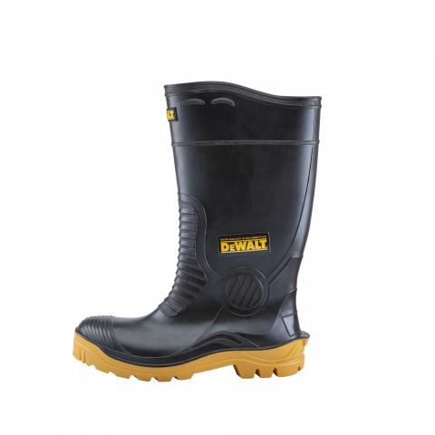
17-Aug-2020 | Rubbish Bin with Lid | Furniture | Choking Hazard and Suffocation Hazard | 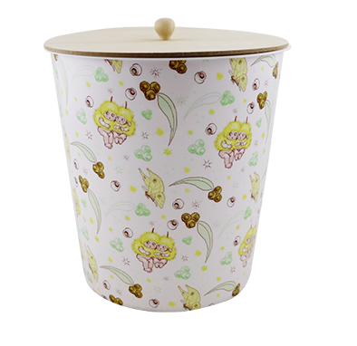
18-Aug-2020 | Battery Energy Storage Device | Computer / Audio / Video / Other Electronics & Accessories | Fire Hazard | 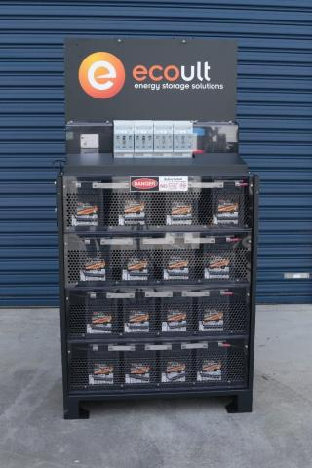
25-Aug-2020 | Multi-Port Charger | Computer / Audio / Video / Other Electronics & Accessories | Electric shock Hazard | 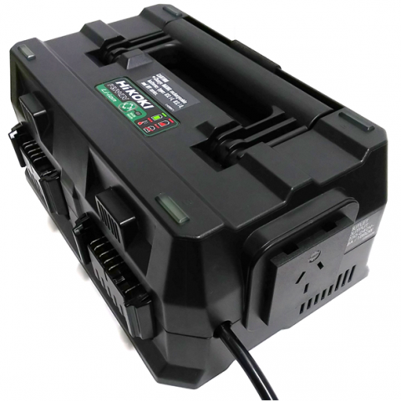
31-Aug-2020 | Spoon | Food Contact Material | Health Risk Hazard | 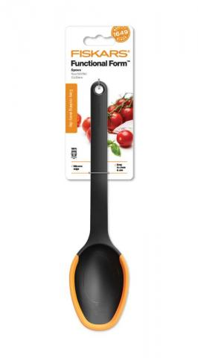
3-Sep-2020 | Hot Water Bottle (used for sore muscles or injury) | Other | Burn Hazard | 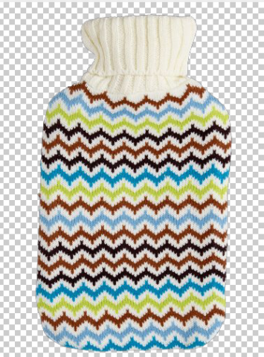
3-Sep-2020 | Bunk Beds | Furniture | Fall Hazard | 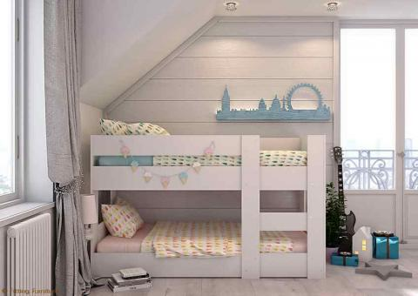
9-Sep-2020 | Magnetic Toys | Toys and Childcare Articles | Injury Hazard and  Choking Hazard | 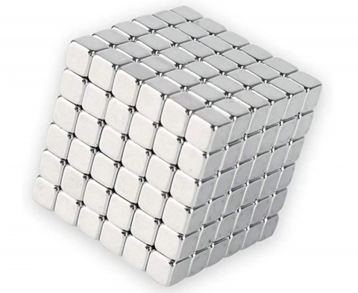
9-Sep-2020 | Children's Bicycles | Sporting Goods/ Equipment | Injury Hazard | 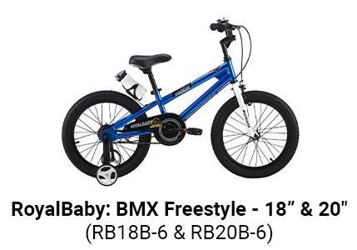
13-Sep-2020 | Power Diverter | Home Electrical Appliances (Hair Dryer, Iron, etc.) | Injury Hazard | 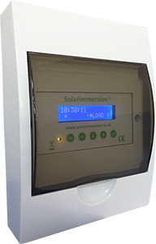
17-Sep-2020 | Cassette Fitted to Bicycles | Sporting Goods/ Equipment | Injury Hazard | 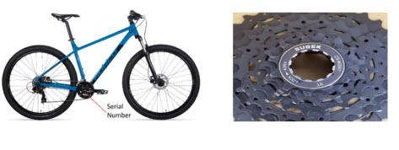
17-Sep-2020 | Fishing Series Toy | Toys and Childcare Articles | Choking Hazard and Suffocation Hazard | 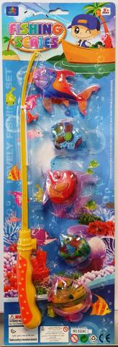
17-Sep-2020 | Hair Balm | Cosmetics | Health Risk Hazard | 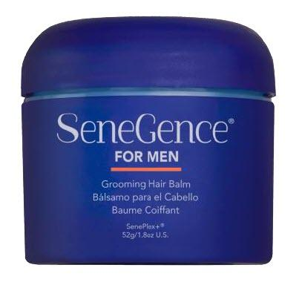
17-Sep-2020 | Wooden Block Sets | Toys and Childcare Articles | Choking Hazard and Suffocation Hazard | 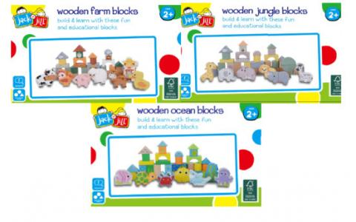
20-Sep-2020 | Hammer Drill Kit | Home Electrical Appliances (Hair Dryer, Iron, etc.) | Injury Hazard | 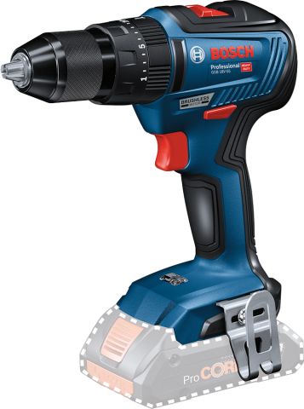
23-Sep-2020 | Flash Receiver | Home Electrical Appliances (Hair Dryer, Iron, etc.) | Injury Hazard | 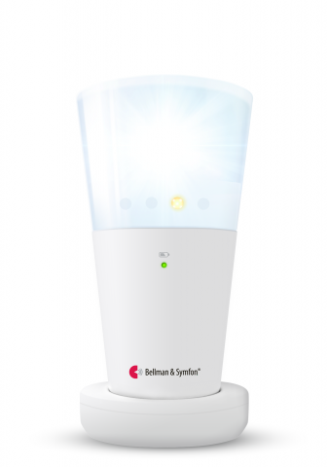
23-Sep-2020 | USB Charger Adapter | Computer / Audio / Video / Other Electronics & Accessories | Electric Shock Hazard | 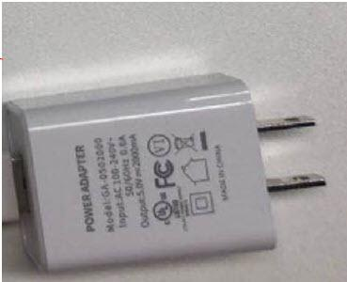
23-Sep-2020 | Insulin Pump | Home Electrical Appliances (Hair Dryer, Iron, etc.) | Health Risk Hazard | 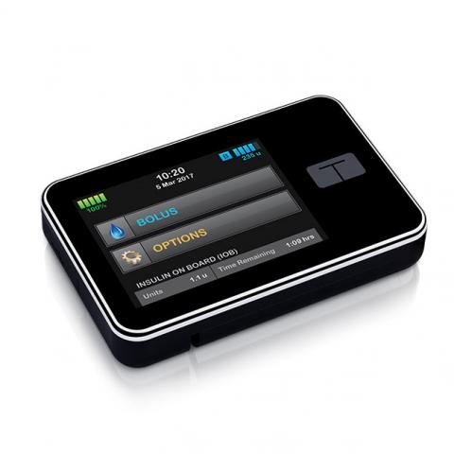
23-Sep-2020 | Mobile Chair | Furniture | Injury Hazard | 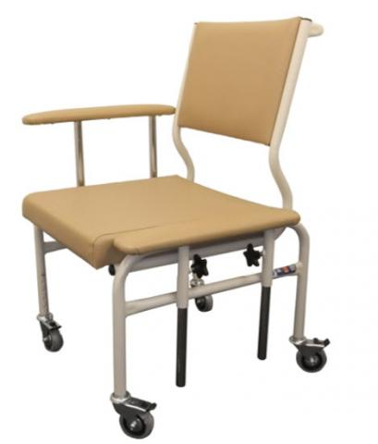
27-Sep-2020 | Cleansing Wipes | Personal Protective Equipment | Health Risk Hazard | 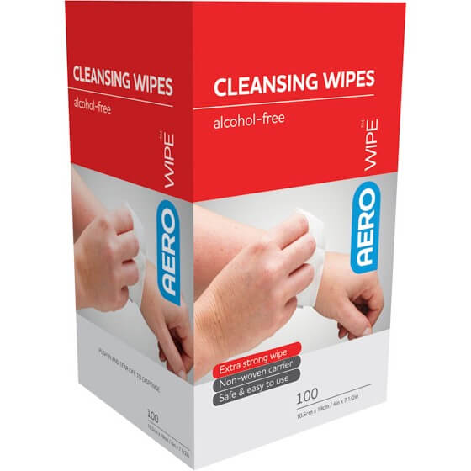
29-Sep-2020 | Projection Pens | Computer / Audio / Video / Other Electronics & Accessories | Burn Hazard and Choking Hazard | 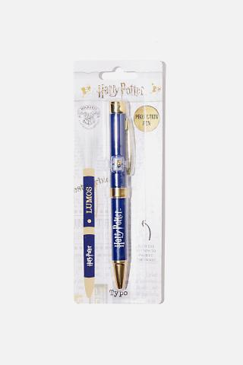
29-Sep-2020 | Reusable Coffee Cup | Food Contact Material | Burn Hazard | 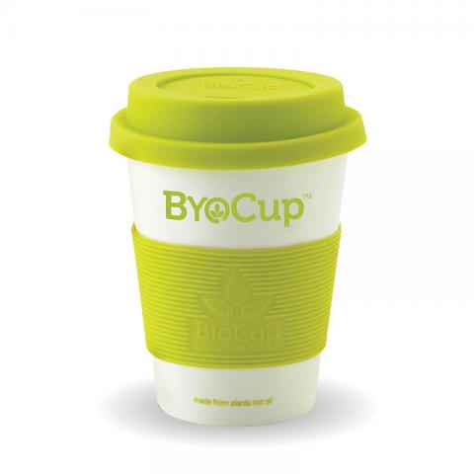
1-Oct-2020 | Electric Bike | Sporting Goods/ Equipment | Fire Hazard | 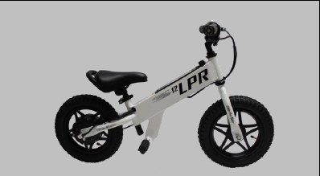
1-Oct-2020 | Magnetic Balls | Toys and Childcare Articles | Injury Hazard and Choking Hazard | 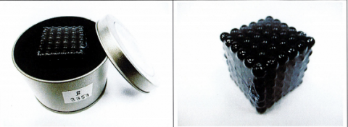
1-Oct-2020 | Silicone Flashing Ring | Toys and Childcare Articles | Burn Hazard and Choking Hazard | 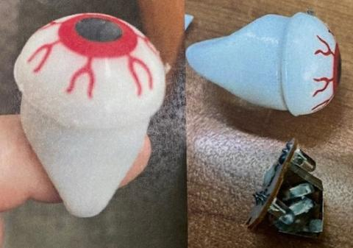
4-Oct-2020 | Hearing Aid Disinfector | Home Electrical Appliances (Hair Dryer, Iron, etc.) | Injury Hazard | 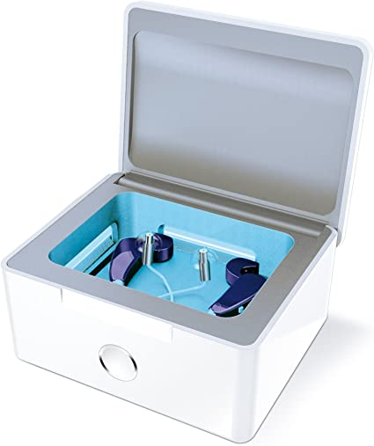
4-Oct-2020 | Hand Cleaner | Personal Protective Equipment | Health Risk Hazard | 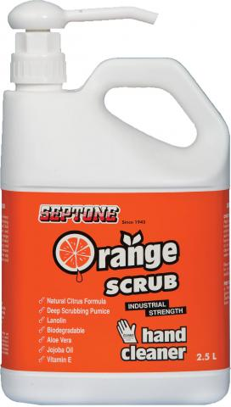
6-Oct-2020 | Sleepwear | Fabric / Textile / Garment / Home Textile | Fire Hazard | 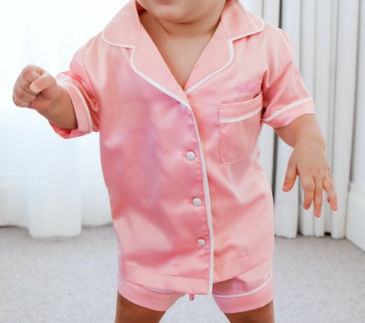
15-Oct-2020 | Pump | Home Electrical Appliances (Hair Dryer, Iron, etc.) | Electric shock Hazard | 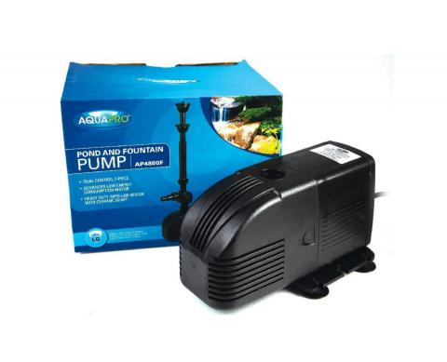
18-Oct-2020 | Hydroframe with Manuka Honey | Personal Protective Equipment | Health Risk Hazard | 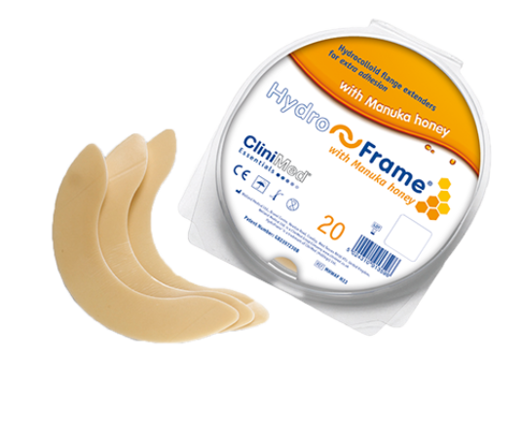
18-Oct-2020 | Sleep Mattress | Furniture | Injury Hazard | 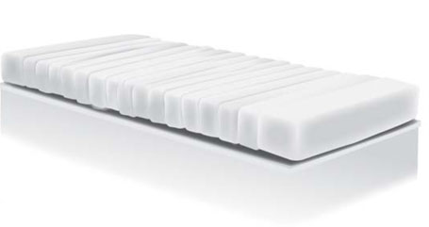
22-Oct-2020 | Stroller | Toys and Childcare Articles | Injury Hazard | 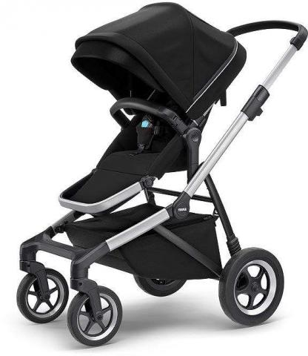
25-Oct-2020 | Hydrate Moisturiser | Cosmetics | Health Risk Hazard | 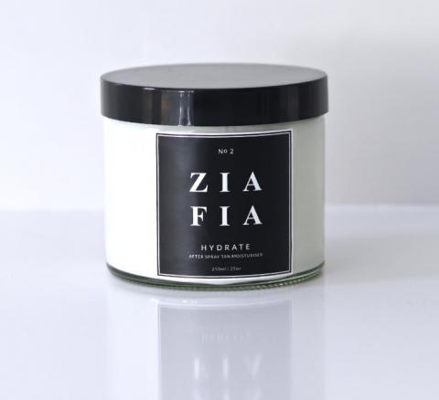
26-Oct-2020 | Dummy Chains | Toys and Childcare Articles | Choking Hazard and Suffocation Hazard | 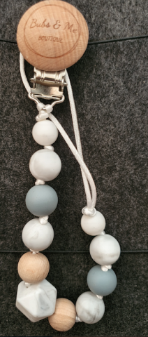
27-Oct-2020 | LED Wristband | Computer / Audio / Video / Other Electronics & Accessories | Burn Hazard and Choking Hazard | 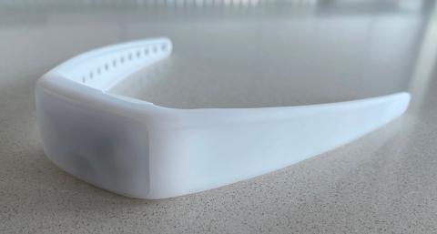
28-Oct-2020 | Cutlery | Toys and Childcare Articles | Choking Hazard | 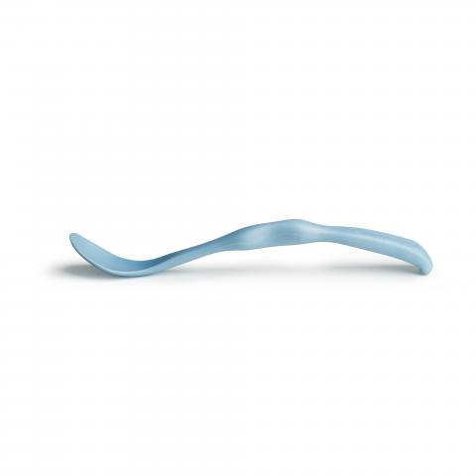
28-Oct-2020 | Massage Gun | Home Electrical Appliances (Hair Dryer, Iron, etc.) | Burn Hazard and Fire Hazard | 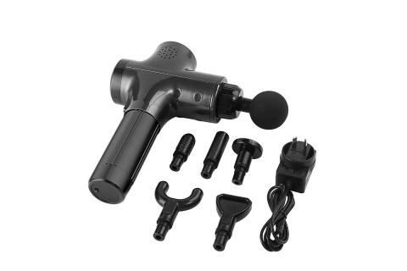
29-Oct-2020 | Bench Press | Sporting Goods/ Equipment | Injury Hazard | 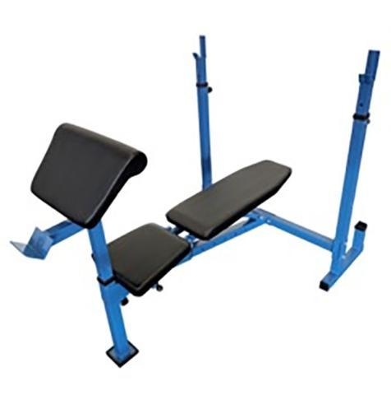
29-Oct-2020 | Infant Rompers | Fabric / Textile / Garment / Home Textile | Fire Hazard | 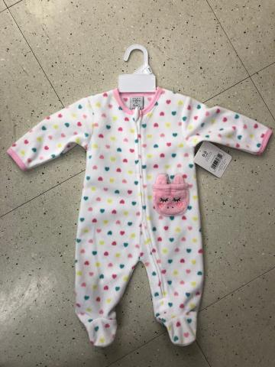
30-Oct-2020 | Romper | Fabric / Textile / Garment / Home Textile | Choking Hazard and Suffocation Hazard | 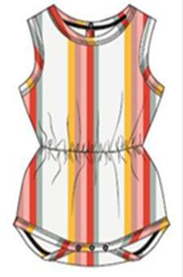
3-Nov-2020 | Soap, Lip Balm, Bath Bombs | Cosmetics | Health Risk Hazard | 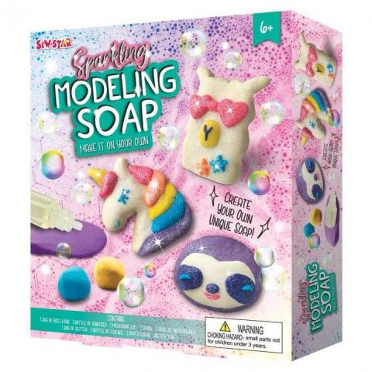
5-Nov-2020 | Wireless Ear Buds | Computer / Audio / Video / Other Electronics & Accessories | Fire Hazard | 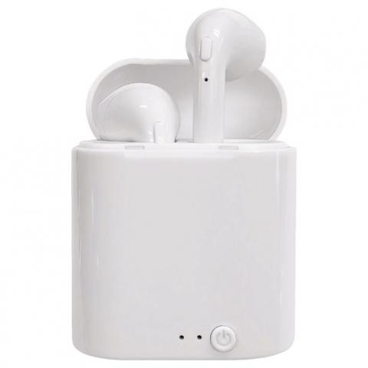
9-Nov-2020 | Childcare Pod High Chair | Toys and Childcare Articles | Injury Hazard | 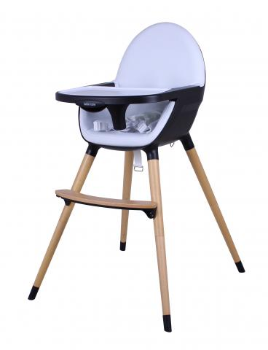
9-Nov-2020 | Sol Cot | Furniture | Entrapment Hazard | 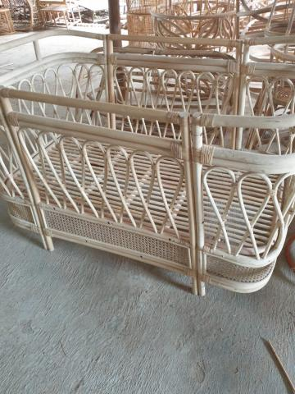
10-Nov-2020 | Mini Fireplace | Furniture | Burn Hazard and Fire Hazard | 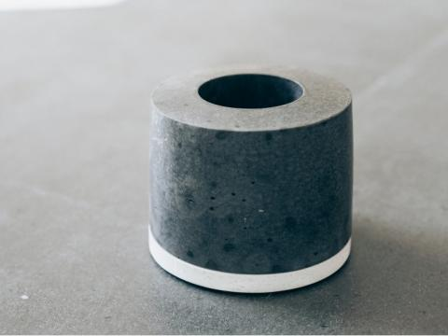
10-Nov-2020 | Power Bank | Computer / Audio / Video / Other Electronics & Accessories | Fire Hazard and Burn Hazard | 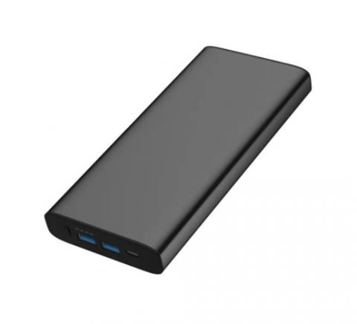
11-Nov-2020 | Animal Bath Sets | Toys and Childcare Articles | Choking Hazard and Suffocation Hazard | 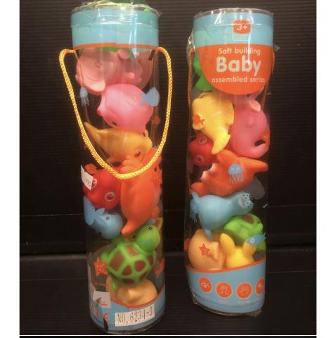
11-Nov-2020 | Video Doorbell | Home Electrical Appliances (Hair Dryer, Iron, etc.) | Fire Hazard | 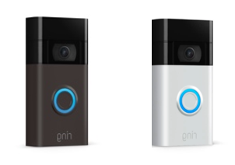
12-Nov-2020 | Socket Outlets | Computer / Audio / Video / Other Electronics & Accessories | Electric shock Hazard | 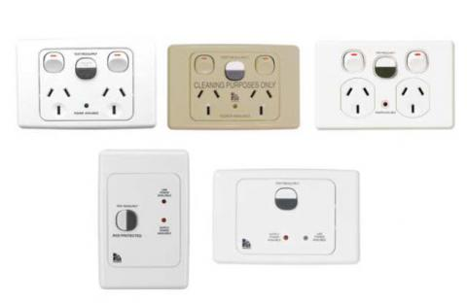
17-Nov-2020 | Cosmetic Products | Cosmetics | Health Risk Hazard | 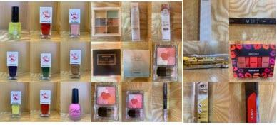
23-Nov-2020 | Travel Adapter | Computer / Audio / Video / Other Electronics & Accessories | Electric shock Hazard | 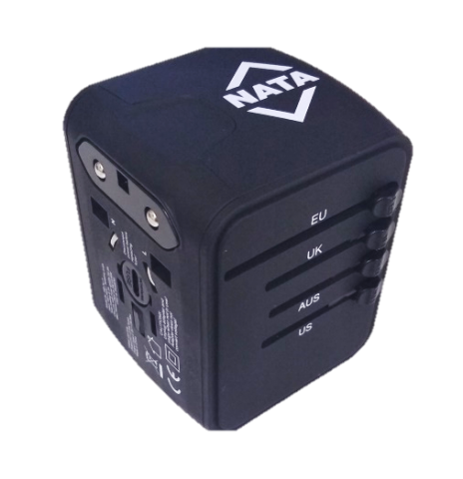
27-Nov-2020 | Wooden Baby Rattle | Toys and Childcare Articles | Choking Hazard and Suffocation Hazard | 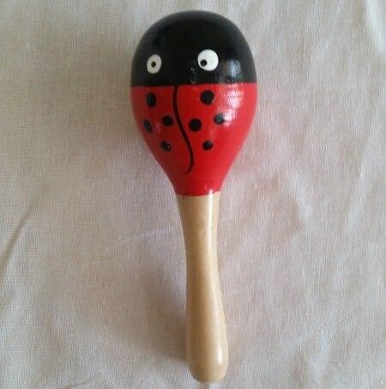
27-Nov-2020 | Circuit Breaker | Computer / Audio / Video / Other Electronics & Accessories | Electric shock Hazard | 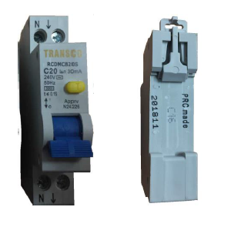
27-Nov-2020 | Children's Products | Toys and Childcare Articles | Choking Hazard | 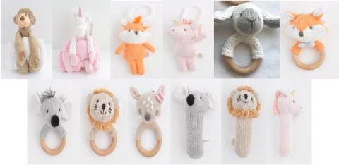
30-Nov-2020 | Gas Fireplace | Furniture | Fire Hazard | 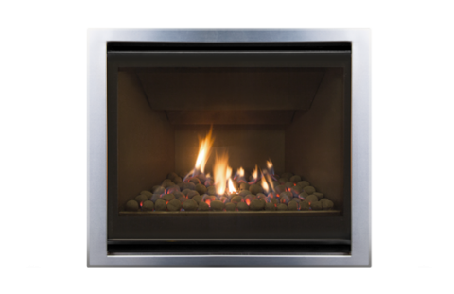
2-Dec-2020 | Bath Toys | Toys and Childcare Articles | Choking Hazard and Suffocation Hazard | 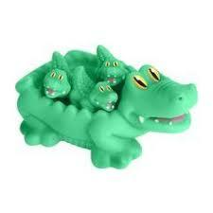
3-Dec-2020 | Baby Bouncer | Toys and Childcare Articles | Injury Hazard | 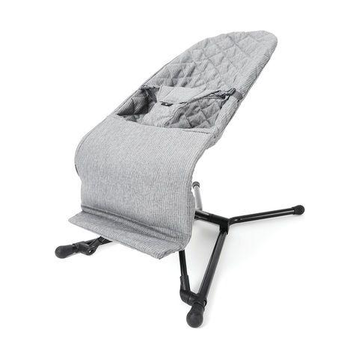
6-Dec-2020 | Electric Road Bike | Sporting Goods/ Equipment | Fire Hazard and Burn Hazard | 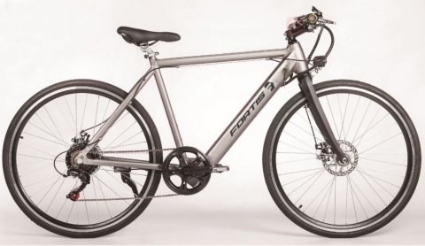
6-Dec-2020 | Body Sunscreen | Cosmetics | Burn Hazard | 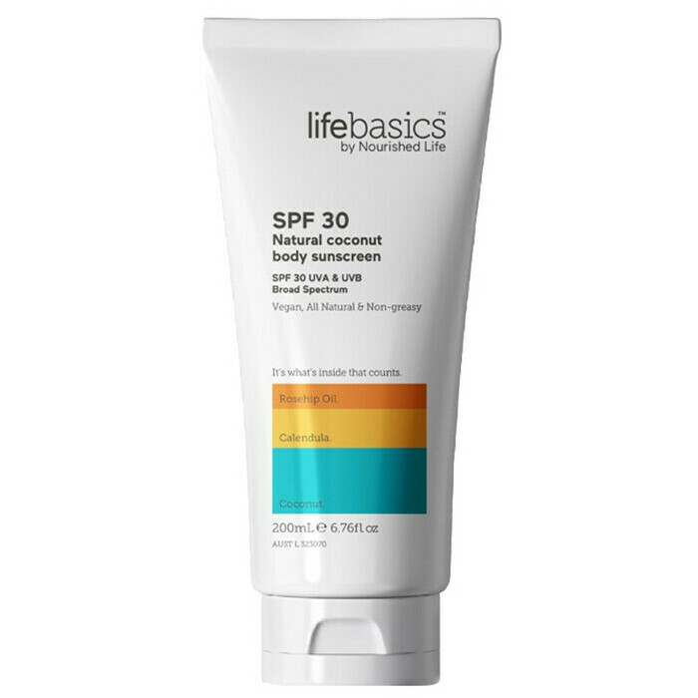
10-Dec-2020 | Kids Bike | Sporting Goods/ Equipment | Injury Hazard | 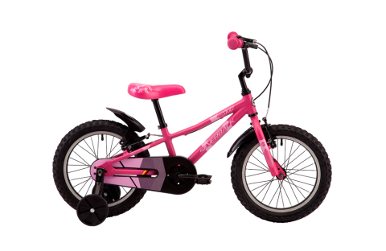
16-Dec-2020 | Hand Sanitiser | Personal Protective Equipment | Health Risk Hazard | 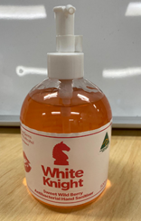
16-Dec-2020 | Micro Shot Blasters | Toys and Childcare Articles | Injury Hazard | 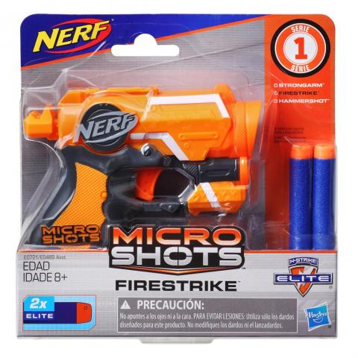
22-Dec-2020 | Trauma Dressing | Personal Protective Equipment | Health Risk Hazard | 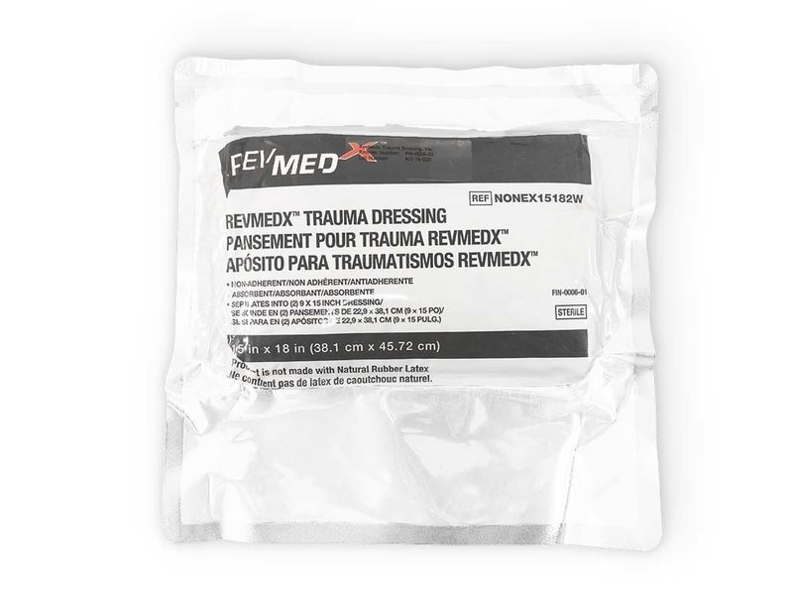
23-Dec-2020 | Residual Current Circuit Breaker | Home Electrical Appliances (Hair Dryer, Iron, etc.) | Electric Shock Hazard | 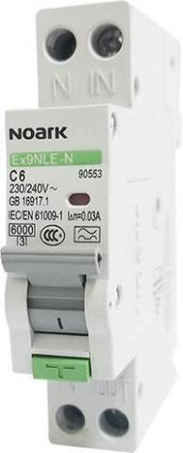
23-Dec-2020 | Bean Bag | Furniture | Choking Hazard and Suffocation Hazard | 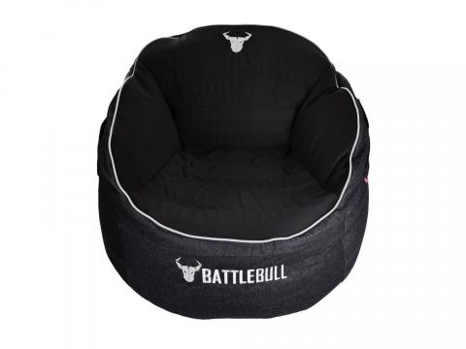
23-Dec-2020 | Vacuum Cleaner | Home Electrical Appliances (Hair Dryer, Iron, etc.) | Injury Hazard | 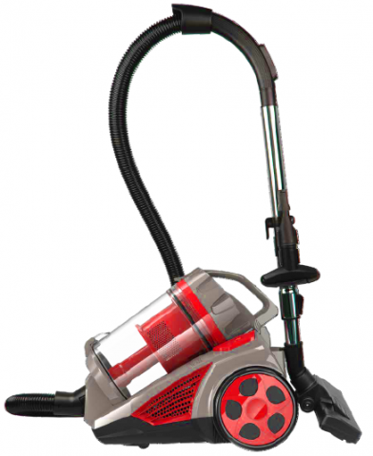
23-Dec-2020 | Wooden Rattle | Toys and Childcare Articles | Choking Hazard and Suffocation Hazard | 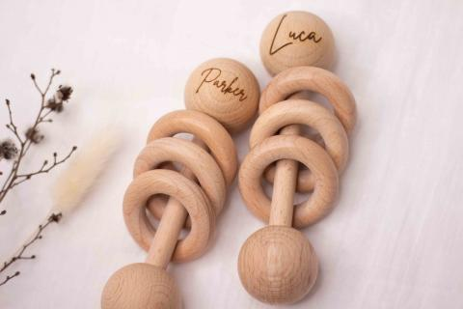
4-Jan-2021 | Wooden Puzzle | Toys and Childcare Articles | Choking Hazard | 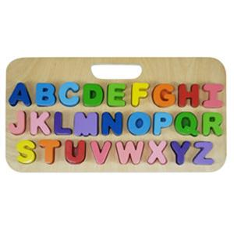
4-Jan-2021 | Wooden Puzzle | Toys and Childcare Articles | Choking Hazard | 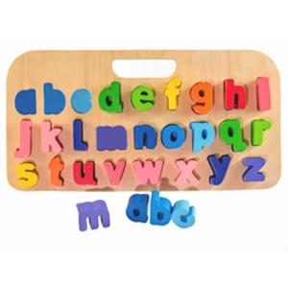
4-Jan-2021 | Wooden Puzzle | Toys and Childcare Articles | Choking Hazard | 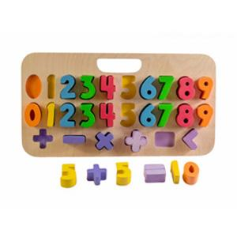
4-Jan-2021 | Wireless Charging Pad | Computer / Audio / Video / Other Electronics & Accessories | Fire Hazard | 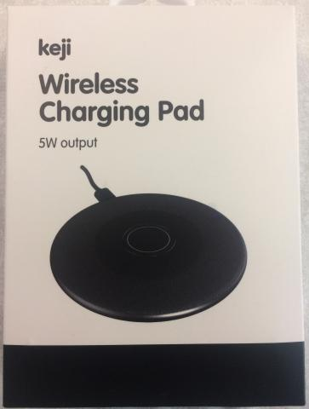
5-Jan-2021 | Maracas | Toys and Childcare Articles | Choking Hazard and Suffocation Hazard | 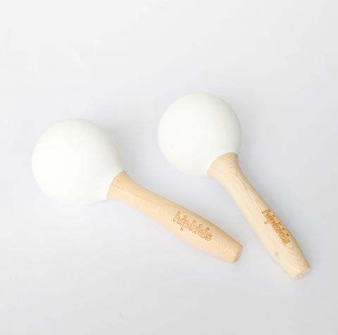
6-Jan-2021 | Montessori Knobbed Cylinders | Toys and Childcare Articles | Choking Hazard and Suffocation Hazard | 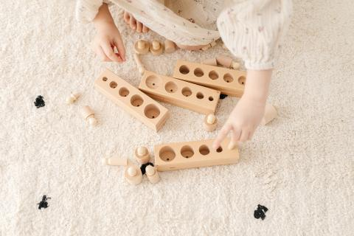
6-Jan-2021 | Inflatable Noodles | Toys and Childcare Articles | Drowning Hazard | 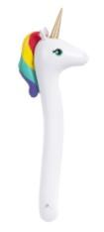
6-Jan-2021 | Wooden Maraca | Toys and Childcare Articles | Choking Hazard and Suffocation Hazard | 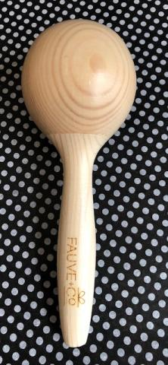
7-Jan-2021 | Wooden Rattles | Toys and Childcare Articles | Choking Hazard and Suffocation Hazard | 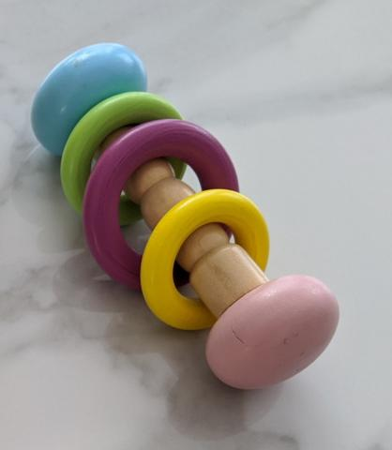
13-Jan-2021 | Wooden Puzzle | Toys and Childcare Articles | Choking Hazard and Suffocation Hazard | 